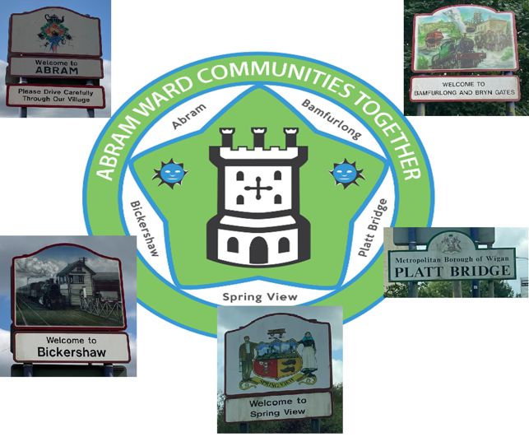

Abram ward Communities Together (ACT)
In 2015, Abram Ward Community Cooperative (now Wigan and Leigh Community Charity) brought together a group of local residents, residents' groups, Ward Councillors, Business and Schools from across the 5 villages of Abram Ward, to discuss the opportunity to develop a Neighbourhood Plan.
Everyone attending felt it was important that local people should have a say on the future of Abram Ward and the Planning Policies that shape the infrastructure of the Ward.

The Localism Act of 2011 introduced the option of Neighbourhood Planning in England. A Neighbourhood Plan document is written by a Town or Parish Council, or in urban areas a Neighbourhood Forum, to guide future development, regeneration and conservation of a particular area. This Plan is about how the land in the Neighbourhood Area will be used and developed and it contains planning policies and proposals for improving the area.

An Abram Ward Neighbourhood Area (Abram, Bamfurlong, Bickershaw, Platt Bridge, Spring View) was developed and a Constituted Forum was established, named Abram ward Communities Together (ACT).
Since 2015, the Forum has met to put together a series of Consultation events to gain the view of the local people who live and work in the Ward.
Feedback from these have been turned into a Neighbourhood Plan and supporting Planning Policies.

Neighbourhood Plan Vision
For our neighbourhood to be a great place to live and work, with the environment at its heart – making it attractive, resilient, ambitious, thriving and sustainable.
As a Neighbourhood Forum we aim to work together to make the ward an even better place to live for jobs, amenities and services, health and wellbeing and community spirit. We want to encourage the five villages to work together to make a positive difference to the ward overall. We acknowledge the distinguishing characteristics and historic roots of each of the five villages and want to build on and enhance these, as part of our offer and approach to attracting new residents. We aim for Abram Ward to be a vibrant, creative, inclusive and safe neighbourhood, which supports a strong sense of community, and is a pleasant and attractive place to live, work, shop and spend leisure time.

Information and Contact Details
To see the full ACT Neighbourhood Plan visit www.abramwardplan.org.uk
Please provide comments and feedback by email on the consultation comment sheet to d.baxter@abramwardcooperative.org or visit us face to face at a drop in session starting from 5th November 2021, every Friday from 11am until 12 noon at the Wigan and Leigh Community Charity, Platt Bridge Community Zone, Ribble Road, Platt Bridge, WN2 5EG.

Policy Consultation
The Abram ward Communities Together (ACT) Neighbourhood Plan covers the period 2022 to 2037.
We are reaching out for community engagement and comments on the below policies.

Policy BEC1: Business, Enterprise and Community Facilities
- New businesses, enterprises and community facilities will be supported in or immediately adjacent to the existing built areas of the villages, providing there is no significant adverse impact on:
  - The amenities of nearby residential properties;
  - The built character of the village, having regard to Policy DES1.
- Diversification of existing businesses in the rural area will be supported, providing there is no adverse impact on:
  - The amenities of residential properties;
  - The open and rural landscape character of the area.
- Within the Green Belt, schemes will only be supported where they comprise appropriate development in the Green Belt.
- Development involving the loss of existing business, enterprise or community facilities will only be supported where:
  - Equivalent or better facilities are provided in close proximity; or
  - It can be demonstrated that the use is no longer required or viable.

Policy RD1: Residential Development
- Residential development will be supported in the following locations:
  - Brownfield sites;
  - Infill sites within existing built frontages in the village centres.
- The following are encouraged and will be supported in the locations described in the first clause:
  - Schemes comprising 100% affordable housing;
  - Smaller (1, 2, 3 bedroom) houses and apartments;
  - Housing suitable for the older people;
  - Special care schemes;
  - Community-led or self-build housing.
- Support for residential schemes is subject to them having no significant detrimental impact on the amenities of existing residential properties and meeting the requirements of design and other policies in this plan.
- Within the Green Belt, schemes will only be supported where they comprise appropriate development in the Green Belt.
- Where developers seek reduction of the proportion of affordable housing provision on viability grounds, the housing mix should include predominantly smaller properties. Viability considerations will not justify poor or unsustainable design, which will not be supported.
- Strong encouragement is given to incorporation of measures to reduce the environmental impact and running costs of the properties, including by achieving environmental performance in excess of building regulation requirements.

Policy REF1: Refurbishment
- Schemes to sensitively refurbish and reuse vacant buildings will be supported, including temporary or ‘meanwhile’ uses, subject to there being no significant adverse impact on the amenities of residential properties.
- Support will be given to refurbishment schemes that would enhance the urban and industrial character of the area through the reinstatement of original features or reversal of previous harmful alterations.
- Refurbishment schemes for designated heritage assets should preserve listed buildings and their settings or preserve and/or enhance the character or appearance of conservation areas.
- Refurbishment schemes for non-designated heritage assets should preserve or enhance the historic or architectural qualities of the building and the setting of the building.

Policy AP1: Air Quality
- Development should not cause any net gain in air pollution. Where development generates vehicle movements or has other potential impacts on air quality, mitigation measures must be included as part of the scheme.

Policy GS1: Local Green Space
- The following spaces are designated as Local Green Spaces:
  - LGS1: Victoria Fields,
  - LGS2: Maypole Wood,
  - LGS3: Polly’s Pond,
  - LGS4: Platt Bridge Community Green;
- Development must not encroach onto Local Green Spaces, unless it comprises small-scale development to enhance the community use of the space and it does not compromise the open or green character.
- Development must not have any detrimental impact on the special community value, amenity, safety or accessibility of Local Green Space.

Policy GS2: Proposed Green Corridor
- Development must not disrupt, compromise or encroach onto the identified area for the proposed green corridor (Figure 8).
- Development must have not have any detrimental impact on the community value, amenity, safety or accessibility of the strategic green space network.

Policy REC1: Recreational Spaces
- Development must not involve the loss of the area’s parks, recreation spaces, play areas and fishing ponds and must have no significant adverse impact on their community use, amenity, safety or accessibility.
- Development should take opportunities to enhance parks, recreation spaces, play areas and fishing ponds and their settings.

Policy DES1: Sustainable Design, Character and Biodiversity
- Development must be well-designed and sustainable and reinforce the locally distinctive character of the area’s villages, built environments and landscapes, meeting the following requirements, proportionate to the scale and nature of the scheme.
- Development must complement the character of the surrounding townscape in terms of height, scale, massing, and set-back from the road. This includes complementing the predominantly 2-3 storey character of the area.
- Development within the five villages must complement their urban and industrial character. High quality materials should be used to complement the existing palette of traditional local materials. Use of recycled materials and materials from sustainable sources is also supported.
- Development must provide convenient pedestrian and cycle links to surrounding paths and footways and allow for easy movement within the site, for people with different levels of mobility.
- Development must provide active frontages (elevations with windows) to streets and spaces and avoid flanking them with high enclosures or blank walls.
- Development must have no detrimental impact on the area’s protected landscapes, wildlife habitats, ecology or biodiversity.
- Development should include positive design features to reduce carbon use, support wildlife and ecology and create net gain in biodiversity.
- High quality landscape design and greenery should be an integral part of the design and layout of development.
- Discretely sited and screened storage for bins and recycling must be provided, in addition to meeting Policy TM1’s requirement for cycle storage.
- Creative and innovative design will be supported, especially where it incorporates green features and superior environmental performance.

Policy TM1: Transport and Movement
- Development must be supported by an adequate and balanced range of transport provision, including sustainable forms of transport, proportionate to the scale and nature of the development.
- The layout of development must prioritise pedestrian convenience and safety, also meeting the requirements of Policy DES1.
- Transport infrastructure should be designed to help create a high-quality public realm and sense of place.
- Development likely to generate additional journeys must include secure and covered storage for cycles, including for all new dwellings, and shower and changing facilities where new employment is being created.
- Drives and parking spaces should be surfaced using water permeable materials or be served by appropriate sustainable urban drainage systems.
- Parking areas should include vehicle charging points, with smart charging functionality.

Policy TM2: Footpaths and Cycleways
- Development must not encroach onto footpaths or cycleways.
- Development must have no significant adverse impact on the amenity, safety or accessibility of footpaths or cycleways.
- Development proposals which restrict pedestrian and cycling access into the village centres from the Abram Ward Circular Walks will not be supported. Enhancements to the Abram Ward Circular Walks, including improved accessibility by walking and cycling, will be supported.

Policy INF1: Infrastructure Priorities
- In the use of planning infrastructure funds, the following are priorities for this Neighbourhood Plan:
  - Improvement to cycle and pedestrian paths, including stronger links to the Abram Ward Circular Walks, and cycle parking;
  - Additional bus stops;
  - Improvements to signage, especially to the Abram Ward Circular Walks;
  - Support to improve community facilities, especially business hubs.

