ACT Neighbourhood Plan Consultation Comments | 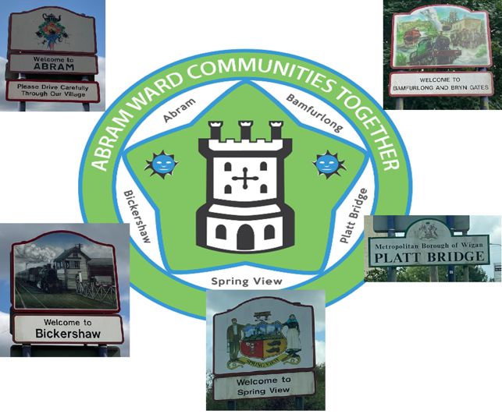

Contact Details

Name / Group:
Address:
Tel No:
Email:

Policies

Policy BEC1: Business, Enterprise and Community Facilities

Comments:

Policy RD1: Residential Development

Comments:

Policy REF1: Refurbishment

Comments:

Policy AP1: Air Quality

Comments:

Policy GS1: Local Green Space

Comments:

Policy GS2: Proposed Green Corridor

Comments:

Policy REC1: Recreational Spaces

Comments:

Policy DES1: Sustainable Design, Character and Biodiversity

Comments:

Policy TM1: Transport and Movement

Comments:

Policy TM2: Footpaths and Cycleways

Comments:

Policy INF1: Infrastructure Priorities

Comments:

