ACT Neighbourhood Plan

Local Green Space Assessment

Introduction
The National Planning Policy Framework (NPPF) created a new designation of ‘Local Green Space’.
Local Green Space (LGS) designation allows local communities to protect green spaces of local importance for reasons including setting and nature conservation. Local communities can identify green spaces through their local and neighbourhood plans, which will then receive protection equivalent to Green Belt land.
If planning permission has already been granted for the land, it is not normally possible to designate it as LGS. If the space already has a designation, such as a site of special scientific interest, consideration will be given if an additional designation would add any local benefit.
In order to qualify as a LGS, the green area must meet the criteria set out in the NPPF. There is no set distance for how close the green space needs to be to the local community, or the minimum size, which will depend on local circumstances. The management responsibilities for the LGS are with the landowner and no specific restrictions or obligations are placed on the landowner with the designation.
NPPF paragraph 76 states: “Local communities through local and neighbourhood plans should be able to identify for special protection green areas of particular importance to them. By designating land as Local Green Space local communities will be able to rule out new development other than in very special circumstances.
Identifying land as Local Green Space should therefore be consistent with the local planning of sustainable development and complement investment in sufficient homes, jobs and other essential services. Local Green Spaces should only be designated when a plan is prepared or reviewed, and be capable of enduring beyond the end of the plan period.”
Abram Communities Together (ACT) Neighbourhood Plan identifies four sites in the Neighbourhood Area (NA) that can be designated as LGS, chosen through study and consultation with the local community. Each fulfils the requirements of the NPPF guidelines as outlined in the evidence below.
The sites identified, the urban area of the NA (see Map A) highlighted in green are:
- LGS1: Victoria Fields
- LGS2: Maypole Wood
- LGS3: Kingsdown Flash [known locally as Polly’s Pond]
- LGS4: Platt Bridge Community Green
Information on the four site’s is outlined as well as how the site’s complies with the NPPF criteria in qualifying it for LGS status. There are no pending planning applications on any of the four sites.

National Policy
The National Planning Policy Framework 2021 sets out the criteria for designating Local Green Space, as follows:
101. The designation of land as Local Green Space through local and neighbourhood plans allows communities to identify and protect green areas of particular importance to them. Designating land as Local Green Space should be consistent with the local planning of sustainable development and complement investment in sufficient homes, jobs and other essential services. Local Green Spaces should only be designated when a plan is prepared or updated, and be capable of enduring beyond the end of the plan period.
102. The Local Green Space designation should only be used where the green space is:
- in reasonably close proximity to the community it serves;
- demonstrably special to a local community and holds a particular local significance, for example because of its beauty, historic significance, recreational value (including as a playing field), tranquillity or richness of its wildlife; and
- local in character and is not an extensive tract of land.
103. Policies for managing development within a Local Green Space should be consistent with those for Green Belts.

Analysis of Sites
The ACT Neighbourhood Plan identifies four key green spaces in the Abram Ward, two of which are identified in Wigan Council’s OSSR as Natural and Semi-Natural Greenspace.
These are:
- Victoria Fields;
- Maypole Woods;
- Kingsdown Flash [known locally as Polly’s Pond];
- Platt Bridge Community Green.
Farming and Coal Mining have been important to the Abram Ward. There are a number of designated rights of way (Abram Ward Baseline Evidence, paragraph 7.16) and many other footpaths and bridle-paths leading through and across the countryside surrounding the five villages.
Wigan Councils’ OSSR characterises Victoria Fields as a Natural and Semi-Natural Open Space and Maypole Wood as Woodland. The ACT Neighbourhood Plan designates pieces of land as Local Green Spaces due to their significance as a green space close to the community these spaces serve, people living and working in Bickershaw and in Abram. This aims to ensure that local people will have ongoing access to high quality green spaces. Victoria fields is a former colliery site, which has been restored back to natural landscape and is managed in part by local groups and organisations including Bickershaw Village Residents’ Association; it creates a key corridor between Low Hall and Bickershaw Country Park. It is adjacent on its eastern edge to Barlow Moor SBI. Maypole Wood is a former site that has partly been used for colliery waste, clay brick production and rail transportation for coal and is managed by Abram Woodland & Wildlife Conservation Group; it forms a link between Bickershaw Country Park and the SSSIs. All sites are regularly used by local people for recreation and walking and form part of the Abram Ward Circular Walks; they hold special significance for local people, due to their heritage as former industrial sites in each of the villages, which remain of strong significance to local people whose families worked there.

Green Space Designations

Key for Maps
Greenspace Site
Neighbourhood Boundary

The Abram Ward
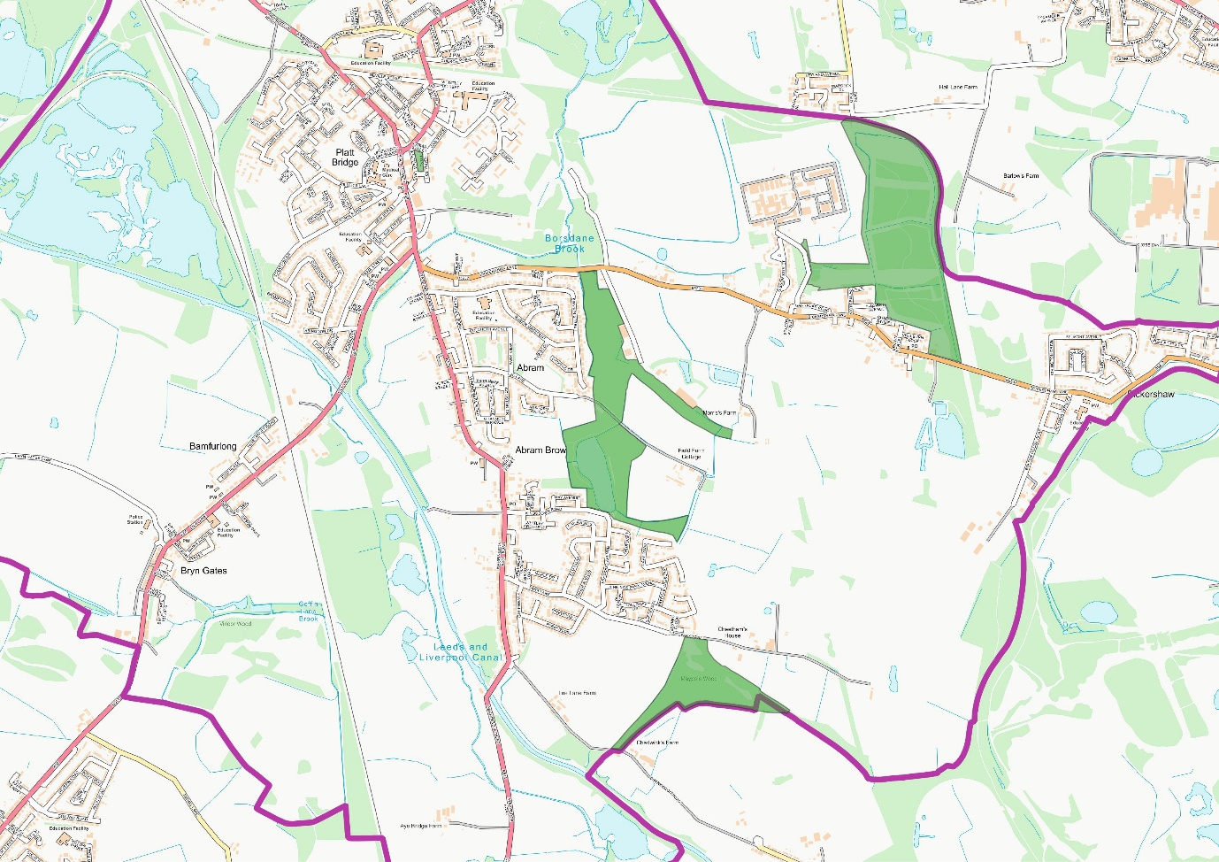
Map A: The Abram Ward

LGS1: Victoria Fields
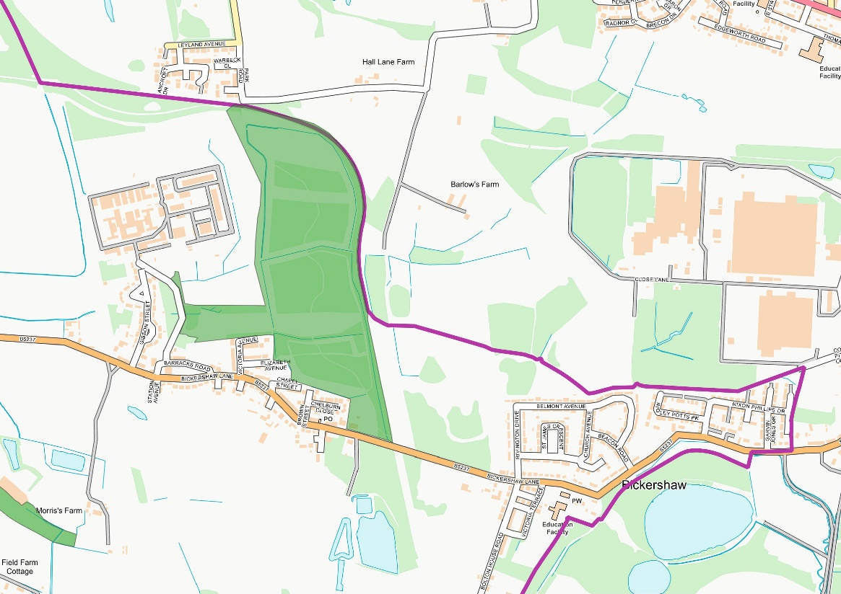
Map B: Victoria Fields

LGS2: Maypole Wood
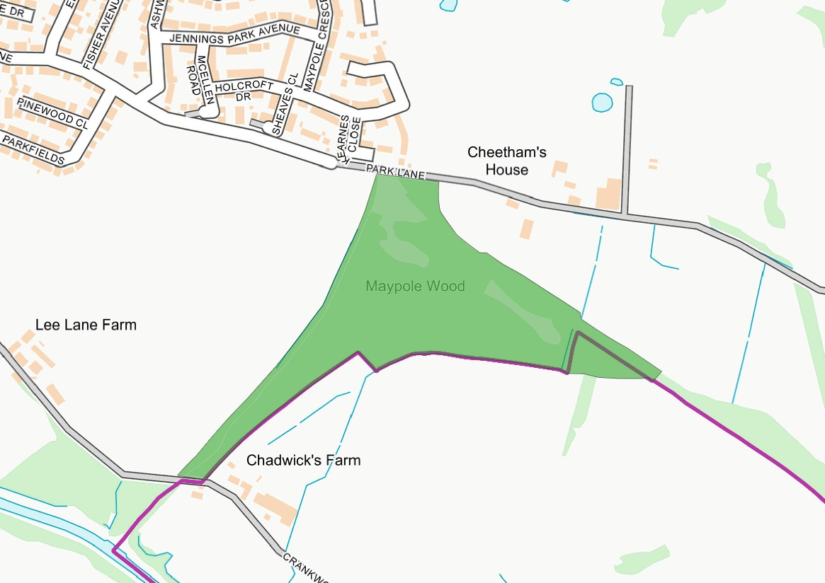
Map C: Maypole Wood

LGS3: Kingsdown Flash [known locally as Polly’s Pond]
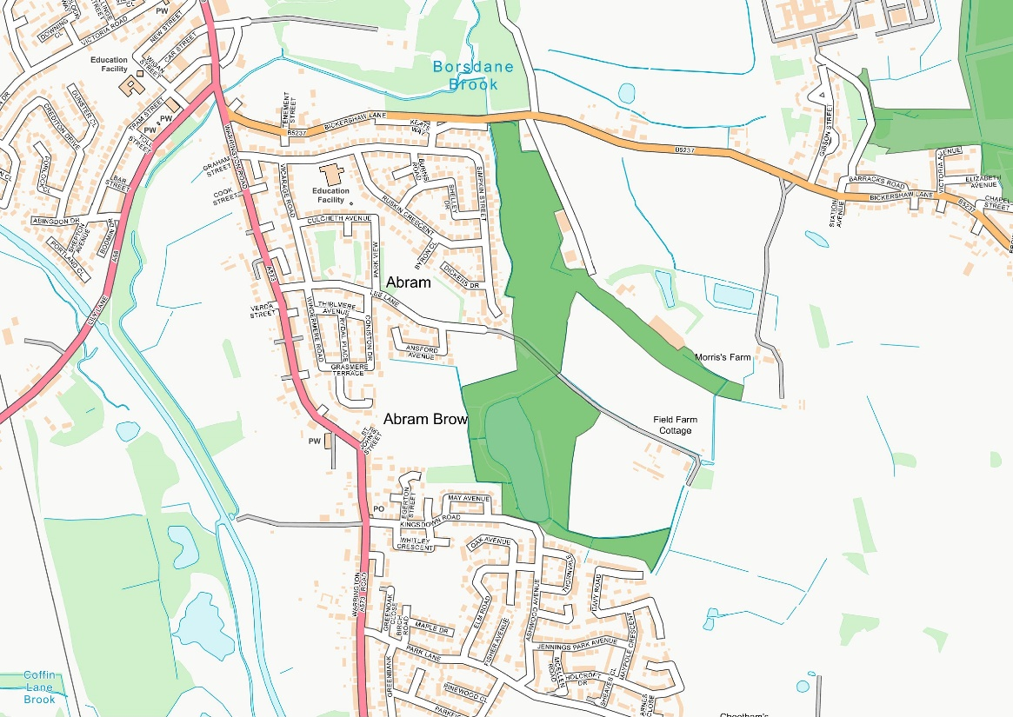
Map D: Kingsdown Flash [known locally as Polly's Pond]

LGS4: Platt Bridge Community Green
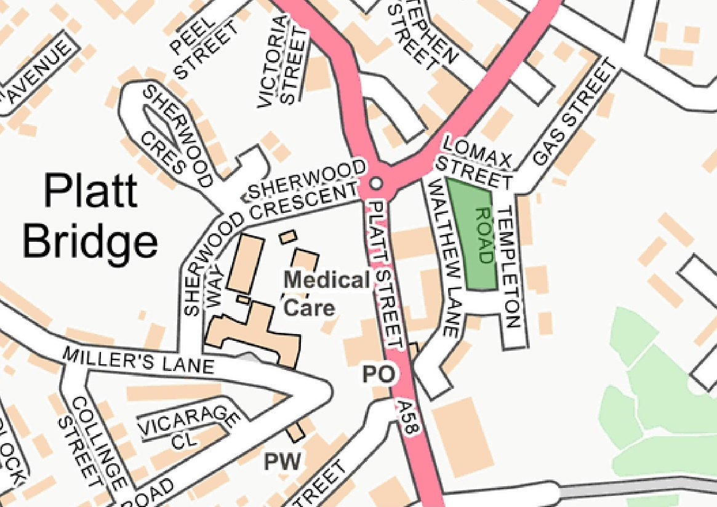
Map E: Platt Bridge Community Green

Community Value
The Abram Ward Neighbourhood Area has a wide range of attractive, accessible green spaces. The entire Plan area is at the centre of Wigan’s countryside “The Greenheart”. There are four Local Nature Reserves (LNRs), two Sites of Special Scientific Interest (SSSIs) and seven Sites of Biological Importance (SBIs).
These green spaces play an important role in providing Wigan’s essential Green Infrastructure. Many of them form important wildlife habitats and the neighbourhood forms a key role in Wigan’s ecological network, being part of the Greater Manchester Wetlands area and the Carbon Landscape Project.
Abram Ward is mainly within the Green Belt and is fully within the Greenheart and the Greater Manchester Wetlands area (Abram Ward Baseline Evidence, paragraphs 3.2 and 3.6). It has a diverse range of habitats [many of which are restored landscapes] including grasslands, woodlands and wetlands. This is a network of key Green Infrastructure which provides resilience to climate change and key local and regional ecological habitats, offering wildlife corridors for insects, birds and small mammals, some of which are rare and endangered (Abram Ward Baseline Evidence, section 3).

LGS1: Victoria Fields
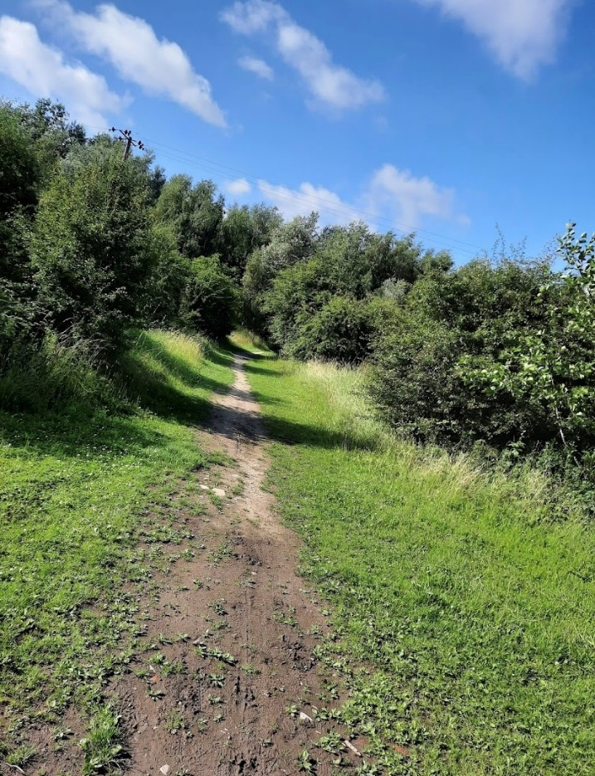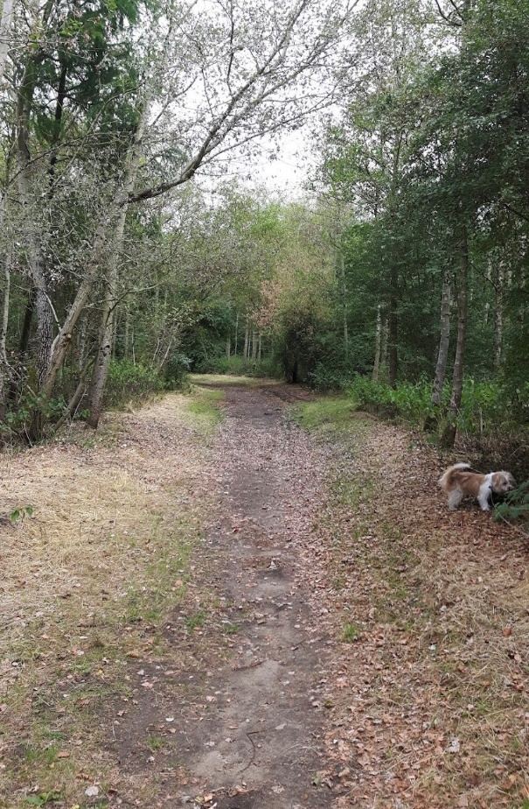

LGS2: Maypole Wood
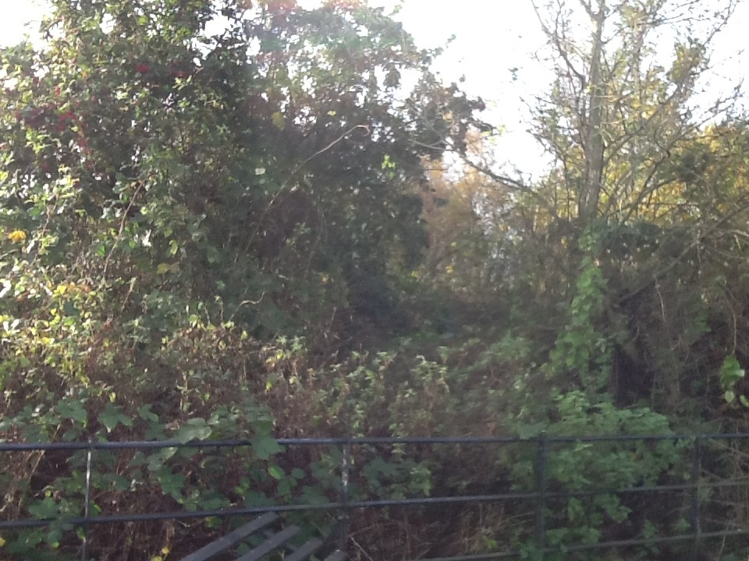

LGS3: Kingsdown Flash [known locally as Polly’s Pond]
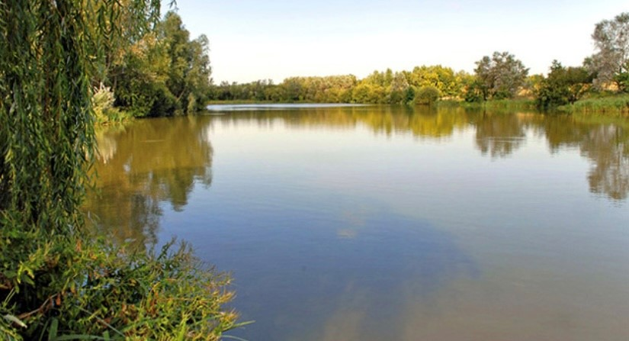

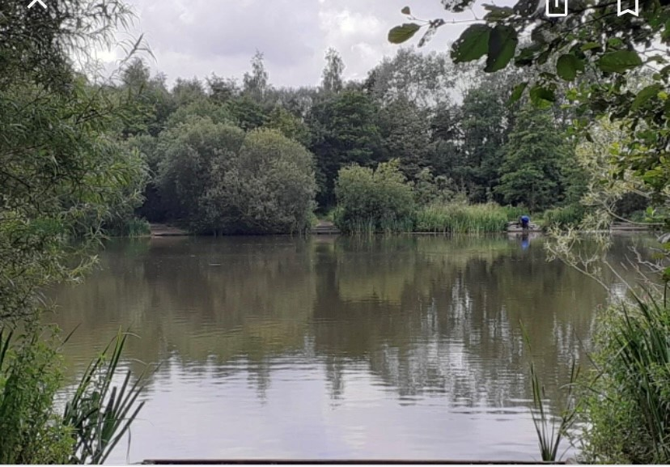

LGS4: Platt Bridge Community Green
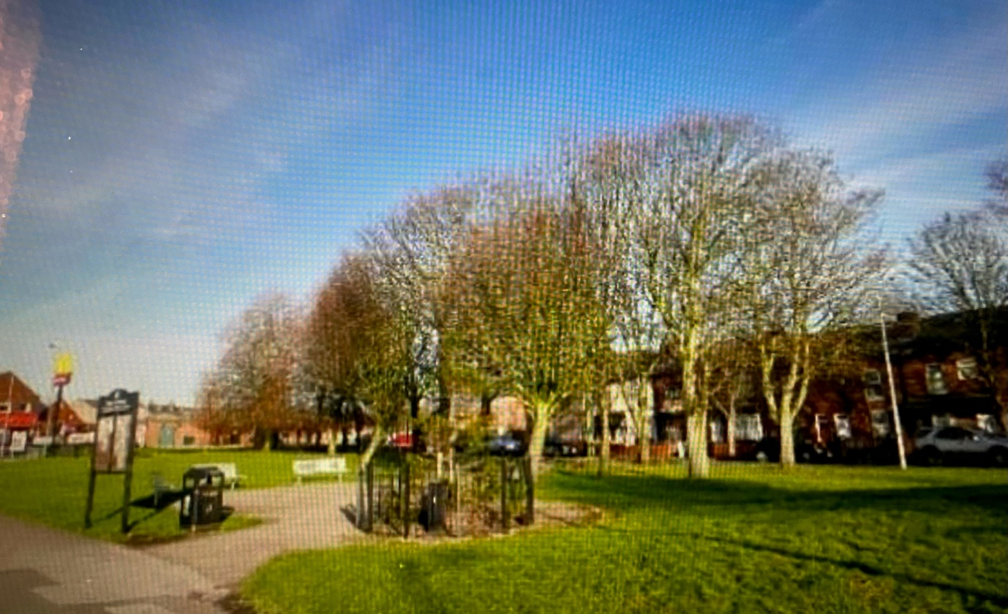

Suitability for LGS Designation

Special Community Value | The four spaces are of special community value, as described above.
Area of Space (Ha) | 52.091 Ha (Victoria Fields: 23.632 Ha; Maypole Wood: 7.811 Ha; Kingsdown Flash: 19.055 Ha; Platt Community Green: 1.593 Ha)
Planning Permissions or Site Allocations | None
Other Designations | In relation to the NPPF criteria “where the green area is demonstrably special to a local community and holds a particular local significance, for example because of its beauty, historic significance, recreational value, tranquillity or richness of its wildlife”, the sites fulfil all these aspects.
Not an Extensive Tract of Land | In relation to the NPPF criteria “where the green area concerned is local in character and is not an extensive tract of land”, the sites fulfil these aspects.
Close to the Community it Serves | All four areas are valuable sites to the community they surround. They provide much-needed recreational space to the nearby populations in the Abram Ward neighbourhood area. They are rich in wildlife and well used by residents and visitors.

Conclusion
There is clear evidence that the four sites closely match the criteria for LGS designation. They are ideally located to support the strategic aims for recreation, health and wellbeing. Retaining it as green space will also bring economic benefits by improving the “Quality of Place” within our neighbourhood area.

