Abram Ward
Public Rights of Way Audit
Summary Report

Intro
Legality
Signage
Previous studies
General Recommendations
Existing Walks Issues and Actions
Proposed new route
Way Forward

Introduction
Local community groups aspire to create a network of rights of way that connect the 5 villages and promote Abram as a central hub for the Wigan Greenheart area.
To ensure this, it is fundamental that existing rights of way are accessible and in a good state of repair. An access audit was undertaken to gain an understanding on current states as well as gather recommendations for actions to be implemented to improve the network.

“Public Rights of Way should be regarded as an integral part of the complex of recreational and transport facilities within their area” (Defra 2009)

Public rights of way provide a convenient, expense free means of travelling between local areas, shops and facilities. They themselves are a facility that can be utilised to improve health, connectivity, encourage activity and make environments more accessible.
By improving the footpaths in the Greenheart area, opportunities will be created for local and long- distance routes to be joined together by improving access onto and within the network.

Legality
The Local Highway Authority, which will usually be a county council, have a statutory duty to keep records of public rights of wayand keep the rights of way open for the public to use. They have a duty to manage, maintain, protect and change public rights of way. To maintain and protect public rights of way the local highway authority must;
- Keep public right of way surfaces (that are maintained at public expense) in fit state for public to use
- Make sure obstructions are removed
- Make sure there are no notices discouraging or preventing use of the public right of way
- Protect publics rights to use Public right of way
- Maintain some bridges over natural watercourses (this includes farm ditches)
- Provide landowners with 25% of the cost of repairs on structures for the control of animals – once completed work has been inspected and deemed of an acceptable standard.
- Add signs where a Public Right of Way leaves a metalled road
- Ensure Landowners carry out their duties and take action when they don’t

It is an offence to block a public right of way. All obstructions should be reported to the local authorities to request they are removed. The local authority should send a letter confirming removal request within 1 month of receiving complaint. If obstruction isn’t removed within 2 months of receiving confirmation of removal request, then the complainant can apply for a court order to have it removed to speed things along.

Landowners cannot erect stiles and gates at their discretion. Interruption of the publics free passage can only occur in circumstances where a gate or structure prevents animals coming in or out of an area, where the new structure will improve access for people with disabilities (and has been authorised) or in places where a stile or gate traditionally existed for many years, pre-dating the right of way records.

Signage
Members of the public should be provided with sufficient information regarding footpaths to enable them to use the public rights of way network. Appropriate signage is required to signify where the public rights of way begin - this is also particularly important at path junctions. The owner or occupier of land crossed by public right of way needs to be consulted before any signs are erected, landowner consent is required if the signs are to be placed on their property. Signs installed on roadside verges usually fall under Highway Authority jurisdiction.

Previous work
Local Access Forums exist throughout boroughs across England. Wigan has a Local Access Forum that discusses things such as Rights of Way Improvement Plans, Cycling Development Plans, Walking Development Plans, Public Path Orders- permanent closures, creations and diversions and the impact of HS2 Phase 2. Wigan Council drew up a Rights of Way Improvement Plan (ROWIP) IN 2007- they consulted extensively with the public and worked with the Wigan Local Access Forum to develop the plan. A sample of the objectives of the 2007 ROWIP include creating an integrated and continuous network which incorporates both local and long-distance routes and to promote the path network. Objectives that we should also aspire to.
Prior to publishing the 2007 plan, a study was conducted of the public right of way network in Wigan to gather baseline data-key issues and areas for action were identified. It is interesting that the issues identified then are similar to the issues that have been identified in this audit.
In 2007 walkers identified problems with; motorcycles illegally using paths, littering, poor stile design, farmers actively deterring people through private signs and dogs and the lack of a strategic route between boroughs.Disabled users of the public rights of way highlighted problems with; stiles, path obstructions, steep gradients, lack of toilets, unsuitable path surface materials- especially when wet.

.

GENERAL RECOMMENDATIONS

As many of the public rights way are within close proximity to housing developments there is always a risk of anti-social behaviour. At anti-social hotspots, in the absence of a custodian, clearly displayed details of someone to contact to respond to antisocial behaviour will allow members of the public to take action against the problem. Additionally, the Council should ensure that it is easy and straightforward to report incidents of anti-social behaviour through their website and social media pages.With limited resources anti-social behaviour can be difficult to tackle but there are some novel, low cost approaches that could be adopted.
A community-based anti-crime campaign in Rotterdam consisted of 10,000 eyes being spray painted onto roads, pavements and attached to buildings throughout the city to communicate anti-crime policies in those neighbourhoods, this campaign was successful and crime rates were reduced.
Based on research that shows people behave differently when they are being observed, in 2016 the forest of Dean conducted an experiment to see if the use of eyes would be effective in reducing rural littering. Local children worked with artists to create faces from litter collected in the forest, these faces were attached to trees at littering hotspots. 50 of the these “communitrees” (fig.1)were installed and some sites saw a 30% drop in litter levels in the first year of the project.

Even if the faces on trees fails to tackle littering, a project similar to this is a great way to get local school children involved in the anti- littering message and additionally the faces themselves could form part of a trail to encourage people to get walking.
In the 2007 report it was suggested to use the old railway line at Low Hall to connect different areas. Making a feature point of the former railway that runs through Platt bridge would highlight the industrial past of the area and create a new interest in the right of way network. Converting this section of line so it is better suited to recreational use and landscaping it to enhance its attractiveness to wildlife would create a linear park that leads nicely onto the trails passing through low hall. The creation of this rail-trail is a project that could involve a wide cross section of the community due to its location passing through housing estates, it also would create an enhanced habitat corridor for wildlife. Inspiration could be drawn from projects such as the Highline Park in Manhattan (https://www.thehighline.org/gardens/garden-zones/).
Figure 1: one of the “communitree” faces created from litter.
The Sustrans Route 55, (National Cycle Route 55) was identified by cyclists in 2006 as a top priority for improvement as it acts as a chord running through the borough and links to many towns and schools. It is still the case that parts of this route are in desperate need of improvement (the section running through Low Hall is dire), ensuring this route is enhanced and usable is imperative if Abram has aspirations of being a central hub.

Walkers should be encouraged to report issues when they see them, so they can be resolved before they escalate into a bigger problem. People should be made aware of who to contact and of organisations such as the Ramblers Charity who have a website and mobile app that can be used to log rights of way problems- so they can then be chased up. To ensure that problems encountered on the network are acted on it could be good to start an initiative that promotes a rolling programme of inspection cycles. Interested individuals or groups could be given an area in which all footpaths would be inspected a minimum of once a year. Splitting the work between a group of people should mean all areas of the network can be covered. Annual checks would also highlight sections of path that are noton routine maintenance schedules – this information can thenbe passed on to the appropriate body.

Existing Walks Issues + Actions

Co-ordinates have been written for exact locations in such a way that they can be copied and pasted directly into google maps – minus the parentheses.

Amberswood Common + Amberswood to Leyland Park:
As you exit the car park on Wigan Road (53.536840, -2.588537)turn right and head along the long the initial stretch of cycle path (National cycle route 55) there is a lot of litter lying around. The addition of a bin near the entrance barriers might be beneficial. The first bench you arrive at on the trail(53.534622, -2.588850)is in state of disrepair- looks unstable and end leg needs reinforced to avoid collapse (fig.2).
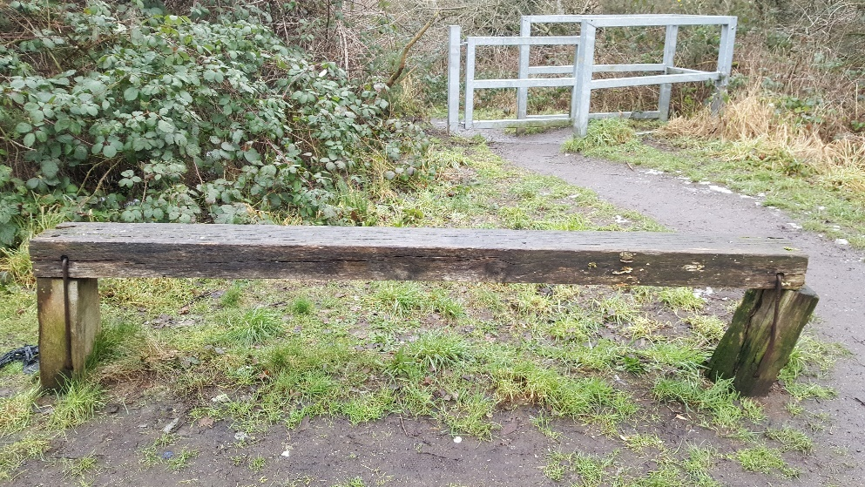

Figure 2: Bench in need of repair

There are some pre-existing concrete artworks on Amberswood that have become obscured by overgrown vegetation(fig.3)- recommend cutting back vegetation so they are more visible(53.531233, -2.596683).Some path flooding occurs on the dirt footpath directly in front of concrete artwork(fig.4) (53.531450, -2.597900), recommend some footpath maintenance here such as levelling off surface and adding a drainage channel to avoid pooling.
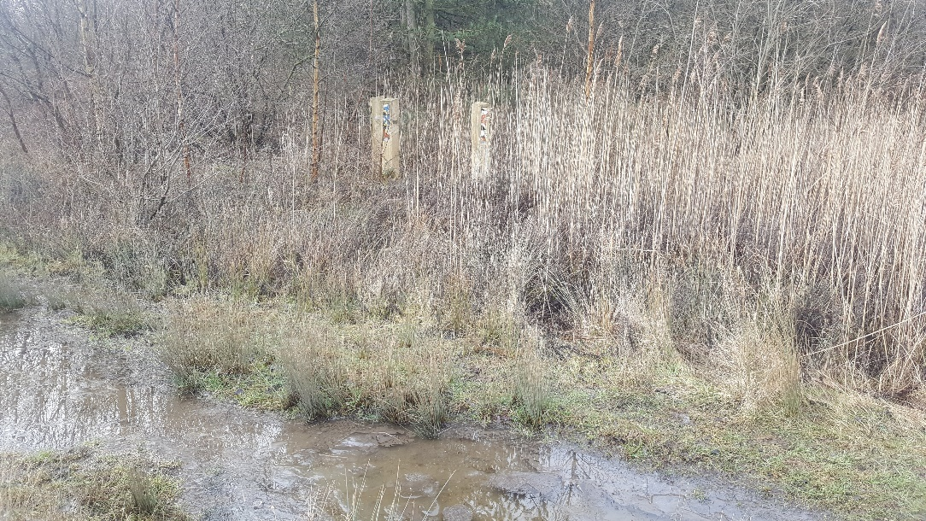
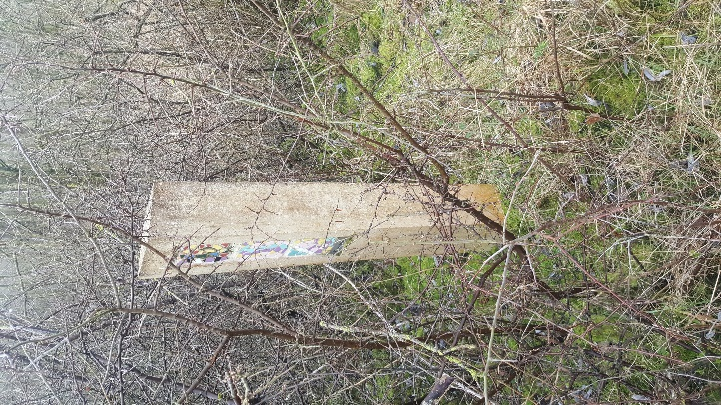
Figure 4: footpath flooding Amberswood
Figure 3: Obscured artwork Amberswood
Following the footpath along the outside of Low Hall Reserve, the path overlooks a steep sided embankment from the former railway line. Under the former railway line bridge is a gully that seems to be used for dumping waste with debris stretched out along the bottom for approx. 30 metres (53.521733, -2.579200).
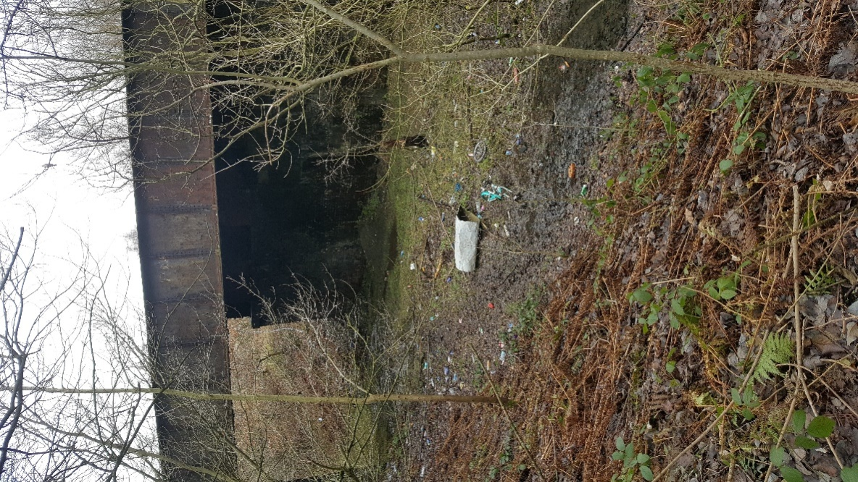
It is going to a real effort to get this section free of litter(fig.5), it will require either organising a volunteer work party or getting council staff involved. The steep sides of the bank might make it unsuitable for a volunteer work party to do a litter collection session in some parts of this area however and some there is a potential for there to be hazardous material under the mud.
Figure 5: lower track currently covered in mud and debris
The section of path leaving Low Hall, heading towards Platt Bridge Estate there is a section where the path becomes very narrow just before the underpass to the estate. A woman was witnessed struggling to get her pram down this section and other users commented that wheelchairs struggle on this section. The vegetation needs scraped back to make the path wide enough to be used by prams and wheelchairs. Section needing widening begins at (53.523579, -2.1591003). Users commented how surrounding footpaths had been refurbished but not this stretch.
Coming out of Low Hall and heading towards Leyland Park, where the footpath meets the end of Leyland Avenue, (adjacent to Leyland Park) the track back towards Low Hall is very muddy and passes through a “den” that has been constructed in the woods, presumably by local children (53.523049, -2.576408).

BICKERSHAW

Bickershaw Walking Group have highlighted a general lack of signposting and deeply muddy tracks throughout the Bickershaw Project area, it would be very difficult for someone without local knowledge to navigate themselves along footpaths. Waymarkers should be included at key areas, especially to follow loops and to direct towards Low Hall. The local community feels that it could potentially be problematic to direct walkers beside the Bickershaw Traveller Site- even though a right of way runs through here. If walkers are aware that the site is there, stick to the right of way and avoid passing directly through the traveller site this should help avoid incidents.
Waymarkers could also be used to the benefit of the community by having additional signs attached that show distances and directions to local cafes or shops- this also has the added benefit for walkers with children or those with restricted mobility as it gives a refreshment destination which in turn could encourage people to walk longer distances.
Some instances of blocked public rights of way have been brought to attention in the area (fig: 6,7).A farmer has blocked the path with many horses (53.511495,-2.5790960) so you can no longer access route, a massively overgrown tree blocks a route that locals have previously enjoyed using for years (53.509407,-2.5759764).

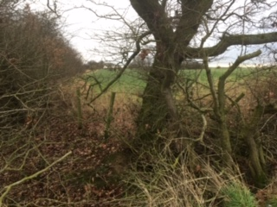
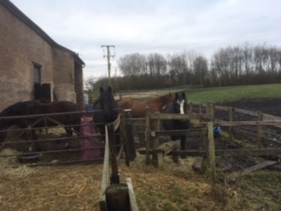
Figure 7: tree and overgrown vegetation blocking right of way
Figure 6: animals blocking right of way

Massive piles of fly tipped waste are partially blocking footpaths at a few separate sites, notably on the landsurroundingT.I.P skip hire at the top of Bolton House Road(53.508439, -2.561857).On Bolton House Road the concrete panel wall belonging to the scrap yard looks like it is in danger of collapsing, the panels are bulging and cracked. This may require an inspection from the appropriate body. Within the water park area, the boundary wall of the scrapyard is lined with debris and builders spoil (fig: 8,9)
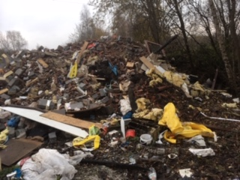
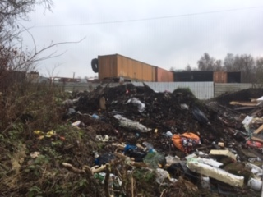
Figures 8 &9 : examples of the scale of fly tipping in the area

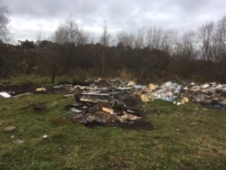
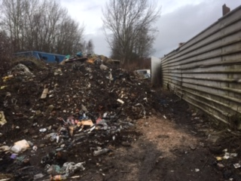
The footpath at Shuttle Hillock Road is in serious need of action (53.508162,-2.563150). Massive piles of waste have been deposited here and form towers that block the route- forcing walkers to squeeze past (fig 10).

Figure 10: debris piles partially blocking path at Shuttle Hillock Road Figure 11: example of the spread of litter

The waste material present on Bickershaw water park covers extensive areas on the ground. Large area of strewn debris and piles of fly tipped waste (fig. 11) can be found at (53.508800, -2.560150). Additionally, a lot of domestic litter can be found along the footpath running across the bottom end of Victoria Fields, alongside the outside of the housing estate (parallel to Rivington Road).
A section of path is completely overgrown and impassable, the fencing alongside it is in serious state of disrepair(fig.12), the path in question runs alongside the edge of Heron Lodge Farm.The overgrown vegetation will need cut back here to allow walkers through, improvement works need to begin around (53.508378, -2.5637189).There is a broken stile on this route (fig.13), it is rotten and both the fencing and stile is in need of replacing as they are currently unsafe (53.510070, -2.5651473).
Clearing the vegetation here is a priority as this section of path leads directly to the town centre of Bickershaw and is currently unusable, re-opening this stretch will greatly improve accessibility to other villages.

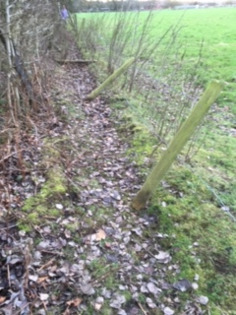
Heron Lodge Farm has a Public Right of Way running through it but this is not immediately apparent from their imposing gating, some signs indicating it is ok for walkers to pass through would be beneficial.On the Path that runs through Heron Lodge Farm and turns right (going directly through farm) walkers have to cross over a broken livestock metal fence that is laying over the right of way. Path not clearly signposted at Heron Farm Gated entrance nor further on.There is a broken stile a little distance from the farm that needs replaced (53.509257, -2.574080).
Figure 12: damaged fencing near Heron Lodge Farm
Overall the path surfaces in the area (that can be accessed) seem to be generally in an ok state of repair but some have been highlighted as being excessively muddy- this issue is exacerbated by illegal off-road vehicles accessing the Bickershaw Project site and churning up the footpaths, this ongoing problem is being investigated by the police who are working with Lancashire Wildlife Trust.

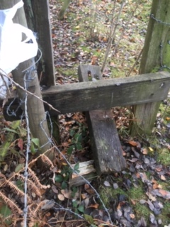
Suggestions for moving forward: find out who owns the land with broken stiles, the fencing and overgrown paths bordering Heron Lodge Farm- approach and ask about making repairs.
Community groups could work with the Wildlife Trust and offer to cut back vegetation on their behalf of owner seems reluctant - could make it a community activity day. Consult Wigan rights of way officers about the horses blocking fields and the massive tree blocking footpath.

Get local walking group to pinpoint exact locations that would benefit from Signage. Pressure council to investigate fly tipping areas and try to come up with solutions that will deter people from doing this in the future.
Figure 13: broken stile near Heron Lodge Farm

Three sisters to Bamfurlong

Starting from Viridor Wood Car Park on Lily Lane. Walking towards Winstanley Road, where at the bottom of this road the entrance to countryside footpathis blocked by large concrete block(fig 14), presumably to prevent vehicles driving up this way but could make access difficult for less mobile.
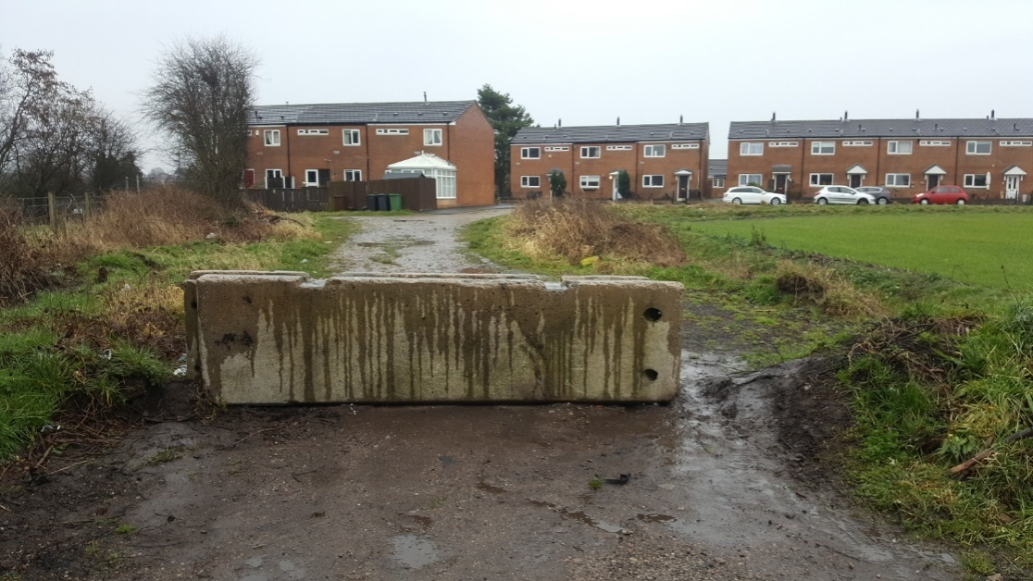
However, subsequent sections of the footpath cross muddy fields, so it is not a route suitable for users who are less abled.

Figure 14: vehicle prevention barrier blocks route and there is a small mound at side

Further along the track, on reaching gate to walk across field at(53.512573, -2.6117434). Walkers are met with a difficult gate (fig.15).
A post has been installed directly in front of gate meaning the gate only opens partially- which makes it quite a squeeze to get through the gap. Not sure if there are reasons for this but something to be wary of as walkers could get body caught on barb wire on adjacent fencing.

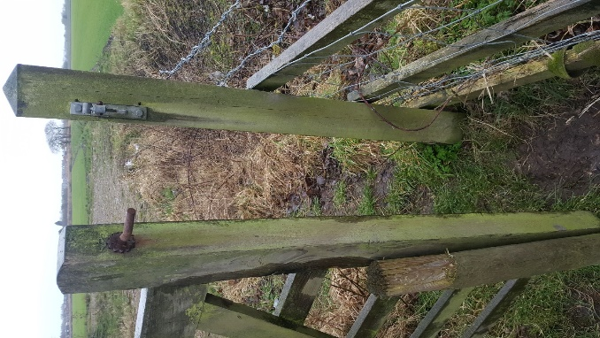
Figure 15: post in front of fence blocking entrance

When the path heads towards Bryn Hall there is an entire section of public right of way the has been deliberately closed off. The public right of way through Park Brook Farm has been totally blocked. The path to side of farm where the route is supposed to be(fig.16) is no longer passable (dense vegetation has grown and fences installed) forcing you to walk directly through farm.
On reaching the exit of farm where path meets Bryn Gates Lane walkers are met with a fully locked security gate that requires the landowner to enter a key into a number pad to open. There is no way to pass around or through- if walkers head this waythey will be forced to turn back unless the owner is around to open the gates.
This should be investigated as whoever installed the fence and blocked public right of way has essentially made this trail unwalkable. Figure 17. Shows the security gating and the wood panelling that has been used to block up the side access to public right of way.

Figure 16: Map showing the official Public Right of Way that runs through and past Park Brook Farm

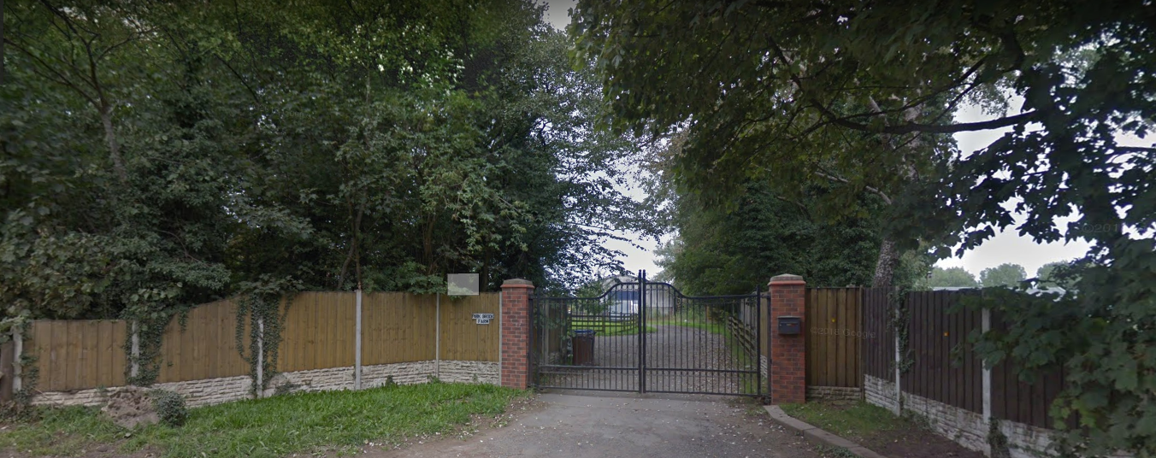
Figure 17: gate and fencing blocking public right of way on Bryn Gates Lane
Three Sisters
There are some access control structures at Three Sisters that would prove to be major obstacles for people with prams or in wheelchairs. As this is a highly visited area there is a good likelihood of users of all mobility levels using the site these issues should be addressed to make the park more inclusive.
There is a wooden structure,(fig.18) purpose unclear, that is creating an obstruction where paths form an intersection at the point where the trail heads off in the direction of Viridor Wood (53.507188, -2.65255)making this route difficult for less ambulatory and pram users.
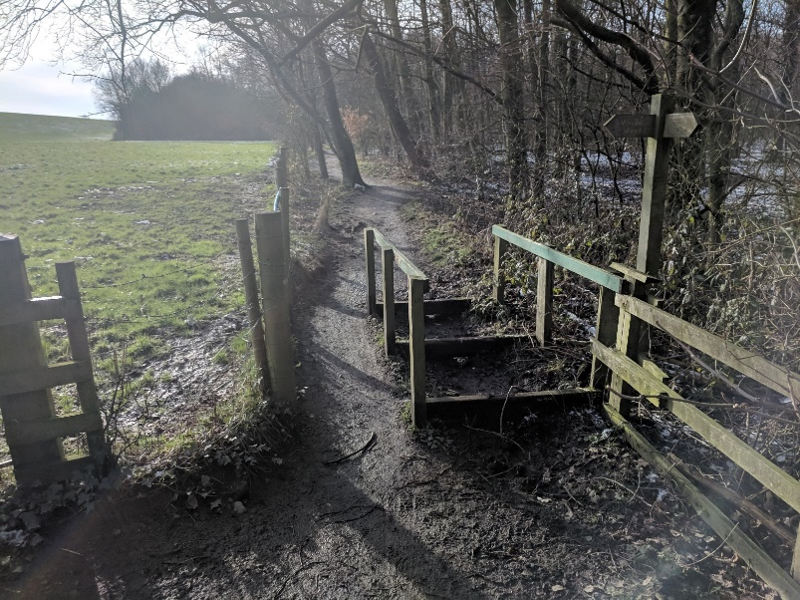
Figure 18: structure blocking 3 sisters circular footpath
The design of the access control at path on Bryn Gates Lane that leads back into Three sisters is a barrier to wheelchair/pram users (fig.19). Very difficult for those with restricted movement or prams to enter the park through this route (53.510424, -2.6272497)
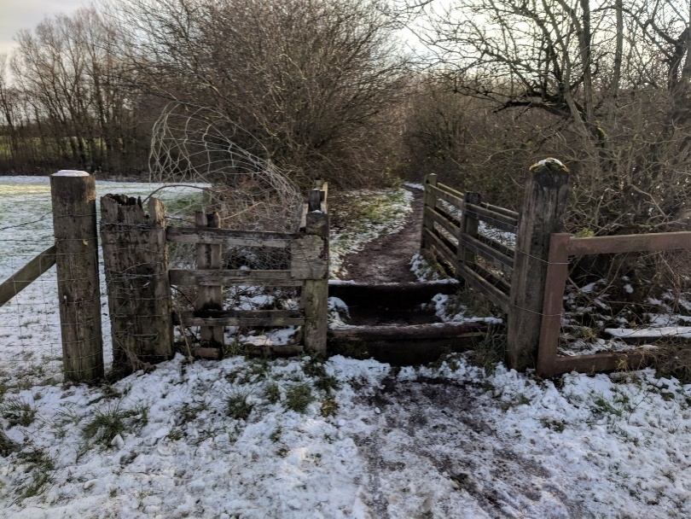
Figure 19: path barrier
In Wales, access controls were removed from various locations in Cardiff on some of its more popular paths to improve accessibility for wheelchair and mobility scooter users and those with pushchairs. There was no notable increase in the misuse of these paths, perhaps Wigan council could adopt a similar approach at heavily used sites.

Viridor Woods
Approaching Viridor Woods from Three Sisters, it is not very well sign posted. There are various trails going through the Viridor Wood site so it is difficult to know which one to take to lead you back to Three Sisters. The tracks themselves however are in a good state overall. There is a point where 4 paths meet where it would be useful to have some sort of waymarker(53.503582, -2.616940).
Where the track leads down to the Viridor Woods entrance site on Bolton Road (53.501750,-2.61465)there is fencing along a field that borders the track. This fencing is in a state of disrepair and poses a risk to walkers- it looks very unstable (fig.20).
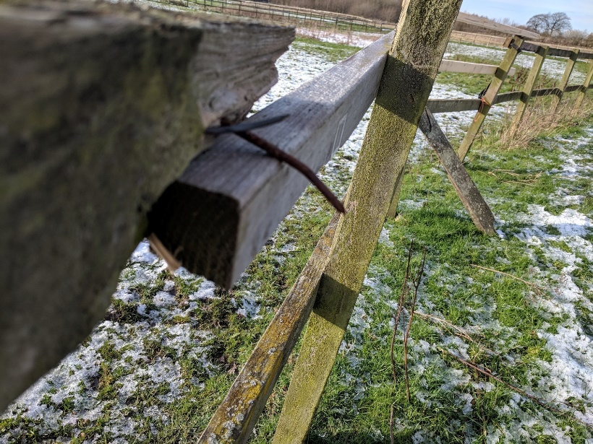
Figure 20: Fencing has nails poking out, broken rails and generally in need of strengthening

Viridor Woods is dissected by the A58, Bolton Road. The official Viridor Woods Car Park (fig.21) is just off this road. Crossing between the two sections of the park is hazardous for walkers as this is a very busy route. Additionally, the car park and Viridor Woods itself is not clearly marked to those passing in cars. The installation of an official crossing point (such as a zebra crossing) near the car park would make a dramatic improvement- making it much easier for those with small children, pets or those less able, to safely access both parts of the park.

Figure 21: Car Park, not clearly sign posted and difficult to access for pedestrians wishing to cross to the other side of park

Ashton Heath and Edge Green

This trail starts at the Harrow Inn (which is now permanently closed). The path alongside the starting point is very muddy and waterlogged(fig.22). The first section of the trail is across farmland, so it is muddy and slippy for the whole of this section.

The council issued written instructions for this route say to turn left 197m after starting point, this is a little vague. The trails are not clearly defined over the fields and there are two left turns next to each other so difficult to know which one is meant.
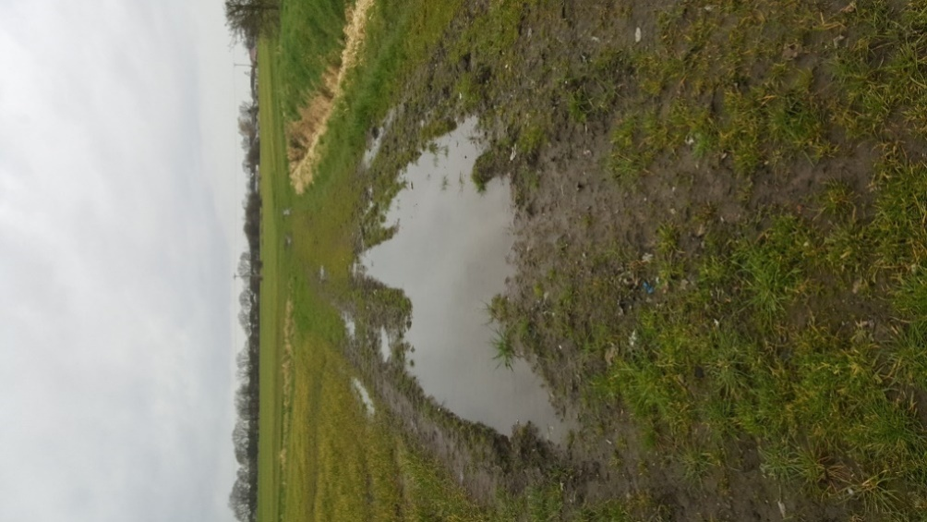
Entrance to footpath that runs down the side of Golborne Road Farm (on Golborne Road 53.488920, -2.614178) is neglected and in a state of disrepair(fig:23,24). Fencing seems to be propped up by hay bale and wooden fence posts look like they may collapse.
Figure 22: example of the walking conditions on first part of trail

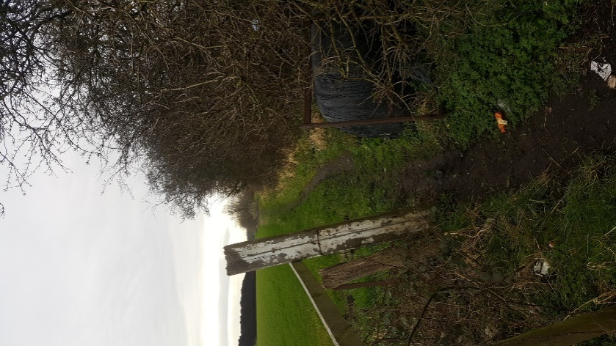
Figure 23: view from front of entrance
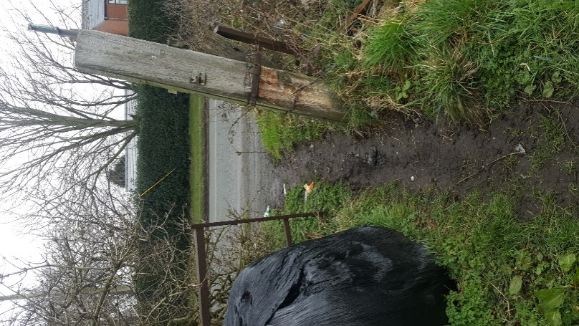
Figure 24: view from back

When you follow this section straight down the farm for approx. 370 m you come to a cross roads where you head into a wooded area, once in the woods it is not totally clear which paths to take. A little way marker around (53.486183, -.617854) may be useful. The section of this walk between the end of Lincoln Drive and emerging onto Mill Street is quite littered. There seems to be an issue with dog waste being left in plastic bags(fig.25), especially around this area (53.487236, -2.626902).
The provision of a dog waste bin where path network is accessed at either Peter Street (WN4 9DQ) may be beneficial, a litter bin here would also be beneficial as it seems the spot that would have optimal footfall.
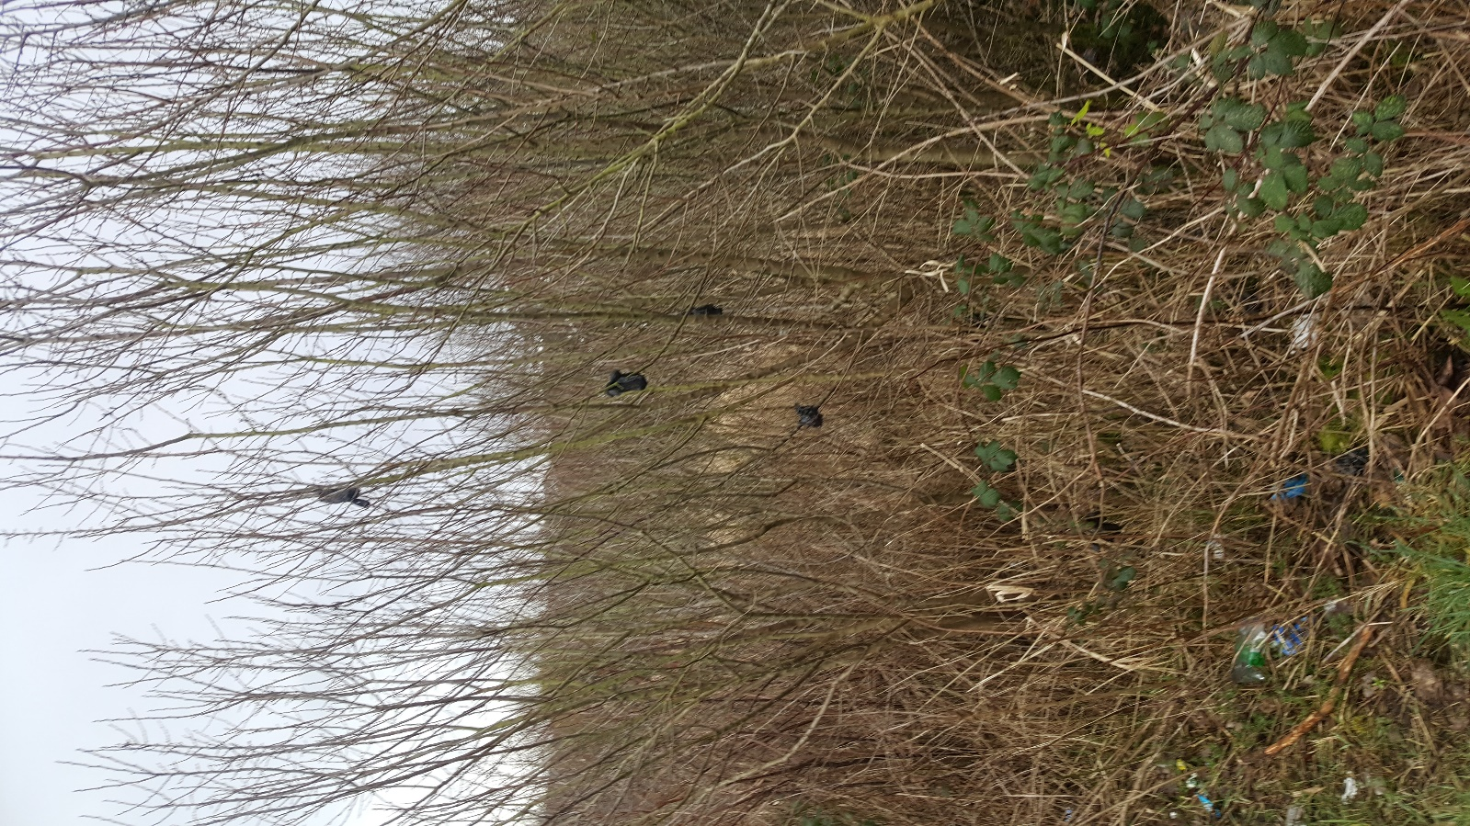
Figure 25: dog waste hung from trees in this spot. Lots of litter.

PROPOSED NEW ROUTE

Low Hall to Pennington Flash
A route has been devised that starts at Low Hall and takes a scenic route to Pennington Flash (fig. 26). Pennington Flash is a popular spot to visit, it also has facilities so is a good stopping off point for a long walk. Having it as a destination point on this route could potentially encourage new users to the public rights of way. The route also stops off at the locally popular Polly’s pond (Kingsdown Flash), so this could act as another starting point for those looking for a shorter walk.
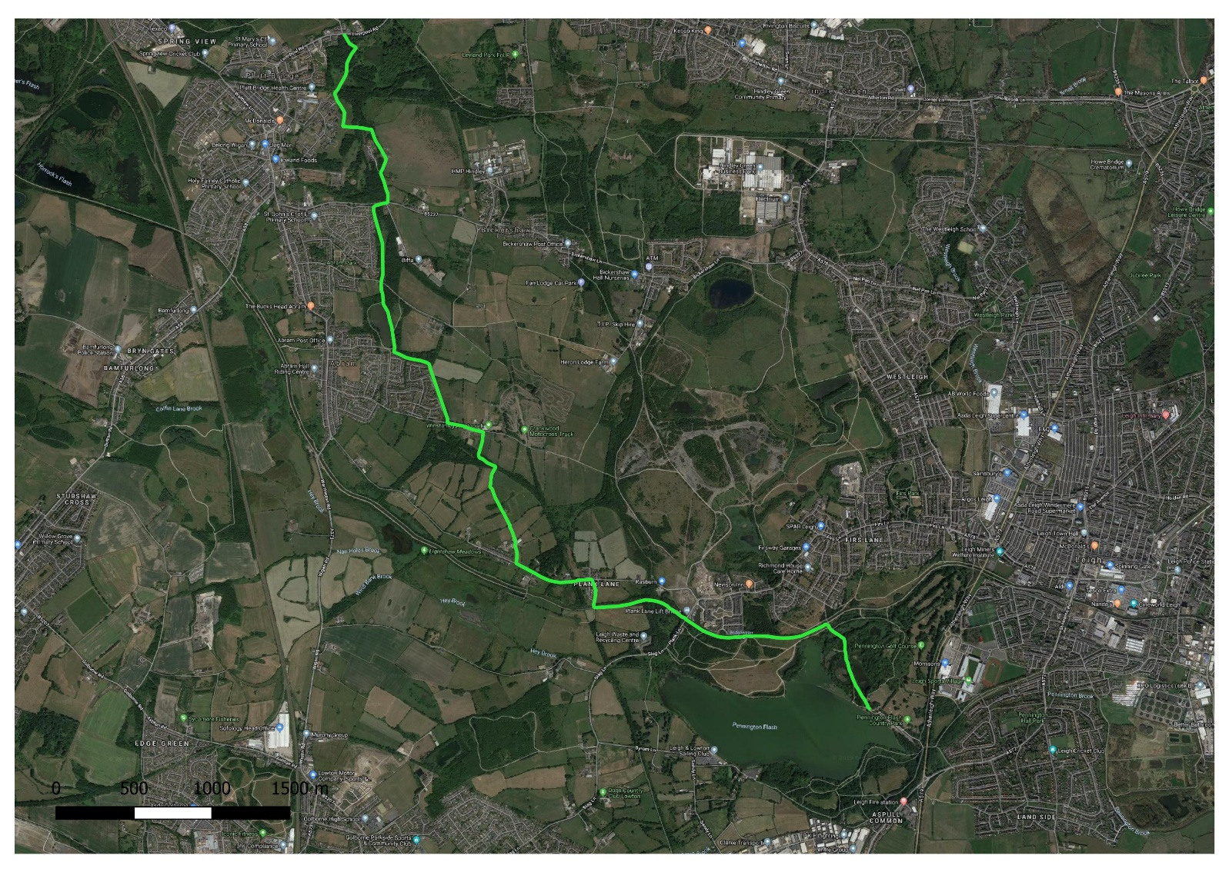
Figure 26: proposed route from Low Hall to Pennington Flash
There are a few issues that need addressed before this route could be publicised, as points of it are potentially unsafe in their current state. Another attractive property of this route is that it directly crosses behind housing estates at Platt Bridge, make it easy to access for many potential users.
Starting at Low Hall and heading towards Platt Bridge you pass through an underpass (fig.27). This underpass is very littered and could use some cleaning up. The access control barrier is very narrow here (53.522739, -2.591920) making it extremely difficult for those with prams to access Low Hall or leave to get onto the proposed footpath.
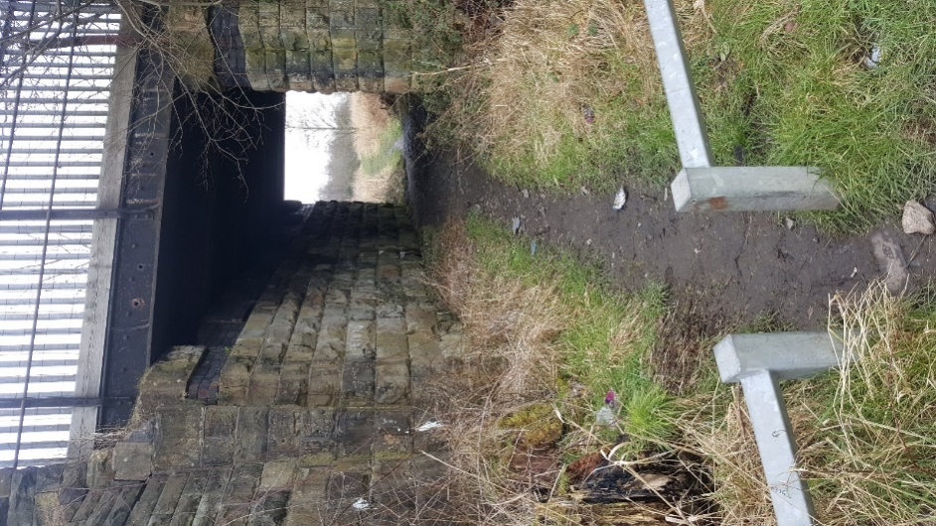
Figure 27: exit/entrance from Platt Bridge to Low Hall
The route then takes you directly behind the Platt Bridge estate, the intention being that this will encourage locals to use the route once they are made aware of it. The path skirts around the outside of the traveller site using cycle route. It would be important to sign post here to avoid people accidentally wandering through the settlement. The cycle route at this section is partially blocked by a permanent looking parked HGV (fig.28) the cycle route is very muddy here and difficult for cyclists to use. There is also a broken footpath sign post (fig.29) and lots of litter at this section (53.518259, -2.587307)

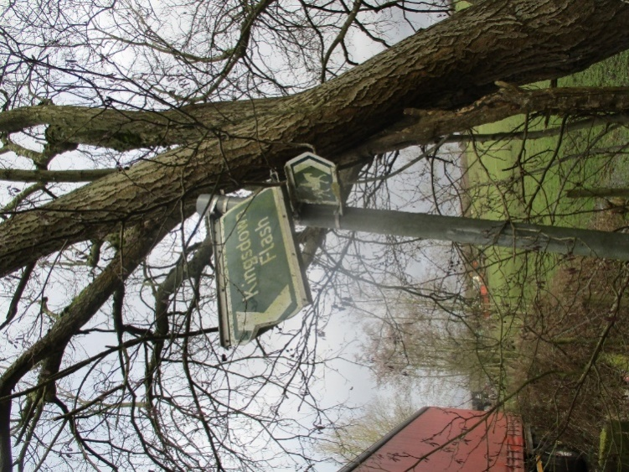
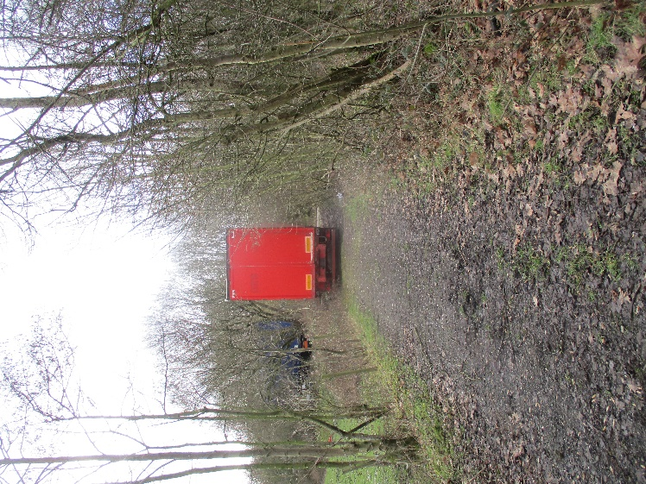
Figure 29: broken sign at same spot
Figure 28: lorry blocking route near traveller site

The section of this trail that leads to Polly’s pond is quite narrow and could benefit from being scraped back of mud around this area to make surfaces easier to walk on (53.514817, -2.587717). After passing Polly’s pond head towards Park Lane. The public right of way goes down through a farm on Park Lane, however signs here don’t make it obvious that this way is open to the public, they currently say “Private Road to Farm” so an additional walkers waymarker here would be useful(53.503704, -2.580635).
The route passes directly over fields on the farm at Park Lane (53.503207, -2577287).This section looks like it has not been used by walkers for a very long time. The farmer has extended his field onto the right of way as the strip left for walkers is very narrow. There is some very steep banking of a ditch running parallel with the path at this point. Due to the encroachment of the field, the uneven ground and the steep sides of the bank, there is a risk of walkers tumbling into the ditch. The landowner should be spoken to reduce his field boundaries to allow enough space for walkers to pass safely.
A waymarker has been knocked down on farmland at (53.501250,-2.576133) and there is a bridge crossing a drainage ditch that needs re-inforced here to ensure it can safely support walkers(fig.30). There is another bridge (fig.31) nearby that needs trimmed back to create a clear passage over bridge (53.499917, -2.576483).

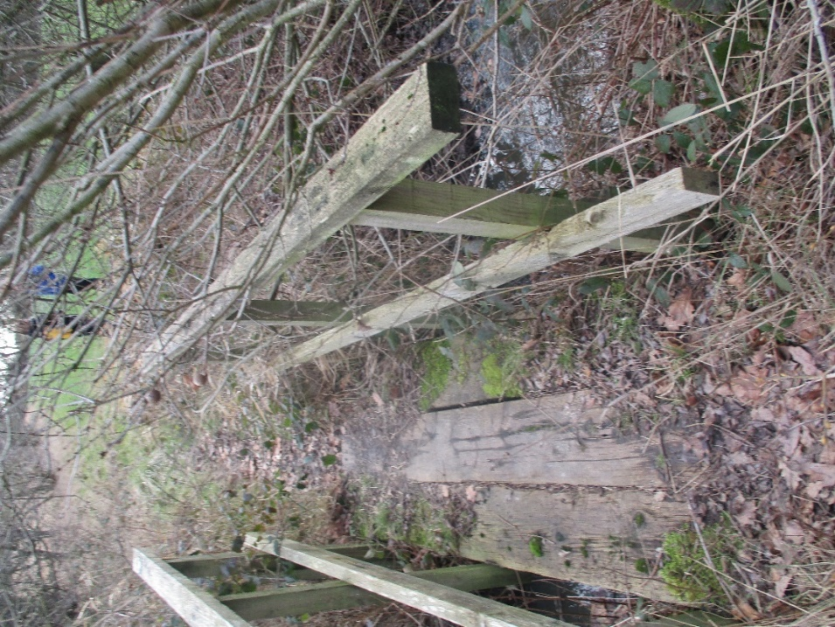
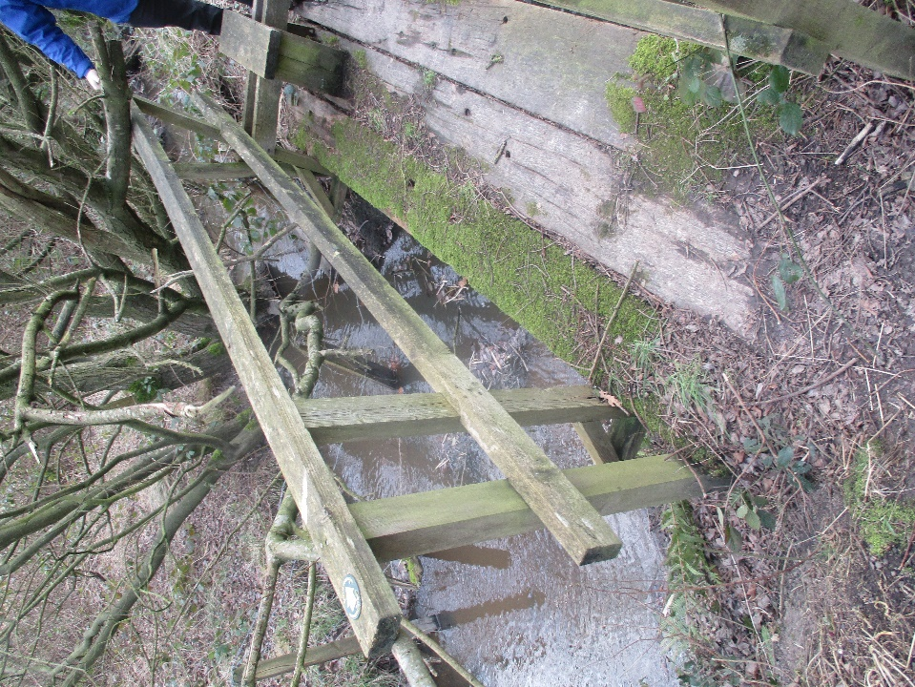
Figure 31: vegetation needs trimmed back from this bridge
Figure 30: slightly unstable bridge

As the path approaches a farm just set behind Crankwood Road, there are a numberof issues with the right of way at this point (53.497096, -2.574236).
The stile here is broken, the structure surrounding stile is unstable, the ground in front of the stile is flooded and the positioning of the stile means having to straddle the farm building to get over safely (figs:32,33)

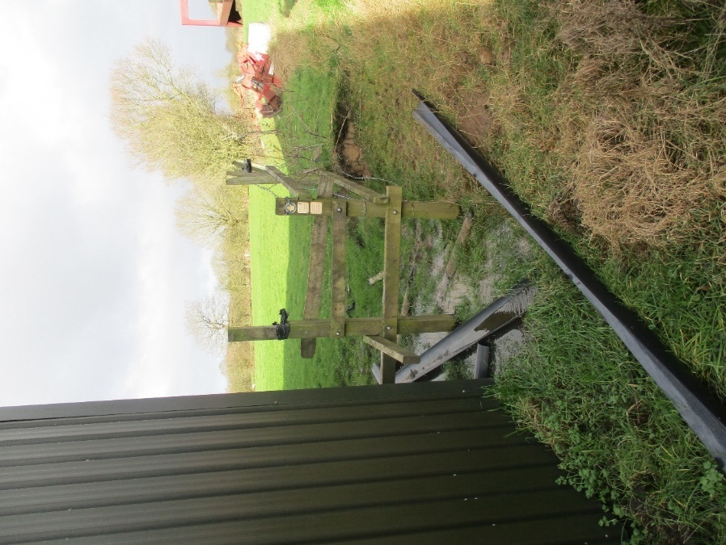
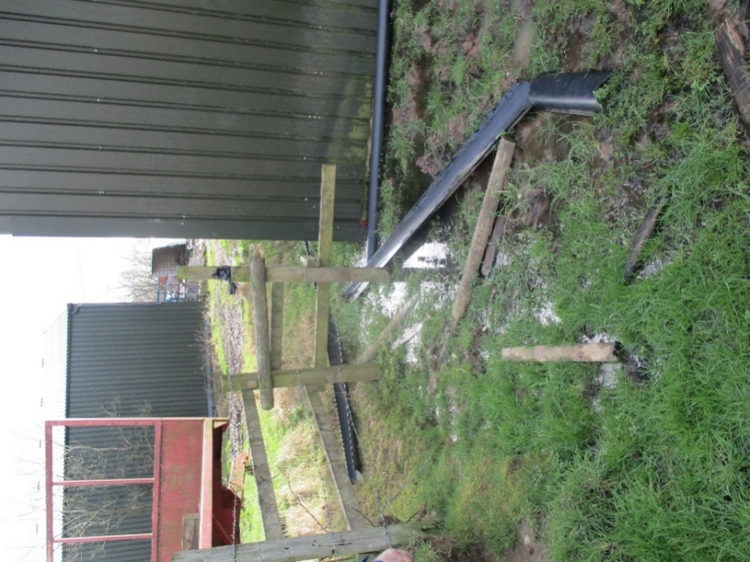
Figure 33: pipes blocking path once over stile

Figure 32: flooding, broken stile

The rest of the route is currently suitable for walkers. Once the issues highlighted above are addressed this could become a popular walking route.

The proposed route from Low Hall ends at Pennington Flash, another route continuing from Pennington Flash back round to Low Hall has been proposed (see proposed route 2 in map below, fig.34). Putting these two new routes together would create a circular walking route of the Abram Ward. The second route passes through Bickershaw Water Park and Victoria Fields, two areas of great natural beauty which would be appealing to walkers. The routes both currently stop/start at Low Hall but either of the proposed routes could easily be extended to loop around Amberswood Nature Reserve.

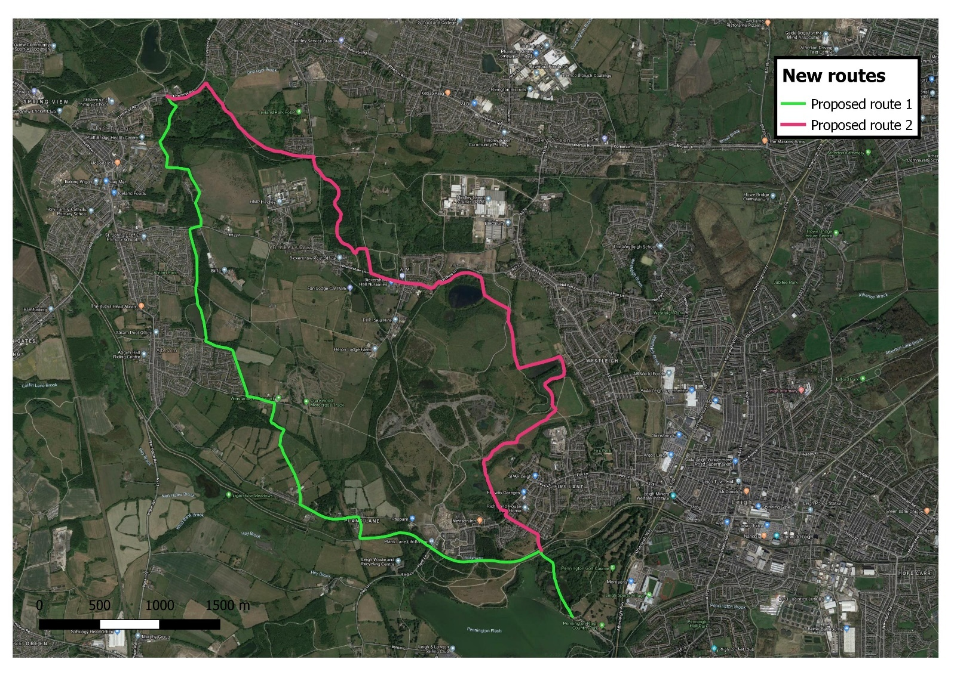
Figure 34: Map showing two new routes that could be combined to create one large circular walking route of the area

GOING FORWARD
There are certain parts of footpaths in this area that suffer from neglect and anti-social behaviour but the potential is there to remedy this. The creation of a new route and making improvements to existing areas (and publicising this) will increase legitimate use and make users more comfortable. Once areas are known to be being regularly used by walkers this could act as a deterrent to decrease incidents of further misuse.

