CORRIDORS AND STEPPING STONE HABITATS

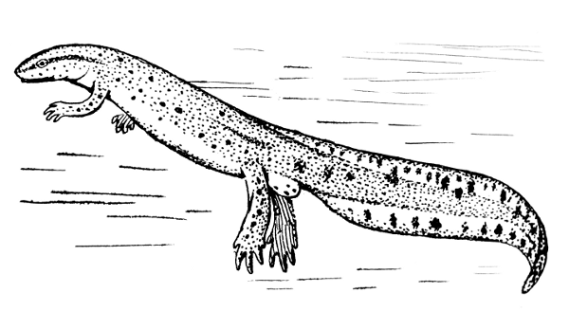

Abram Ward

February 2019
INTRODUCTION

Wigan, like most other urban areas, is heavily developed, this has resulted in a landscape that is peppered with fragmented areas of green space. To ensure species populations remain viable in fragmented landscapes it is important for individuals to be able to move between suitable habitat patches; to access food, escape predators, reproduce, disperse and maintain genetic diversity.
Despite ongoing disturbances there is still the opportunity for wildlife to thrive in an urban environment. Even though fragmented, the Abram ward comprises a patchwork of diverse habitats that support considerable numbers of plants and animals. As urban sprawl and new developments are likely to further increase habitat fragmentation in the future, it is key to identify wildlife connectivity pathways in the area. Maintaining and enhancing the network of wildlife corridors and stepping stones (patches of habitat) in the Abram ward will improve the chances of a species survival.
To promote biodiversity and mitigate the effects of habitat fragmentation, wildlife areas need to be properly managed to ensure the quality of habitat, as this will play a key role in determining whether a species will inhabit an area or not.

Existing Wildlife Habitat
Abram ward has a mix of woodland, wetland, scrub, open water, Fen and Reedbed habitats that are rich in wildlife.
Using Lancashire Wildlife Trust habitat GIS data, nature areas in the ward have been plotted (Fig.1). The map shows wildlife areas that are already connected and highlights where restoration efforts will have the greatest effect on connectivity.
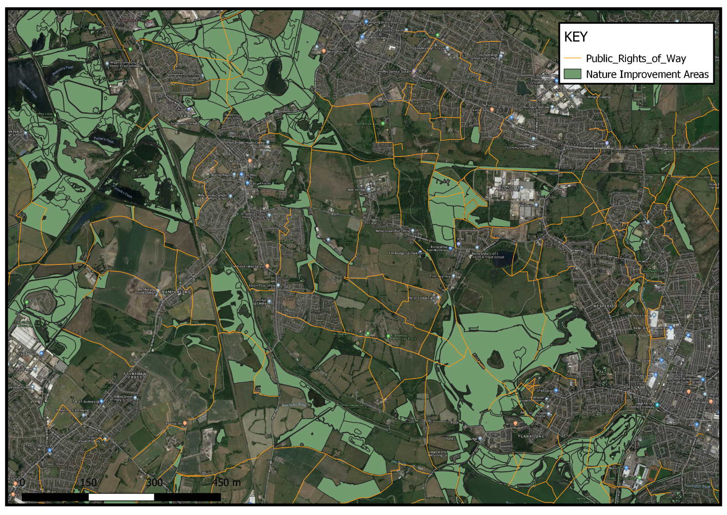
Local Wildlife

Nationally important Red list Bird species are resident or visitors to greenspaces within the Abram Ward. Red List species are species that are globally threatened, have suffered a severe UK population decline and have seen at least a 50% reduction in their UK breeding range. Red list species have the highest conservation priority followed by Amber List species who are still of concern but at less urgent risk.
The following species, all designated Birds of Conservation Concern 4 (Bocc4) havebeen spotted locally within the last 2 years;
RED LIST AMBER LIST
Willow Tit Tawny Owl
Song Thrush Whooper Swan
Yellow Hammer Barnacle Goose
Skylark Gadwall
Pochard Nightjar
Grey Wagtail
Herring Gull

The Wigan area is a breeding ground for one of the UKs most threatened birds the Willow Tit. Willow Tits favour wet woodland and scrub areas, it’s crucial that woodland in the ward is managed in a way that is sympathetic to the Willow Tits requirements.
There are records of Water Vole within the Abram Ward (National Water Vole Database and Mapping Project, 2017). Water voles are a priority species in the UK Biodiversity Action Plan (BAP) and are vulnerable to extinction. A comprehensive survey of waterways should be undertaken to find local populations. Restoring areas adjacent to water vole colonies and increasing overall habitat connectivity will allow range expansion- which is vital for a local population to survive. A survey will also reveal the presence and abundance of Mink which may need to be addressed, as well as highlighting waterways and banks that when properly managed could potentially support future water vole populations.
Brown Hare are present within the ward, because the hare population is declining, Brown Hare are classified BAP priority species.
Wigan has one of the largest populations of great crested newts in Greater Manchester. The continued protection of GCN and associated habitats is imperative to preserve population numbers.
White Letter Hairstreak and Grizzled Skipper butterflies are found in Abram, both are BAP priority species and designated a high priority by the Butterfly Conservation group.
A recent sighting of a herd of Roe deer at Amberswood Common (SBI) suggests that existing landscape is suitably connected to allow these larger land mammals to move around.

Recommend further wildlife and plant surveys throughout the area to get a better idea on what species are present, invertebrate and vegetation surveys would be useful as records for these groups are sparse. The local community can be encouraged to participate in citizen science surveys to help foster a sense of appreciation for local wildlife.

Habitat Improvement work on existing sites

Woodland in the ward should be managed in a way that diversifies structure, age and species of tree. Leaves, trees and branches should be left where the fall or stacked into habitat piles. Standing dead trees should never be removed.
Biodiversity improvements can be made in the council owned woodland surrounding Polly’s Pond (Kingsdown Flash) and along the footpath that leads up to Maypole Wood.The narrow stretch of woodland beside the footpath here is the only woodland corridor connecting the woods at Maypole to Polly’s Pond and on to Low Hall woods- it is an important connectivity link. As this stretch is so important, the privately owned and currently fenced off small woodland patch(where the footpath meets Park Lane) should be considered for wildlife friendly management, the pond here should be surveyed to make sure it is functioning optimally.Trees could be thinned to create successional woodland, stumps should be left to provide nesting habitats and the removed trees can be used to form piles of deadwood which provide excellent habitats for invertebrates and amphibians. Scrub species and native wildflowers could be planted to create new habitats.
Barlow’s Farm, a Forestry Commission area off Bickershaw Lane has wetland areas that could be enhanced- this site should be surveyed to see what improvements can be made before approaching the Forestry Commission.

Potential Restoration Sites
Key sites that would join up the existing Wildlife Corridor have been identified (see Fig.2) - as these sites are on privately owned land the current landowners should be contacted to see if they are prepared to allow an initial survey of their sites. Going forward from this (if the areas have potential) it should be established if the landowner would be willing to allow restoration works to enhance these areas for wildlife. It would be ideal to have any Landowner liaison work spearheaded by local community group members- with the backing of Lancashire Wildlife Trust staff, as landowners may be more receptive to a locally backed initiative.
a

Figure 2:Orange areas denote privately owned sites to be investigated
There is a large neglected field, 53°29.913’N 002°34.517’W (marked ‘a’ on map) that has potential to be turned into a wetland area, this site also has a few infilled ponds that could be reclaimed and existing pond that could be restored. This area directly adjoins Maypole Woods and could act as a stepping stone habitat to Bickershaw Water Park.
There are some parcels of land opposite Lightshaw Meadow (on opposite side of Canal) that, with the owner’s consent, should be investigated for habitat restoration opportunities.
A meeting with the Canal and River Trust will be arranged to discuss the possibility of less intensive bankside vegetation management- habitat diversity can often be achieved simply through allowing growth of taller vegetation. Enquiries could be made to see if they are open to the idea of reprofiling a section of canal or installing floating vegetation pontoons to make a canal crossing point- thus connecting Lightshaw Meadow to the greenspaces in Abram Ward.
If any new sites were to be acquired community involvement in the conservation effort would be pivotal for success. The Wildlife Trust could assist in setting up new Friends of Groups to make sure any management plans are sustainable.

Maypole Wood
The potential restoration areas are all sighted around Maypole Woods. Maypole Woods is a woodland managed for wildlife, it has prime Willow Tit habitat and is already functioning as a habitat corridor. Nightjar and numerous bat species have been sighted in the area. Improving or creating wetland areas around the site would strengthen the wildlife linkage network.
Maypole woods is in an excellent position to encourage locals to engage with wildlife and conservation activities due to its ease of access and mix of habitats.
At Maypole Wood they plan to create a wildflower area, a community orchard and work with the Wigan branch of the Community Growing Project Incredible edible to grow and distribute food locally. It would be great to expand these ideas to other green spaces in the surrounding area, the council owned recreation/parkland area at Grimshaw Park Road and Leyland Park would be good spots to have dedicated areas for growing wildflowers and edible plants.Increasing the numbers of flowers at these sites, for example by mowing less often, can help urban pollinators.
Growing wildflowers, herbs & vegetables doesn’t need to be confined to park areas- verges, disused waste-grounds, front gardens and various public spaces could be utilised. Planters of various sizes can be used to create growing spaces in built up areas. The development of small community gardens, planters, window boxes throughout the ward would be extremely beneficial for wildlife- offering a range of feeding stations throughout the urban area for vitally important pollinators but more importantly it would create points of contact where locals can converse, exchange ideas, learn new skills and grow fresh, healthy, free food.

Creating, joining up and promoting public rights of way through the ward will help people access greenspaces, creating an opportunity to engage with nature and hopefully increasing their awareness of native wildlife habitats.

