Abram Ward
Neighbourhood Plan

Strategic Environmental Assessment and
Habitats Regulation Assessment
Screening Report and Decision Statement.

September 2021

Screening Decision
This screening report was issued to the three statutory consulting bodies (Natural England, Historic England and Environment Agency) for comment on 22 September 2021. All three bodies agreed with the conclusion that the screening outcome was negative.
It is therefore determined that an SEA or an HRA are not needed.

06/10/2021.
- Introduction
  - This is a screening report to assess whether or not the Abram Ward Neighbourhood Plan needs to be supported by a Strategic Environmental Assessment and/or a Habitat Regulation Assessment, as required by European legislation.
  - A Neighbourhood Plan must meet certain criteria or ‘Basic Conditions’, as outlined in Paragraph 8 (2) of Schedule 4B of the Town and Country Planning Act, before it can be formally adopted or ‘made’. The Basic Conditions require that the making of the plan “does not breach, and is otherwise compatible with, EU obligations”, including Directive 2001/42/EC ‘on the assessment of the effects of certain plans and programmes on the environment’.
  - This is often referred to as the strategic environmental assessment (SEA) Directive. The SEA Directive seeks to provide a high level of protection of the environment by integrating environmental considerations into the process of preparing plans and programmes. The SEA Directive is transposed into English law through the Environmental Assessment of Plans and Programmes Regulations (the ‘SEA Regulations’) and it is these regulations that the plan will need to be compatible with.
  - The Habitats Directive 92/43/EEC also requires an Appropriate Assessment to be undertaken if the Neighbourhood Plan is likely to have a significant effect on European protected wildlife sites. As the Abram Ward Neighbourhood Area is within 10 kilometres of the Special Area of Conservation at Manchester Mosses, which is located approximately 6.5km to the south east in Astley Mosley Common Ward, this report also includes a HRA screening, which is undertaken within Tables 2 and 3.
- Methodology for screening
  - There are three recommended steps in the screening process:
- Preparing a screening report (this document);
- Requesting a screening opinion from the consultation bodies in light of this report; and
- In light of their responses, determining whether the plan is likely to have significant effects on the environment (and therefore require SEA / HRA).
  - This screening report, prepared by Wigan Council, is the first step in this process for submission to consultation bodies for a screening opinion. It has been prepared in line with the SEA screening toolkit prepared by AECOM on behalf of Locality in 2020 and also follows the process set in A Practical Guide to the Strategic Environmental Assessment Directive (ODPM, 2005).

- Key information on the emerging Neighbourhood Plan and the designated Neighbourhood Area
  - The vision of the emerging Neighbourhood Plan is for the neighbourhood to be a great place to live and work, with the environment at its heart – making it attractive, resilient, ambitious, thriving and sustainable.
  - It has the following aims, which underpin its policies:
- Enhance and protect internationally significant green spaces;
- Create local business and employment opportunities; and
- Provide affordable, energy-efficient and high quality homes for all.

  - The Neighbourhood Area is known as Abram Ward and is located in the centre of Wigan Borough. A map of the Neighbourhood Area is shown at Appendix A. It is largely covered by Green Belt and has 5 distinct villages; Abram, Bamfurlong, Bickershaw, Platt Bridge and Spring View. There is a small area of Safeguarded Land within the Neighbourhood Area at Smiths Lane, Hindley Green to the east.
  - Key transport links include the A573, which runs north-south through the area providing links to the wider borough, and the A58 which runs southwest from Platt Bridge providing a link to the M6. There are good bus connections in the area. There are no rail stations within the Neighbourhood Area, with the closest stations at Ince and Hindley (both on the Wigan-Manchester line) around 1km and 2km to the north respectively. Bryn rail station (providing hourly services on the Liverpool-Wigan line) is around 3km to the south-west of the Neighbourhood Area.
  - The environmental designations within the Neighbourhood Area are as follows and are shown in Appendix B:
- Abram Flashes and Ince Moss (Horrock’s Flash) Sites of Special Scientific Interest to the north within the Green Belt
- 7 Sites of Biological Importance
- 3 Local Nature Reserves at Ince Moss, Low Hall Park and Three Sisters (largely in Ashton ward).
  - The draft policies in the Neighbourhood Plan are set out in Table 1:
Table 1: Draft policies
Theme | Policy
Business, Enterprise and Community Facilities | BEC1: Business, Enterprise and Community Facilities
Residential Development | RD1: Residential Development
Refurbishment | REF1: Refurbishment
Air Quality | AP1: Air Quality
Green Spaces | REC1: Recreational Spaces
 | GS1: Local Green Space
 | GS2: Proposed Green Corridor
Sustainable Design | DES1: Sustainable Design, Character and Biodiversity
Transport and Movement | TM1: Transport and Movement
 | TM2: Footpaths and Cycleways
Infrastructure | INF1: Infrastructure Priorities
  - Proposed allocations and designations
- There are no proposed allocations
- There are 4 proposed Local Green Space designations at:

- Victoria Fields;
- Maypole Wood;
- Polly’s Pond (Kingsdown Flash); and
- Platt Bridge Community Green.
  - Maps of the four proposed Local Green Space designations are set out in Appendix X.

- Contextual overview against environmental issues set in SEA Regulations
  - To assist the consultation bodies in taking a view on the likely effects of implementing the plan, this section provides a high level contextual understanding of the Neighbourhood Area against each of the issues set out in Schedule 1 of the SEA Regulations.
Biodiversity, flora and fauna
  - As set out in Appendix B, the Neighbourhood Area contains a number of notable local designations, including the Abram Flashes and Ince Moss Sites of Special Scientific Interest, 7 Sites of Biological Importance, 3 Local Nature Reserves and multiple wildlife corridors.
Population
  - The 2011 Census identified the population in Abram Ward as 15,020. The average age being 37 years with 51% male and 49% female.
  - The affordability ratio for Abram Ward, based on household disposable income, was 4:1, compared to a regional ratio of 6.1:1. The lower quartile house price to income ratio in Abram Ward was 6:1, compared to Wigan Borough at 5:1.
Human health
  - Wigan has seven Area Profiles, known as Service Delivery Footprint (SDF) Profiles. The Neighbourhood Area falls within the Hindley SDF area, covering Ince, Hindley, Abram and Platt Bridge. The latest profile for the area was produced in 2018. Key messages include:
- The SDF area has a younger population than the Borough average, there has been a notable increase in the 0-4 age group in recent years.
- The SDF has the second highest rate of primary school pupils eligible for Free School Meals and the highest rate for secondary school pupils, and the highest rate of both Special Educational Needs and Looked After Children.
- Fuel poverty is above average and is highlighted as one of the most fuel poor areas in the borough.
- The SDF ranks 2nd for drug misuse clients and 3rd for alcohol misuse clients.
- The SDF has the highest prevalence of epilepsy in the borough. It is also above the borough average for osteoporosis, smoking, diabetes, dementia, learning disabilities, mental health, coronary heart disease, and heart failure.

Soil
  - The 2010 Natural England Agricultural Land Classification Map of the North West Region (ALC002), classifies the land in the area as generally good to moderate.
Water
  - The southern part of the Neighbourhood Area, from the centre of Abram southward, is identified as being within Source Protection Zone 3.
Air
  - The A573 Warrington Road has several points within designated Air Quality Management Areas with the majority in Platt Bridge. As at September 2021, there are no active roadside diffusion tube monitoring sites within the Neighbourhood Area recording nitrogen oxide levels in excess of 40 µg/m³, which is the annual limit value set by the European Union.
Climatic factors
  - See section below.
Material assets
  - The Environment Agency resource maps identifies areas within Flood Zone 3 alongside Hay Brook running from the centre of the Neighbourhood Area southward. There are also areas identified within Flood Zone 3 to the north in Spring View around Ince Brook and to the east around Amberswood Brook and Borsdane Brook.
Cultural heritage, including architectural and archaeological heritage
  - The Neighbourhood Area includes two Grade II listed buildings at Crook Farm in Abram and Brookside Farm in Bickershaw.
Landscape
  - The Wigan Landscape Character Assessment identifies the area as a mix of Character Type 1: Undulating Enclosed Farmland to the east, Type 4: Wetland and Flashes to south east, and Type 5: Degraded and Partially Restored Landscapes to the west.
Summary
  - There are no proposed site allocations within the Neighbourhood Plan for development.
  - 4 sites are proposed as a Local Green Space designation which should have little or no environmental impact.
- Screening Assessment
  - The screening assessment is set out in Tables 2 and 3 and has been undertaken following the process set out in the diagram below taken from A Practical Guide to the Strategic Environmental Assessment Directive, Figure 2, ODPM 2005.
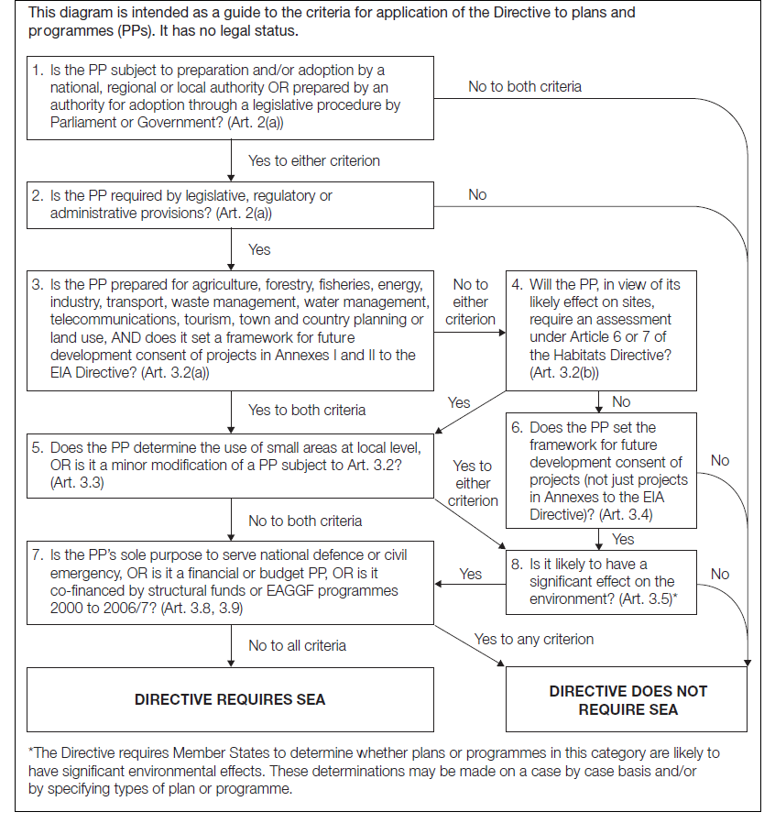

Table 2 – Screening of Abram Neighbourhood Plan
Stage in Flow Diagram | Yes / No | Justification
- Is the plan subject to preparation and/or adoption by a national, regional or local authority OR prepared by an authority for adoption through a legislative procedure by Parliament or Government? | Yes | Neighbourhood Plans are prepared by a qualifying body (Parish/Town Councils) under the Town and Country Planning Act 1990 (as amended). This Neighbourhood Plan has been prepared by Abram Communities Together (as the “relevant body”) and will be adopted by Wigan Council as the local authority.  The preparation of Neighbourhood Plans is subject to The Neighbourhood Planning (General) Regulations 2012 and The Neighbourhood Planning (Referendums) Regulations 2012.
- Is the plan required by legislative, regulatory or administrative provisions? | No | Although local communities have a right to be able to produce a Neighbourhood Plan, it is not a legislative, regulatory or administrative requirement.  However, once the plan is adopted, it will form part of the Wigan Council statutory development plan. The remainder of the flow diagram has therefore been considered, to determine whether full SEA is required.
- Is the plan prepared for agriculture, forestry, fisheries, energy, industry, transport, waste management, water management, telecommunications, tourism, town and country planning or land use, AND does it set a framework for future development consent of projects in Annexes I and II to the EIA Directive? | Yes | The NP includes policies relating to industry, transport, town planning and land use. Furthermore, once adopted it will set the framework for future developments (at the plan level) that could fall within Annex II of the EIA Directive.
- Will the plan, in view of its likely effect on sites, require an assessment under Article 6 or 7 of the Habitats Directive?  (Although this question is skipped on the flow diagram, it is included for robustness.) | No | Under Article 6 of the Habitats Directive, an assessment is required where a plan or project may give rise to significant effects upon a Natura 2000 site (also known as a ‘European Site’). This includes Special Areas of Conservation (SAC), designated under the Habitats Directive for their habitats and/or species of European importance, and Special Protection Areas (SPA), classified under Directive 2009/147/EC on the Conservation of Wild Birds (the codified version of Directive 79/409/EEC as amended) for rare, vulnerable and regularly occurring migratory bird species and internationally important wetlands. In addition, it is a matter of law that candidate SACs (cSAC) and Sites of Community Importance (SCI) are considered in this process; furthermore, it is Government policy that sites designated under the 1971 Ramsar Convention for their internationally important wetlands (Ramsar sites) and potential SPA (pSPA) are also considered.  HRA Screening is the process which initially identifies the likely impacts upon a European site of a project or plan, either alone or in-combination with other projects or plans and considers whether these impacts may have a significant effect on the integrity of the site’s qualifying habitats and/or species. If significant effects are anticipated, Appropriate Assessment under the Habitats Directive is required.  In accordance with national planning practice guidance, consideration of European sites within 10 km should be undertaken, due to the potential for connection via hydrological links or if mobile species from neighbouring sites have a significant functional link with areas within the plan boundary, such as for foraging. There are no European sites within the Neighbourhood Area, but the Manchester Mosses Special Area of Conservation (SAC) is located approximately 6.5km to the south east. However, there are limited connections or functional links between the Neighbourhood Area and the SAC.  On this basis an Appropriate Assessment is not deemed to be required.
- Does the plan determine the use of small areas at the local level or is it a minor modification of a plan subject to Article 3.2? | Yes | The Neighbourhood Plan does not seek to determine the use of small areas at a local level, there are no sites identified for development.
- Does the plan set the framework for future development consent of projects (not just projects in annexes to the EIA Directive)?  (Included for consistency and robustness as the answer to the HRA question was no.) | Yes | Once adopted the plan will form part of the Wigan Council statutory development plan and will therefore be used in the determination of planning applications in the Neighbourhood Area. Therefore, it sets the framework for future developments at a local level.
- Is it likely to have a significant effect on the environment? | No | The plan will accord with the strategic policies contained within the Wigan Council statutory development plan (Core Strategy 2013 and associated Sustainability Appraisal), and therefore the non-site specific policies are not anticipated to generate significant environmental effects. However, the plan seeks to designate a limited number of sites within the Neighbourhood Area as Local Green Space, 3 of which are within the Green Belt. These designations are not expected to have any significant effects on the environment.
OVERALL CONCLUSION |  | Directive does not require SEA or Appropriate Assessment

  - Table 3 sets out the Annex II series of criteria for determining the likely significance of effects, as represented in the left hand column of the table.
Table 3 – Likelihood of Significant Environmental Effects
Criteria for Determining Likely Significant Effect (Annex II) | Significant Effect?
1. The characteristics of plans and programmes, having regard, in particular, to:
(a) the degree to which the plan or programme sets a framework for projects and other activities, either with regard to the location, nature, size and operating conditions or by allocating resources; | Not significant. Once adopted the plan will form part of the Wigan Council statutory development plan and will therefore be used in the determination of planning applications in the Neighbourhood Area. It does not seek to allocate land for development / regeneration, however the plan sets out positive planning policies seeking to encourage sustainable development. The majority of policies are in line with the Wigan Core Strategy, 2013 and Unitary Development Plan saved policies, 2006, which have been subject to SEA.
(b) the degree to which the plan or programme influences other plans and programmes including those in a hierarchy; | Not significant. Although it is possible that the Neighbourhood Plan could inform future supplementary guidance in the area, such provisions would be in line with the adopted Core Strategy 2013 which has already been subject to SEA.
(c) the relevance of the plan or programme for the integration of environmental considerations in particular with a view to promoting sustainable development; | Not significant. The Neighbourhood Plan seeks to promote sustainable development overall in accordance with sustainable development principles set out in higher-level plans. Furthermore, it does not seek to support any large-scale development.
(d) environmental problems relevant to the plan or programme; | Not significant. Due to the scale of development / re-development proposed, the environmental impact of the Neighbourhood Plan is not anticipated to be significant.
(e) the relevance of the plan or programme for the implementation of Community legislation on the environment (for example, plans and programmes linked to waste management or water protection). | Not significant. The Neighbourhood Plan will be in conformity with the strategic policies contained within other relevant planning documents. Once adopted the Neighbourhood Plan will become part of the statutory development plan for Wigan and will be used in the determination of planning applications.
2. Characteristics of the effects and of the area likely to be affected, having regard, in particular, to:
(a) the probability, duration, frequency and reversibility of the effects; | Not significant. The Neighbourhood Plan is supportive of sustainable development within the overall protective policy context of the development plan in terms of the built and natural environment. Largely positive effects are expected as a result of the plan.
(b) the cumulative nature of the effects; | Not significant. No significant cumulative effects with other developments are anticipated.
(c) the transboundary nature of the effects; | No. The plan lies wholly within Wigan Borough, and no transboundary effects (i.e. within neighbouring borough boundaries) are likely.
(d) the risks to human health or the environment (for example, due to accidents); | No. It is not likely that risks to human health or the environment would be generated by the plan.
(e) the magnitude and spatial extent of the effects (geographical area and size of the population likely to be affected); | Not significant.
(f) the value and vulnerability of the area likely to be affected due to—  (i) special natural characteristics or cultural heritage;  (ii) exceeded environmental quality standards or limit values; or  (iii) intensive land-use; | Not significant. The Neighbourhood Area contains a number of notable local designations, including 2 Sites of Special Scientific Interest, 7 Sites of Biological Importance, 3 Local Nature Reserves and several wildlife corridors. However, the policies would not adversely impact such sites, but would seek to protect and enhance them (although the benefits are not considered to be significant).
(g) the effects on areas or landscapes which have a recognised national, Community or international protection status. | Not significant. The Neighbourhood Area contains a number of notable local designations, including 2 Sites of Special Scientific Interest, 7 Sites of Biological Importance, 3 Local Nature Reserves and several wildlife corridors. However, the policies would not adversely impact such sites, but would seek to protect and enhance them (although the benefits are not considered to be significant).

Conclusion
  - As part of this screening assessment, with reference to the criteria for assessing the likely significance of effects as set out in Annex II of the SEA Directive (Table 2) and Schedule 1 of the SEA Regulations, it is suggested that a full SEA is not required.
  - However, consultation with the appropriate regulatory bodies (Natural England, Environment Agency and Historic England) is required for a formal recommendation to be reached.

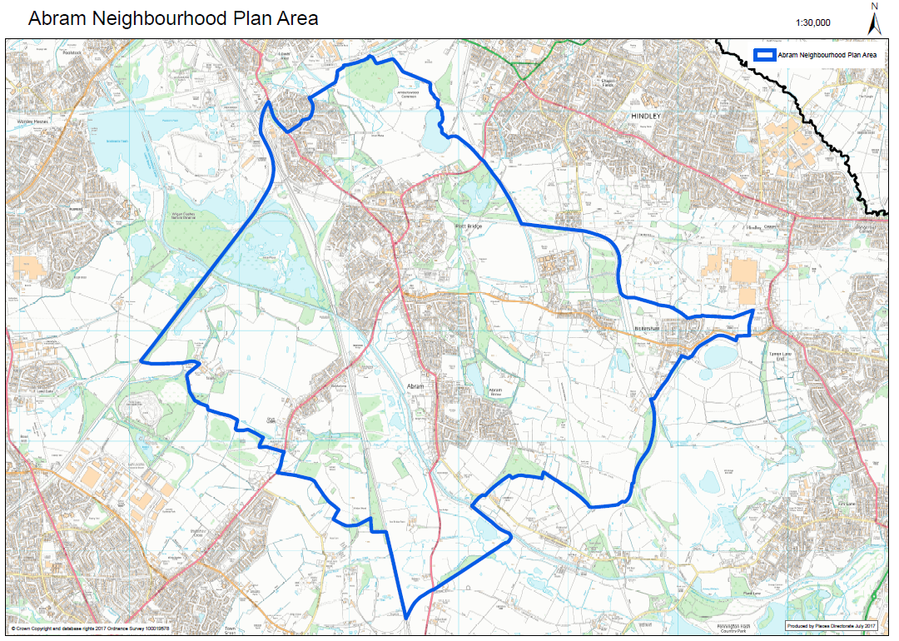
Appendix A: Abram Neighbourhood Area

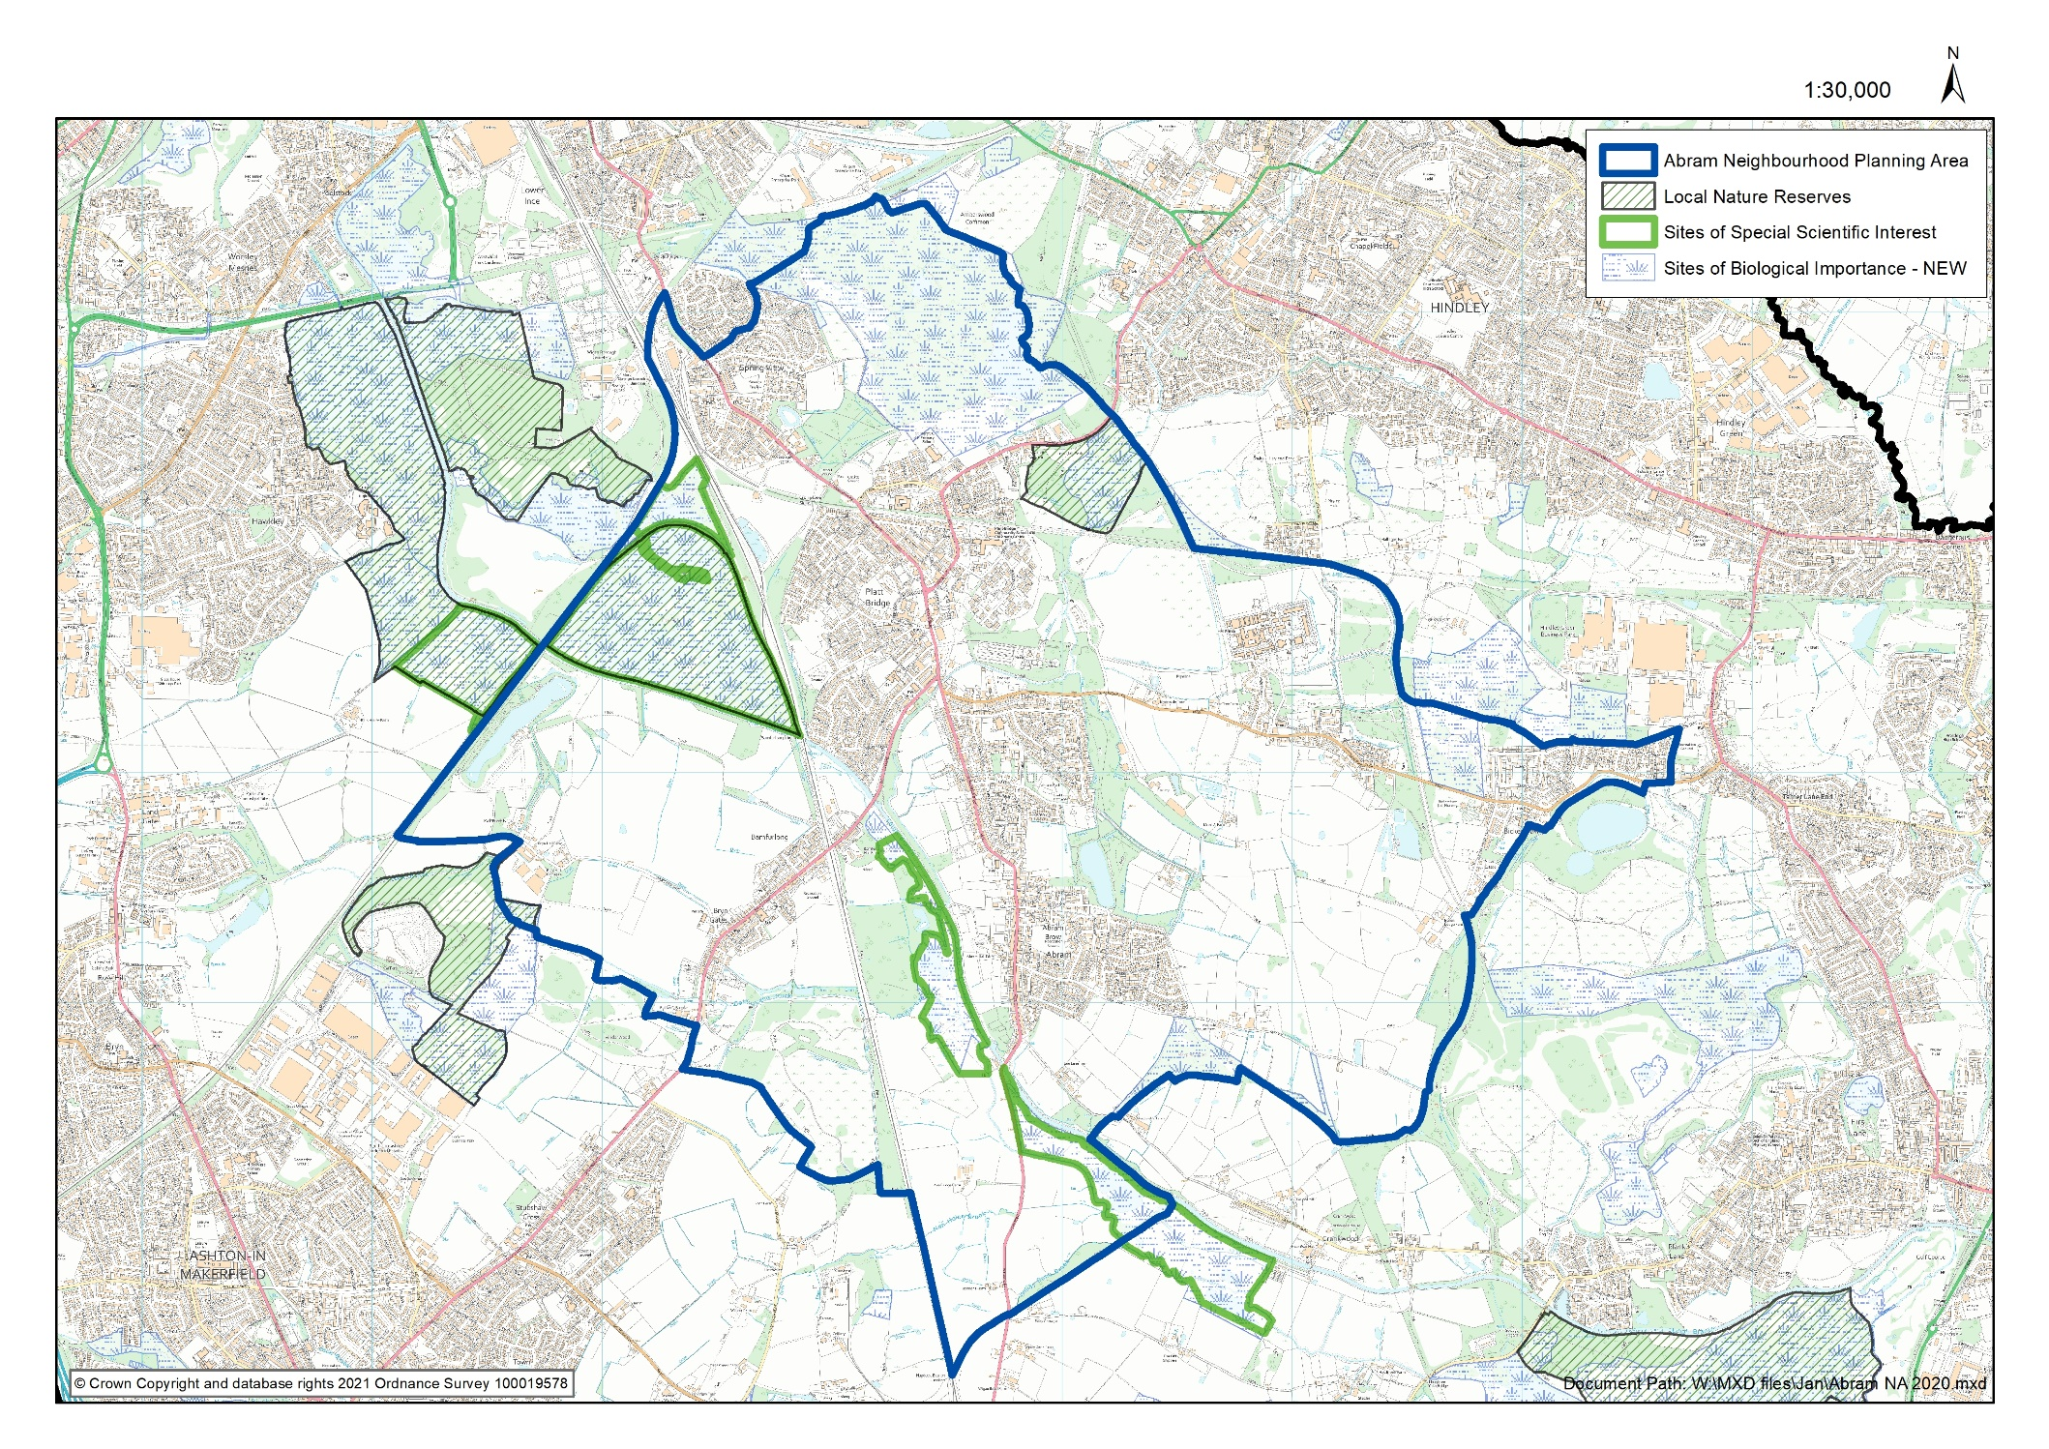
Appendix B: Environmental designations within the Neighbourhood Area

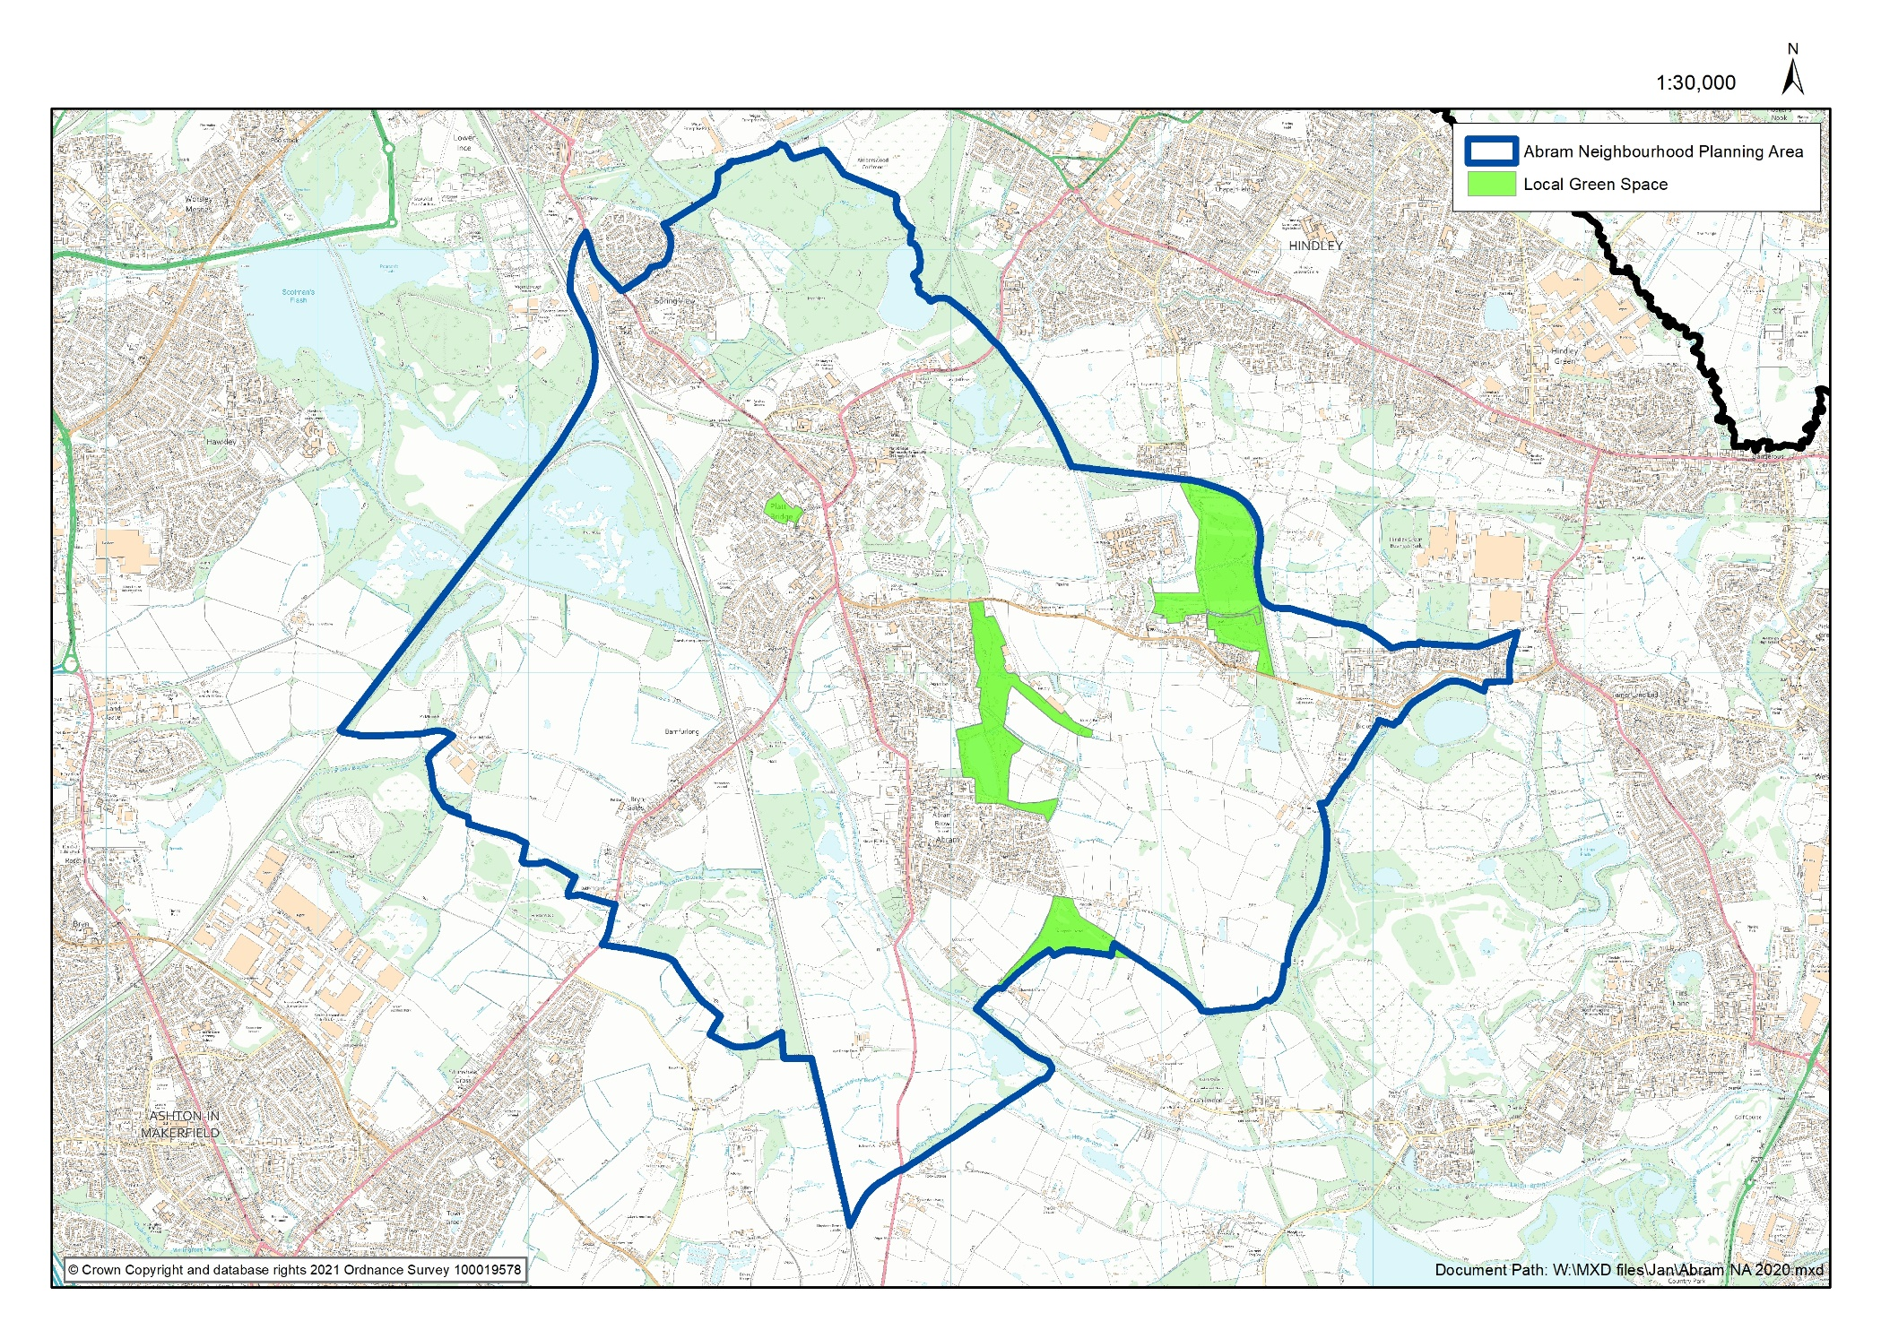
Appendix C: Proposed Local Green Space Designations
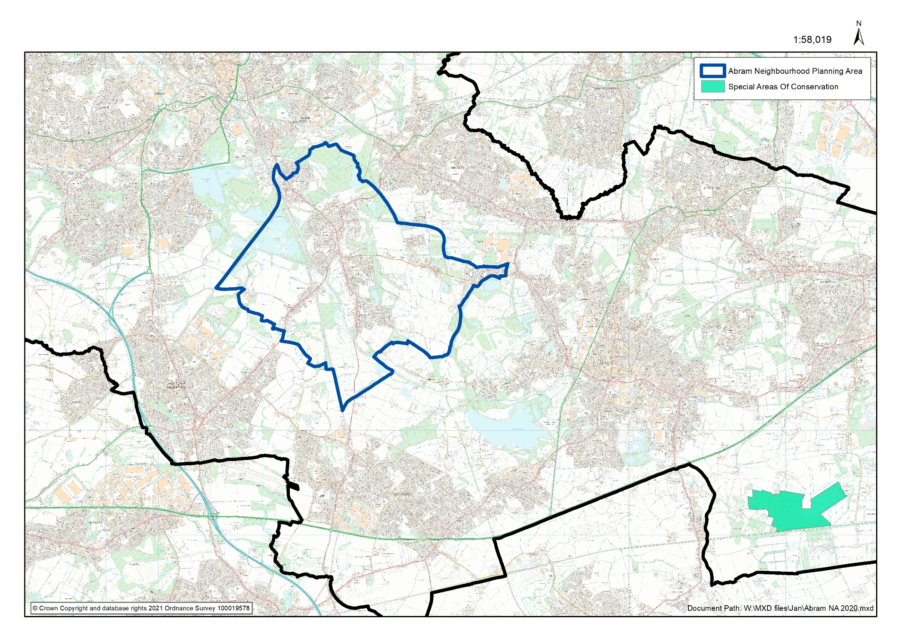
Appendix D: Manchester Mosses Special Area of Conservation

The Environmental Assessment of Plans and Programmes Regulations 2004 (legislation.gov.uk)

