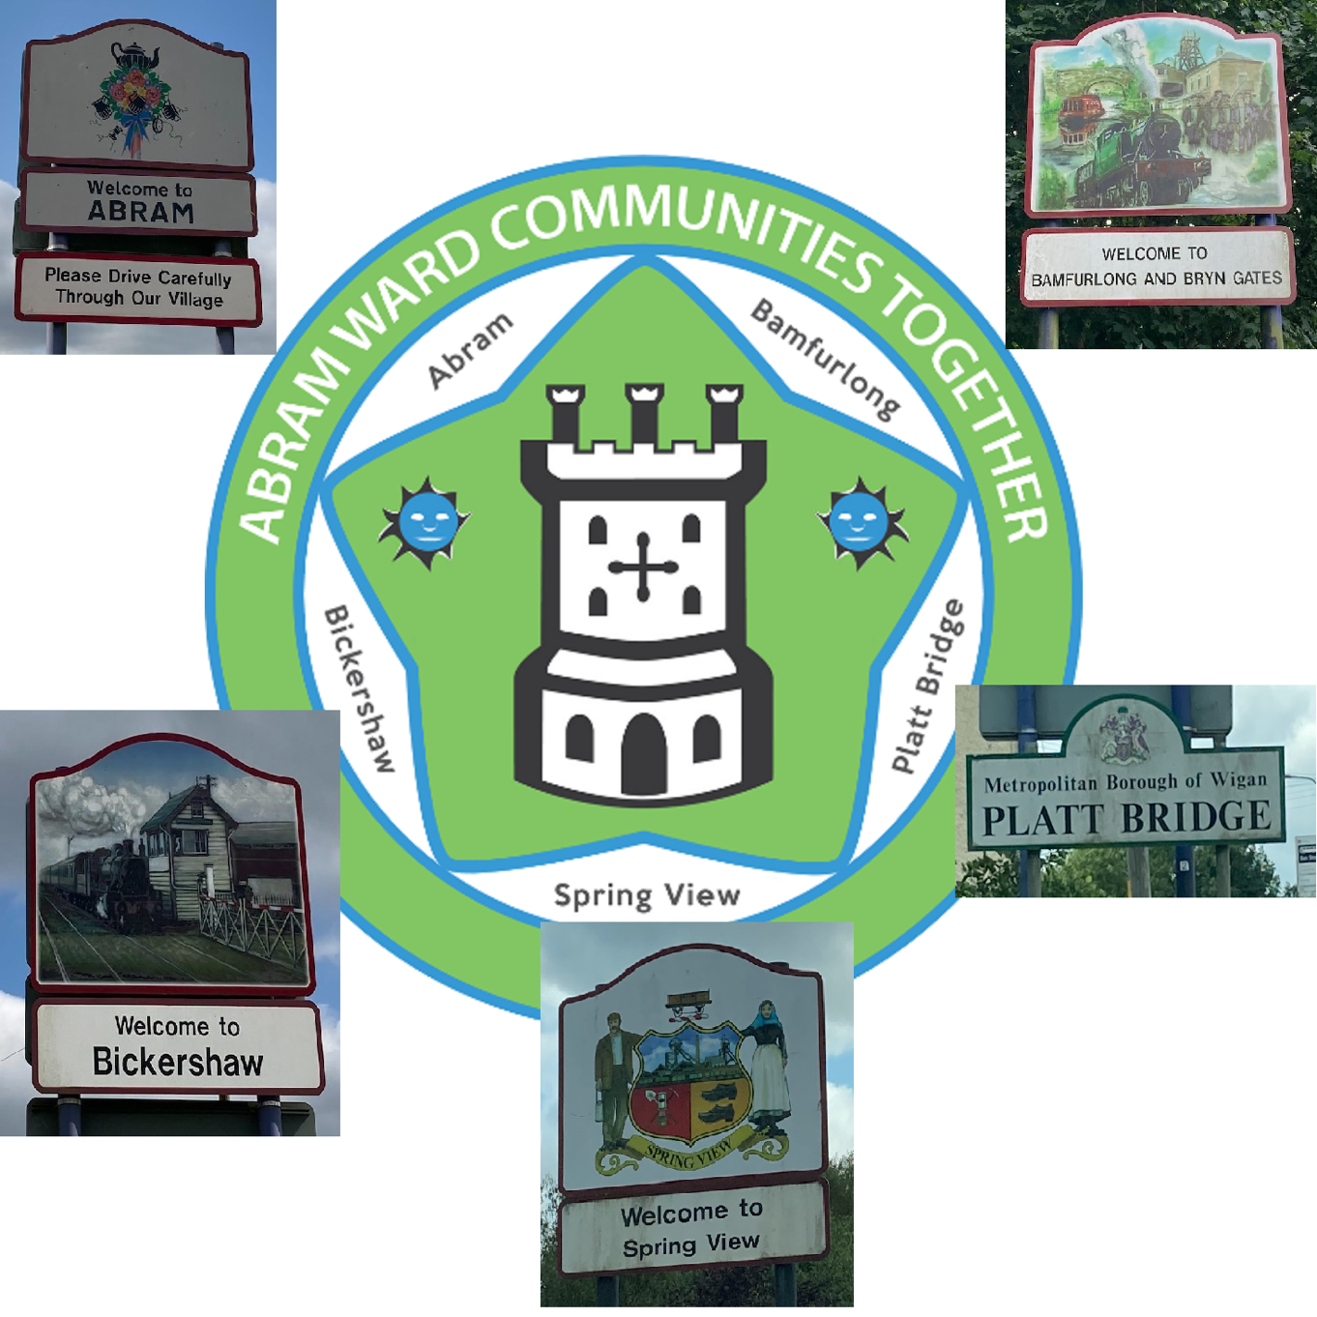

ACT Neighbourhood Plan

  - 2022 – 2037

Contents
1 Contents 2
1.1 Table of Figures 4
1.2 Supporting Documentation 5
2 Introduction 6
2.1 The Neighbourhood Plan 6
2.2 Conforming to basic conditions 7
2.3 Setting up our Neighbourhood Plan 7
2.4 Neighbourhood Area 7
2.5 Community Consultations 9
ACT Survey 2016 9
ACT Survey 2017 10
Placed Consultation 2018 11
Picture This Project 2018-2019 12
3 Key Characteristics 13
3.1 Location 13
3.2 Green Spaces 13
3.3 History 13
3.4 Population 13
3.5 Housing 13
3.6 Occupation 14
3.7 Employment 14
3.8 Health and Education 14
3.9 Leisure 14
3.10 Younger Generation 14
4 Vision and Objectives 15
4.1 Introduction 15
4.2 Vision 15
Vision Alignment with Policy Frameworks 15
4.3 Objectives 16
Objective 1: Environment, Health and Wellbeing 16
Objective 2: Economic Development 17
Objective 3: Housing and Planning 18
5 Policies 19
5.1 Policies Map 19
5.2 Business, Enterprise and Community Facilities 21
Purpose 21
Rationale and Evidence 22
Policy BEC1: Business, Enterprise and Community Facilities 29
5.3 Residential Development 30
Purpose 30
Rationale and Evidence 30
Policy RD1: Residential Development 37
5.4 Refurbishment 38
Purpose 38
Rationale and Evidence 38
Policy REF1: Refurbishment 39
5.5 Air Quality 40
Purpose 40
Rationale and Evidence 40
Policy AQ1: Air Quality 41
5.6 Green Spaces 42
Purpose 42
Rationale and Evidence 42
Policy GS1: Local Green Space 49
Policy GS2: Proposed Green Corridor 50
Policy GS3: Recreational and Green Spaces 51
5.7 Sustainable Design 52
Purpose 52
Rationale and Evidence 52
Policy DES1: Sustainable Design, Character and Biodiversity 54
5.8 Transport and Movement 55
Purpose 55
Rationale and Evidence 55
Policy TM1: Transport and Movement 59
Policy TM2: Footpaths and Cycleways 60
6 Infrastructure Priorities 61
Purpose 61
Rationale and Evidence 61
7 Delivering the Plan 63

Table of Figures
There are a number of maps that support the Neighbourhood Plan and its policies.
Figure 1 - Neighbourhood Area 8
Figure 2 - Policies Map 20
Figure 3 - Heritage Assets 27
Figure 4 - Abram Urban Area 31
Figure 5 - Bamfurlong and Bryn Gates Urban Area 32
Figure 6 - Bickershaw Urban Area 33
Figure 7 - Platt Bridge Urban Area 34
Figure 8 - Spring View Urban Area 35
Figure 9 - Proposed Green Corridor, Sites of Special Scientific Interest (SSSIs), Sites of Biological Importance (SBIs) and Flashes of Wigan and Leigh National Nature Reserve (NNR) 43
Figure 10 - Amenity Greenspace and Recreational Space 46
Figure 11 - Local Green Space Designation 48
Figure 12 - Abram Ward Circular Walks 58

Supporting Documentation
The following supporting documentation should be referred to in conjunction with this Neighbourhood Plan. Where supporting documents are directly referred to within the Neighbourhood Plan document, the acronym will be used.
AS2016 | ACT Survey 2016
AC2017 | ACT Consultation 2017
ACS2017 | ACT Consultation Summer 2017
ANPCP | ACT Neighbourhood Plan Community Projects
ANPLGS | ACT Neighbourhood Plan Local Green Space Assessment
AWBE | Abram Ward Baseline Evidence
AWPRW | Abram Ward Public Rights of Way Audit Summary Report
BHL | Building for Healthy Life 2020
GMAQR | Greater Manchester Combined Authority Air Quality Report
GMTS | Greater Manchester Transport Strategy 2040
NPPF | National Planning Policy Framework 2023
OSSR | Open Space, Sport and Recreation Provision and Needs Assessment
PBBPR | Platt Bridge Business Premises Report
PBCGVR | Platt Bridge Community Green Visioning Report
PC2018 | Placed Consultation 2018
PfE | Places for Everyone [emerging local policy]
PT2019 | Picture This Engagement Project 2019
SHLAA | Strategic Housing Land Availability Assessment
WHNA | Wigan Housing Needs Assessment - Final Report May 2020
WHNASAP | Wigan Housing Needs Assessment - Sub Area Profile May 2020
WLPCS | Wigan Local Plan Core Strategy
WLR | Wildlife Report

Introduction

The Neighbourhood Plan
The Abram Ward Communities Together (ACT) Neighbourhood Plan covers the period 2022 to 2037. It enables local people to lead on shaping development in the area through a joint vision for the neighbourhood.
It is important that local people have a say on how the Neighbourhood Area (Abram, Bamfurlong, Bickershaw, Platt Bridge, Spring View) develops, giving people a voice in the future of their area. Localism and Neighbourhood Planning allow residents and businesses of the Neighbourhood Area to influence how the area is developed in the coming years through a Neighbourhood Plan.
The Localism Act of 2011 introduced Neighbourhood Planning in England. Neighbourhood Plans are prepared by Parish Councils, or by designated Neighbourhood Forums in non-parished areas, to guide future development, regeneration and conservation of a particular area. This Plan is about how the land in the Neighbourhood Area will be used and developed and it contains planning policies and proposals for improving the area.
A Neighbourhood Plan must have regard to National, Regional and Local Planning Policy, ultimately conforming to policies set out in the National Planning Policy Framework 2023. Neighbourhood Plan policies must ensure sustainable development is achievable and have clear evidence as to why they are justified.
The Neighbourhood Plan must have sustainability at its core. Sustainability has been defined as “meeting the needs of the present generation without compromising the ability of future generations to meet their own needs”. The Neighbourhood Plan seeks to balance social, environmental and economic issues – the three interconnecting areas of sustainability. These policies seek to address each aspect of sustainability to ensure decisions are made to create a better future for the community within the Neighbourhood Area, both now and in the future.
There are a number of stages to successfully completing the process of undertaking a Neighbourhood Plan, these are:
- Designation of the Neighbourhood Area;
- Designation of the Neighbourhood Forum;
- Engagement with the local community;
- Authoring of the Neighbourhood Plan;
- Consultation with the local community;
- Submission of the plan to the Local Authority for further consultation;
- Inspection of the plan by an independent Planning Examiner;
- A local referendum to decide whether the plan should be adopted
(Greater than 50% of those voting in the referendum must vote ‘yes’ for the plan to be adopted).
When a Neighbourhood Plan has been made it forms part of the Statutory Development Plan for that area; the policies within the plan must be taken into account by anyone making a planning application and when planning applications and appeals are considered and decided by the Local Planning Authority.

Conforming to basic conditions
Neighbourhood Plans must meet the Basic Conditions and these are:
- Have appropriate regard to national policies and advice contained in guidance issued by the Secretary of State;
- Seek to contribute to the achieving of sustainable development;
- Be in general conformity with the strategic policies of the statutory development plan;
- Be compatible with EU law and human rights obligations.
Additionally, a Neighbourhood Plan may not impose less development than that identified in the development plan for the borough.

Setting up our Neighbourhood Plan
Community consultation to discuss the possibility of developing the Neighbourhood Plan began in early 2014, following a meeting between community representatives and local residents from across the Neighbourhood Area.
On 25 May 2014, a meeting was attended by 90 Abram Ward residents at which the idea of a Neighbourhood Plan was discussed and supported.
In 2015, formal applications were submitted to Wigan Council to designate Abram Ward as a Neighbourhood Area and to form a Neighbourhood Forum.
On 6 August 2015, the Neighbourhood Area and Neighbourhood Forum were formally designated.
In April 2018, the forum formally changed its name to Abram Ward Communities Together (ACT Forum).
In 2020, the ACT Forum was redesignated to enable all consultations and their outcomes to be incorporated within the Neighbourhood Plan and to include new adjustments to ways of living and working nationally due to outside influences such as Brexit and the worldwide pandemic.

Neighbourhood Area
The Neighbourhood Area is illustrated in Figure 1.
The area lies at the centre of Wigan Borough. It includes all of the electoral Ward of Abram, except for a number of streets within Chatsworth Fold housing estate in the north of the Ward, as half of this estate is within the Ince Ward and the Ward boundary does not relate well to features on the ground.
The Neighbourhood Area includes the villages of Abram, Platt Bridge, Bickershaw, Bamfurlong, Bryn Gates and Spring View. Within this document, Bamfurlong and Bryn Gates are jointly known as Bamfurlong.
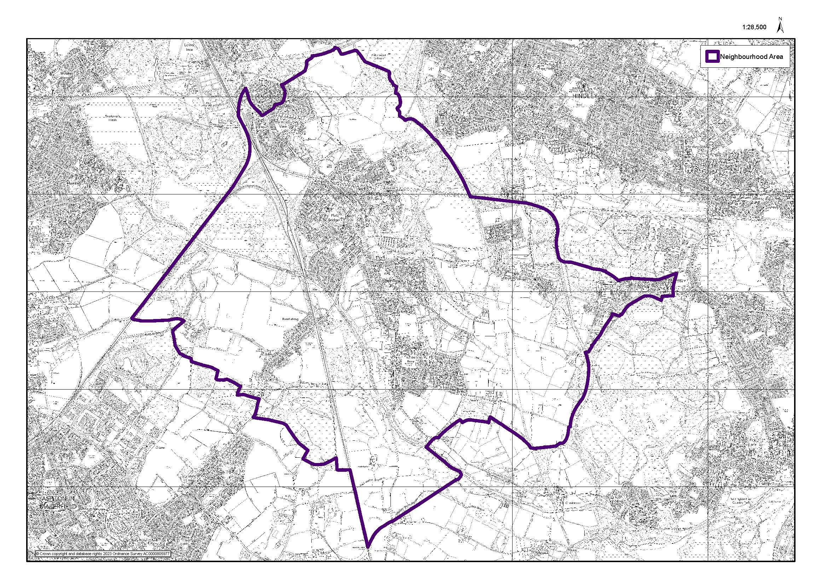
Figure 1 - Neighbourhood Area

Community Consultations
The ACT Forum has consulted with local people across the Neighbourhood Area in order to inform the development of the vision and objectives and the development of policies.
Evidence from the engagement surveys and projects have been integrated into the development of policies.

ACT Survey 2016
The 2016 consultation took place over 5 days, utilising 5 venues in key locations across the Neighbourhood Area. In total 149 people took part representing all 5 villages.
The consultation at this stage identified several key issues, including on the following themes:
- Local activities / areas for teens;
- Supporting the ageing population;
- Development of the canal towpath;
- Clean up all communal areas;
- Safer roads;
- Improved car parking facilities;
- Higher police presence;
- High school;
- Additional primary school;
- Regeneration of dilapidated buildings;
- Protect green spaces;
- Quality housing;
- Community events for all;
- Better local shops.

ACT Survey 2017
The 2017 consultation took place over 3 days, utilising 3 venues in key locations across the Neighbourhood Area. In total 110 people took part during events held in Bamfurlong, Bickershaw and Platt Bridge.
The consultation at this stage identified several key issues, including on the following themes:

Green spaces
- Walking, running and cycling with visual signposts and maps, organised walks;
- Football facilities;
- Wildlife;
- Protect green forestry and flashes;
- Canoeing;
- Picnic areas.

Allotments for green growing
- Community allotments and help with access to allotments to enable local resident to source fresh fruit and vegetables;
- Community planters;
- Links with Incredible edible;
- Young and old working together.

Types of housing
- Top end quality apartments;
- Mixed age homes;
- Affordable apartments;
- Bungalows;
- Enable older people to stay in their own area;
- Mixture of housing, e.g. bungalow, family, single.

Vision for the Neighbourhood Area in the next 15 years
- Greenheart centre;
- Nature trails;
- Interactive maps for walks;
- No empty shops;
- New shops;
- High school;
- Community growing areas;
- Outdoor facilities, e.g. skate park/BMX/go karting.

Green gym
- Healthy living, keeping fit utilising park areas, focusing on family use within all areas of the Neighbourhood Area.

New ideas
- Grants for home improvements;
- Empowering local groups;
- Speed management and Improved road surfaces and safety;
- Official sites for quad bikes/scramblers;
- Improved play areas;
- Community hubs in the Neighbourhood Area with better use of community buildings.

Placed Consultation 2018
In 2018, ACT Forum commissioned Placed, an engagement specialist, to undertake a more in-depth survey with local people. This took place over five days in May 2018, with an exhibition and interactive engagement activities being held in five outdoor locations, one in each village. In total 136 people took part in the survey.
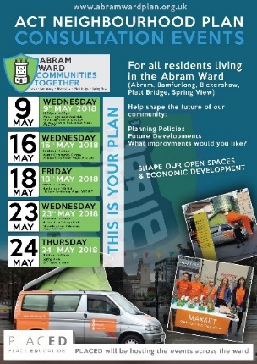
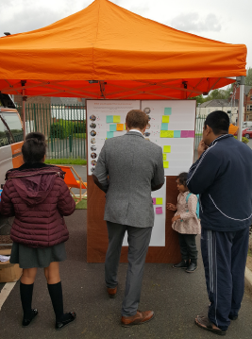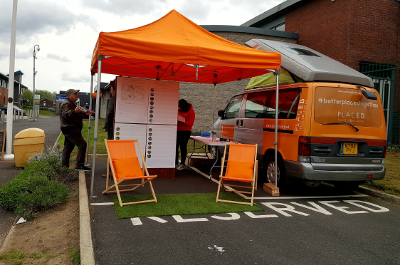
Key findings from the Placed consultation were as follows:
- Concerns around losing green space and traffic congestion;
- The importance of quality, safe, accessible and well-maintained green space;
- Green Gym provision was very popular;
- Providing cycle paths that connect green spaces;
- A lack of awareness of the network of green spaces in the Neighbourhood Area;
- Support for community markets and community cafes;
- Importance of retaining community centres and clubs;
- Enhancing safety and maintenance at children’s play spaces;
- A lack of awareness of what community facilities are available in other villages.

Picture This Project 2018-2019
A six-month long engagement project took place entitled ‘Picture This’ from November 2018 to April 2019.
It was co-designed and produced with a team of nine people who live and/or work within the Neighbourhood Area. The project asked local people to consider the history of shops and small businesses across the Neighbourhood Area. Local people engaged in various stages of the project: 130 people responded with stories and memories of shops and small business, on postcards and via Facebook; 65 people attended a final event focussed on community wealth building; 18 business managers/owners in Platt Bridge commented in Platt Bridge Business Premises Report; seven local people took part in Platt Bridge Community Green design workshops and 65 people from across the Neighbourhood Area commented on the draft vision for the Community Green redesign.

Key Characteristics
A Baseline Evidence Report of the Neighbourhood Area has been written to describe in depth the character of the neighbourhood and its five settlements. This evidence underpins the policies contained within this Plan.
The key features of the Neighbourhood Area listed below are described here (see Abram Ward Baseline Evidence for detail).

Location
The Neighbourhood Area occupies a central location in Wigan Borough. It has five villages: Abram, Bamfurlong, Bickershaw, Platt Bridge and Spring View. Adjacent neighbourhoods are: Lower Ince, Ashton in Makerfield, Golborne and Hindley. The Neighbourhood Area has several busy main roads running through it, forming a junction in the centre of Platt Bridge; these are A537, A58 and B5237. The Neighbourhood Area does not have a train station.

Green Spaces
The Neighbourhood Area has a wide range of attractive, accessible green spaces. The entire Neighbourhood Area is at the centre of Wigan’s countryside “The Greenheart”. There are two Sites of Special Scientific Interest (SSSIs) and seven Sites of Biological Importance (SBIs). The Neighbourhood Area now also includes part of the Flashes of Wigan and Leigh National Nature Reserve (NNR) which was formally designated in October 2022.
These green spaces play an important role in providing Wigan’s essential Green Infrastructure. Many of them form important wildlife habitats and the neighbourhood forms a key role in Wigan’s ecological network, being part of the Greater Manchester Wetlands area and the Carbon Landscape Project.

History
Coal Mining was the major industry in the 19th and 20th centuries, however little of this cultural and architectural history is visible now. Many of the Neighbourhood Area’s green spaces are landscapes restored from former coal mining sites over the last 30 years. The five villages have distinct and separate identities, however there remains a lack of connectivity between them.

Population
In 2015 the population of the Abram Ward was 15,544 (Abram Ward Baseline Evidence paragraph 4.1). The local population experiences some deprivation; there are particular concerns about poor levels of health, with life expectancy in the ward significantly lower than both Wigan and England as a whole.

Housing
Housing character differs within each of the five villages. There is a range of types and tenures of housing, dating from Victorian times to the present day. There have been 564 house building completions within the 13-year period 2008 to 2021. Current average prices paid for housing are in the medium to low range, as per table 4.19 and 4.20 in Wigan Housing Needs Assessment - Final Report May 2020, and the numbers of housing transactions are low. A fairly large number of households are unable to afford these low house prices.

Occupation
The proportion of residents with formal qualifications is low (Abram Ward Baseline Evidence paragraph 7.4) and the level of unemployment in the ward is quite high (Abram Ward Baseline Evidence paragraph 7.1), relative to other parts of the Wigan Borough. There are a higher percentage of people working as ‘process plant and machine operatives’ than in the Wigan Borough and England as a whole and a lower percentage of people working in professional jobs (Abram Ward Baseline Evidence paragraph 7.3).

Employment
Across the ward there are various, generally small- to medium-sized, local employers; plus a few larger establishments (Abram Ward Baseline Evidence paragraph 7.5). Platt Bridge is a designated Local Centre; the other four villages are classed as having ‘small shops and services’. There are 61 business premises in Platt Bridge Centre, 49 of which are active businesses. 75% of active businesses in Platt Bridge Centre are local, independent businesses (Abram Ward Baseline Evidence paragraph 7.11). There are fewer business premises in the other villages; Abram has 18, Bickershaw has 12 and Spring View has 9. The number of business premises in Bamfurlong has recently reduced to 2 (Abram Ward Baseline Evidence paragraph 7.12).

Health and Education
Whilst there is a reasonable level of local health and education services, based mainly in Platt Bridge, there is no mainstream secondary school in the area. Many local people travel by private car to access facilities in nearby towns, as public transport availability is limited.

Leisure
There are a limited number of facilities offering leisure, culture or entertainment. In recent years several pubs and bars have closed in the area, leaving just 2. There are 3 membership-based bars. Other social facilities are mainly privately-run sports and leisure-focussed (table tennis, amateur rugby league, cricket, motocross).

Younger Generation
There is a higher percentage of children and young people within the Abram Ward than in the Wigan Borough and England as a whole (Abram Ward Baseline Evidence paragraph 4.2). Provision for children and young people is centred on outdoor playgrounds and playing fields, with few other facilities or activities available in the Neighbourhood Area.

Vision and Objectives

Introduction
As a Neighbourhood Forum we aim to work together to make the Neighbourhood Area an even better place to live for jobs, amenities and services, health and wellbeing and community spirit. We want to encourage the five villages to work together to make a positive difference to the Neighbourhood Area overall. We acknowledge the distinguishing characteristics and historic roots of each of the five villages and want to build on and enhance these, as part of our offer and approach to attracting new residents. We aim for the Neighbourhood Area to be a vibrant, creative, inclusive and safe neighbourhood, which supports a strong sense of community, and is a pleasant and attractive place to live, work, shop and spend leisure time.

Vision
For our neighbourhood to be a great place to live and work, with the environment at its heart – making it attractive, resilient, ambitious, thriving and sustainable.

Vision Alignment with Policy Frameworks
The Neighbourhood Plan vision is closely aligned with Places for Everyone [emerging local policy]’s Sustainable Places policy (Policy JP-P1), which states that Greater Manchester aims ‘to become one of the most liveable city regions in the world, consisting of a series of beautiful, healthy and varied places’.
It states that all development, wherever appropriate, should be distinctive with a clear identity, visually stimulating and imaginative, socially inclusive, resilient, adaptable, durable, resource efficient, safe, functional and convenient, legible (easy to understand and navigate around), easy to move around for all, well-connected, comfortable, incorporating high quality and well-managed green infrastructure, and well-served by local shops.
The ACT Neighbourhood Plan aims for the Neighbourhood Area to develop into a highly liveable area within the Wigan Borough; in other words, a great place to live and work, with the environment at its heart.

Objectives
Three key objectives have been set out to help deliver the vision:

Objective 1: Environment, Health and Wellbeing

To enhance and protect our nationally significant landscapes and green spaces
The Neighbourhood Area is home to some beautiful, biodiverse habitats and countryside which need ongoing protection and enhancement. We want local people within the Abram Ward, across the Wigan Borough and regionally to be able to appreciate and enjoy these nationally significant landscapes, green and open spaces, through improved access and providing learning opportunities and outdoor leisure opportunities. We aim to support community and local businesses to find the productive potential of some of these green spaces.

Environment, Health and Wellbeing Policies
The following policies feed into the Environment, Health and Wellbeing objective:
- Policy AP1: Air Quality;
- Policy GS1: Local Green Space;
- Policy GS2: Proposed Green Corridor;
- Policy GS3: Recreational and Green Spaces;
- Policy TM2: Footpaths and Cycleways.

Environment, Health and Wellbeing Alignment with Policy Frameworks
The policies within the Environment, Health and Wellbeing objective support policies in the following frameworks:
- National Planning Policy Framework 2023
  - Chapter 4,
  - Chapter 8;
- Wigan Local Plan Core Strategy
  - Policy CP1 – Health and Wellbeing,
  - Policy CP2 – Protection and Enhancement of Open Space,
  - Policy CP3 – Enhancement of Community Facilities,
  - Policy CP7 – Accessibility,
  - Policy CP9 – Strategic Landscape and Green Infrastructure.

Objective 2: Economic Development

To create local employment opportunities, including supporting the development of local community businesses and encouraging local and regional tourism
We aim for the Neighbourhood Area to be an ambitious, innovative and prosperous neighbourhood, where current and new residents can find fulfilling and varied employment opportunities. We are keen to attract new residents, businesses and visitors into the area. We actively support the development of new local and community businesses, along with the provision of appropriate premises and work-places in our neighbourhood. We aim to encourage local and regional tourism, and ‘green’ business opportunities which will make the most of our landscapes and green spaces.

Economic Development Policies
The following policies feed into the Economic Development objective:
- Policy BEC1: Business, Enterprise and Community Facilities;
- Policy TM1: Transport and Movement.

Economic Development Alignment with Policy Frameworks
The policies within the Economic Development objective support policies in the following frameworks:
- National Planning Policy Framework 2023
  - Chapter 1,
  - Chapter 2,
  - Chapter 3;
- Wigan Local Plan Core Strategy
  - Policy CP5 – Economy and Employment.

Objective 3: Housing and Planning

To provide affordable, energy efficient, high-quality homes for our communities of all ages
We aim for our neighbourhood to provide homes for families, couples and single people of all ages and backgrounds, these homes will include small and large properties: apartments, houses and bungalows. We also aim for homes in the Neighbourhood Area to have a mix of tenures, from social housing, affordable rented homes and affordable homes to buy, as well as larger homes to rent or buy. Schemes to refurbish and reuse vacant buildings will be strongly supported. It is essential that new and refurbished homes are built to high-quality standards with environmental sustainability and energy efficiency at the forefront. The plan is to target to lower the carbon footprint by 10% by 2035.

Housing and Planning Policies
The following policies feed into the Housing and Planning objective:
- Policy RD1: Residential Development;
- Policy REF1: Refurbishment;
- Policy DES1: Sustainable Design, Character and Biodiversity.

Housing and Planning Alignment with Policy Frameworks
The policies within the Housing and Planning objective support policies in the following frameworks:
- National Planning Policy Framework 2023
  - Chapter 5;
- Wigan Local Plan Core Strategy
  - Policy CP6.

Policies
This section outlines the Neighbourhood Plan’s neighbourhood development policies and provides reasoning and justification for each.
Several documents containing evidence to support the policies outlined are referred to in this section, as explained in the Supporting Documentation section.

Policies Map
The Policies Map shows Commercial, Community & Leisure Facilities, Local Green Space Designations, proposed sites for green gyms and designated heritage assets for each of the five villages that make up the Neighbourhood Area. These are referenced within the Policies.
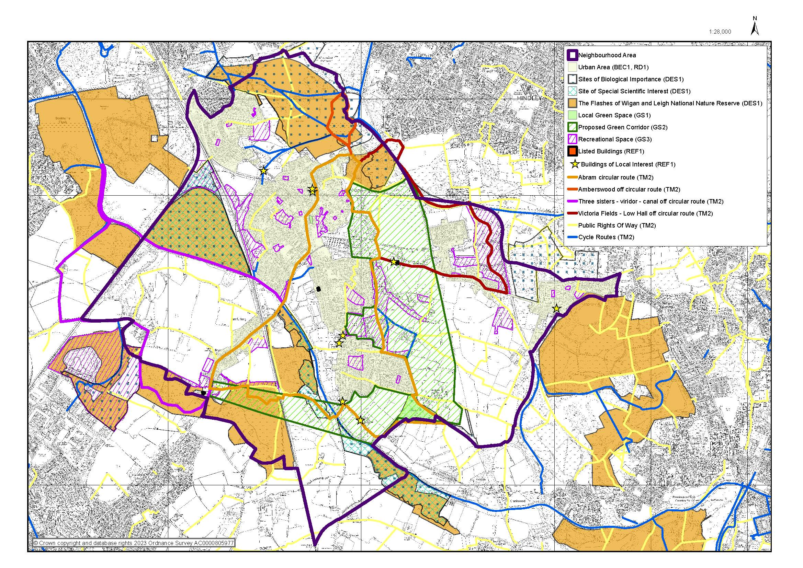
Figure 2 - Policies Map

Business, Enterprise and Community Facilities

Purpose
To create more sustainable work/life patterns, supported by a range of community facilities and local employment opportunities.
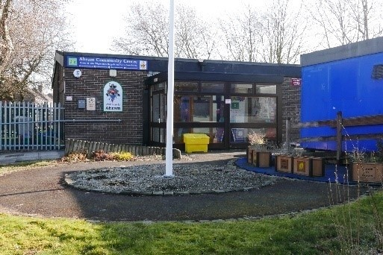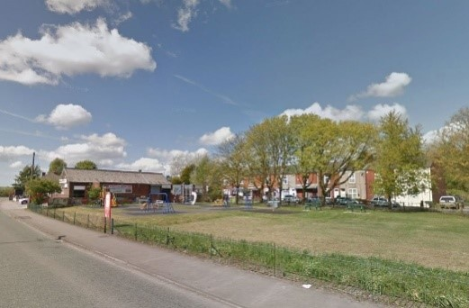
Abram Community Centre Bickershaw Village Community Club

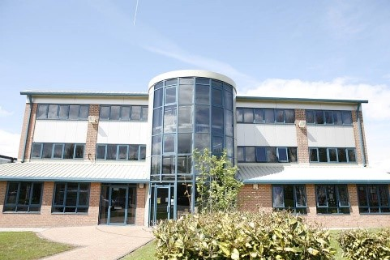
Platt Bridge Community Zone

Rationale and Evidence
This feeds into Economic Development Alignment with Policy Frameworks.
The Neighbourhood Plan aims to enhance the vitality and viability of each village, to meet the day-to-day needs of the community and enrich and enliven the public realm, as well as help identify where existing business premises should be retained, where new business premises should be sited and to encourage the development of new business or mixed use premises within the boundaries of each zone. The locations of Business, Enterprise and Community Facilities for each of the five villages can be found in the Policies Map section.
The five villages were originally built along the main arterial roads through the Neighbourhood Area, with rows of shops [and other businesses] fronting onto these roads. Of the five villages, Platt Bridge is central to the Neighbourhood Area, and has the only designated Local Centre located at the key junction which connects all five villages. It is the largest village with 61 business premises [housing 49 active businesses]. This Plan defines business as retail, servicing, production and employment sites. Abram, Bickershaw and Spring View have 18, 12 and 9 active business premises in them respectively. These premises are now dislocated, with one or two business premises next to each other and gaps with residential houses in between. In the last two years Bamfurlong has lost some businesses and now has only 2 active business premises. In Bamfurlong, access to shops and local facilities for its residents has decreased significantly.
As of April 2021, Platt Bridge’s commercial centre is located around the central junction and Walthew Lane. Identifying a central and coherent commercial zone was more challenging for the other four villages, however it is considered essential to this Plan to support the drive towards inclusively regenerating each village. Bickershaw has two commercial zones [east and west], aligning with its two residential areas and existing active business premises. Each of the five villages have a commercial zone and supports the development of new business premises and mixed-use developments in these zones. The Neighbourhood Plan supports the Neighbourhood Area being home to a breadth of businesses at different scales and types and is especially supportive of the development of new local, independent businesses in the area, as these businesses contribute most fully to its community economic development approach, often strongly supporting the local community and vice versa.
Use Class information for Platt Bridge is detailed in Section 8 of Platt Bridge Business Premises Report. 54% of all business premises are in Class E (Commercial, Business and Service), of which 39% are Shops; 2% are Restaurants/Cafes; 8% are Business Light Industry; 5% are Non-Residential Institutions. Additionally, 6% of business premises are in Class B8 (Storage) and many business premises are defined as Sui Generis or unique (17% of business premises are Hot Food Takeaways). Whilst business premises in Class B2 (General Industrial) and the Sui Generis or unique Drinking Establishments exist, there are no active businesses in either of these. There is only one active business in the category of Restaurants/Cafes.
The Wigan & Leigh Community Charity (WLCC), based in the Neighbourhood Area, is using a Community Wealth Building (CWB) approach, also known as Community Economic Development, within the Wigan Borough. WLCC is working with local people and the ACT Forum to build a stronger local economy in the Neighbourhood Area, by developing more community businesses and social enterprises which trade for the benefit of the community, creating more local jobs and training, ensuring more people shop and spend locally, with less money leaking out of the area.
The commercial zones identified in each village highlight the relationship between the commercial and community facilities. Where possible community facilities are included or are adjacent to the zones, to encourage people to dwell longer in each village, by having more reasons to be there, to strengthen the local economy. The commercial zones aim to enable easy access to key green spaces local to each village and Abram Ward Circular Walks. For example, Bickershaw’s commercial zone, is adjacent to Victoria Fields and Abram Ward Circular Walks lead to the Bickershaw Village Community Club, one of the businesses [and community facilities] in the commercial zone.
The Neighbourhood Plan supports the extending of the National Cycle Route through Victoria Fields and to Bickershaw. Encouraging active travel modes to access and use local villages, particularly Bickershaw which is the nearest to the National Cycle Route, would enhance local people’s health and wellbeing, and commuting or day visitor cyclists would use the commercial and community facilities there and strengthen the local economy.
The PBBPF reported that shop managers and owners felt very positive about the strong community spirit in Platt Bridge, however it also identified that 32% of business premises in Platt Bridge are unattractive and in a poor condition. The attractiveness of shop and business frontages impacts on pride in a place, for local people and shoppers as well as business owners and their staff. It also impacts on the community’s choice to regularly use their local businesses, as shop fronts in poor condition can discourage shopping in an area. A strong link is recognised between ‘the quality of an environment and economic success of a place’.
Streets feel safer when they have good natural surveillance (when people can see out of windows from buildings adjacent to the street, and when there are plenty of passers-by). Surveillance is a natural way for shopkeepers to keep an eye on the street outside their shop, meaning that anti-social or criminal activity is discouraged because this activity is easily seen. A shopping area with good natural surveillance also feels more welcoming, neighbourly and attractive to shoppers and potential shoppers. PBBPF identified that 38% of businesses were not able to see out onto the street outside their business in daytime. As part of supporting the vitality and viability of commercial zones in the Neighbourhood Area, the Neighbourhood Plan encourages better street surveillance from shops to have a positive effect on daytime (and potentially night-time) safety and security for residents and shoppers.

Community Facilities
The vitality and viability of a neighbourhood is weakened when its community facilities are closed. Closures of facilities including pubs and post offices have taken place across the Neighbourhood Area in recent years, leaving some residents (older people without a car in Bamfurlong in particular) unable to easily access community and commercial facilities. The Neighbourhood Plan defines community facilities as buildings which provide community organising, social, leisure, learning, entertainment opportunities and meeting spaces.
The Neighbourhood Plan identifies buildings in all five villages as Community Facilities:
- Abram
  - Abram Community Centre,
  - The Bucks Head,
  - Abram Scout Hut,
  - St John’s C of E Primary School,
  - Abram St Johns’ the Evangelist Church;
- Bamfurlong
  - Bryn Hall Pub,
  - Church of the Good Shepherd,
  - Bamfurlong Methodist Church;
- Bickershaw
  - Bickershaw Village Community Club,
  - Bickershaw C of E Infants and Junior School,
  - Bickershaw Parish Church;
- Platt Bridge
  - Holy Family CMS Club, Tram Street,
  - Kes’ Public House,
  - Platt Bridge Community Zone,
  - Platt Bridge Community Centre,
  - Newbridge Learning Community Sports Hall,
  - Holy Family Catholic Primary School,
  - St Mary’s Primary School,
  - Platt Bridge Community School,
  - St Nathaniel’s Parish Church;
- Spring View
  - Spring View Cricket and Recreation Club,
  - Spring View Community Sport Association,
  - Spring View United Methodist Church.
Some of the community facilities are going through the process of becoming Assets of Community Value [Bickershaw Community Village Club, Kes’s Public House] and some are also identified as Non-Designated Heritage Assets.
The Neighbourhood Plan recognises that good quality community facilities impact positively on health and wellbeing by for example overcoming social isolation in older people and being key to young people’s healthy development. As in Places for Everyone [emerging local policy] Policy JP-P 1 Sustainable Places, the Neighbourhood Area aims to have a range of good quality and well-managed community facilities that are socially inclusive and provide activities and services for all members of the community, enabling equal and independent participation, providing social contact and support and promoting a sense of community. Good quality community facilities also support the nurturing of community pride and stronger sense of local identity and culture.
The Neighbourhood Plan recognises that there is a positive relationship between community and commercial activity, where commercial businesses can also be a community facility. Especially when they are community businesses, which are set up to trade for the benefit of the community. Community organisations WLCC and ACT Forum will explore creating a formal partnership to work with local small, independent businesses to work together on an inclusive regeneration strategy, focussing on building a stronger local economy in the Neighbourhood Area.
Given the high number of children and young people in the Neighbourhood Area, the community has concerns about the lack of community facilities for them. There are a limited number of facilities centred on sport, fitness, leisure, culture or entertainment that young people can access. Young people are particularly underserved in an area where they have to travel out of the Neighbourhood Area to go to secondary school. Across the whole Neighbourhood Area, there is one Boys Brigade group, one Scouts group and one youth project. The bulk of provision comprises 20 free to access playing fields, play areas and recreation grounds, some of which have play equipment.
Community facility closures have also resulted in a decrease in community facilities for adults. There remain a few social activities taking place at Abram Community Centre, Bickershaw Village Community Club, and Holy Family CMS Club. Sports and fitness activities take place at a number of mainly private sports clubs, such as Spring View Cricket and Recreation Club. This policy supports developments which retain and add to quality local community facilities and services in the village commercial zones.
There are no dedicated premises for cultural or arts activities [such as theatre, visual arts or cinema] in the Neighbourhood Area. This plan supports new class E(d), F2 (c-d) (Assembly and Leisure) uses in village commercial areas and also the relocation of arts, heritage and creative organisations and businesses to the Neighbourhood Area.
The strong community spirit identified in the Platt Bridge Business Premises Report is being harnessed in the Neighbourhood Area. This plan supports community groups and organisations that seek to take on managing community assets, via Community Asset Transfer, where these previously Local Authority managed sites are retained as sites for ongoing community facilities and remain accessible to the public. WLCC and the ACT Forum are partnering with Wigan Cosmos Football Club to secure the community asset transfer of St John’s Street Recreation Ground. The commercial zones identified will make the most of both the Neighbourhood Area’s community facilities and local business sector, by increasing footfall and therefore local spend.

Community Pubs
Since the start of 2018, there have been 3 public house closures within the Neighbourhood Area. These were Dover Lock Inn, King William Inn and Walmsley Arms. These closures have added to the number of vacant business premises, in turn contributing to the lack of congregating/social space within the Neighbourhood Area and the loss of heritage and local culture.
There are now only 4 Public bars in the Neighbourhood Area. These are:
- Kes’ Public House, Platt Bridge;
- Bryn Hall, Bamfurlong;
- Bickershaw Village Community Club;
- The Bucks Head, Abram.
The recent closure of public houses has added to the number of vacant business premises. This has contributed to the lack of congregating/social space within the Neighbourhood Area and the loss of heritage and local culture.

Heritage Assets
The Neighbourhood Area has a long history, with farming settlements being recorded in Abram in 1212 and Platt Bridge in 1599, and Bickershaw being named after Bickershaw Hall in the 1600s. The character of the Neighbourhood Area was formed in the 19thand 20thcenturies through the Industrial Revolution and the coal mining industry, which took place across the Neighbourhood Area, including deep, shallow and surface level mining. The Neighbourhood Area has two listed buildings: a mid-18thcentury detached house [126 Warrington Road in Abram] and Brookside Farmhouse in Bickershaw, built in 1716. Much of the recent coal mining history of the neighbourhood is no longer visible through its buildings but is remembered mainly through the naming of streets after historic events and significant events.Developments of the last 40 years have seen the loss of many of its significant socio-historic buildings in the area such as Abram Labour Club and Platt Bridge Labour Club, meaning that evidence of the area’s recent coal mining history has disappeared. The character of the villages is now disparate featuring a range of houses built in the 1960s, 1970s, 1980s and 1990s using a range of contemporary styles, although many of the original Victorian terraced houses built for workers in the 19thcentury still survive.
The heritage of the Neighbourhood Area, in particular its recent coal mining history, is still preserved in some buildings and sites:
- Abram
  - Morris Dancing Ground,
  - Abram St Johns’ the Evangelist Church;
- Bamfurlong
  - Bryn Hall Pub;
- Bickershaw
  - Bickershaw Parish Church;
- Platt Bridge
  - St Nathaniel’s Parish Church.
Cultural and social identity is important to the community of the Neighbourhood Area. This links to social cohesion and fabric of society.
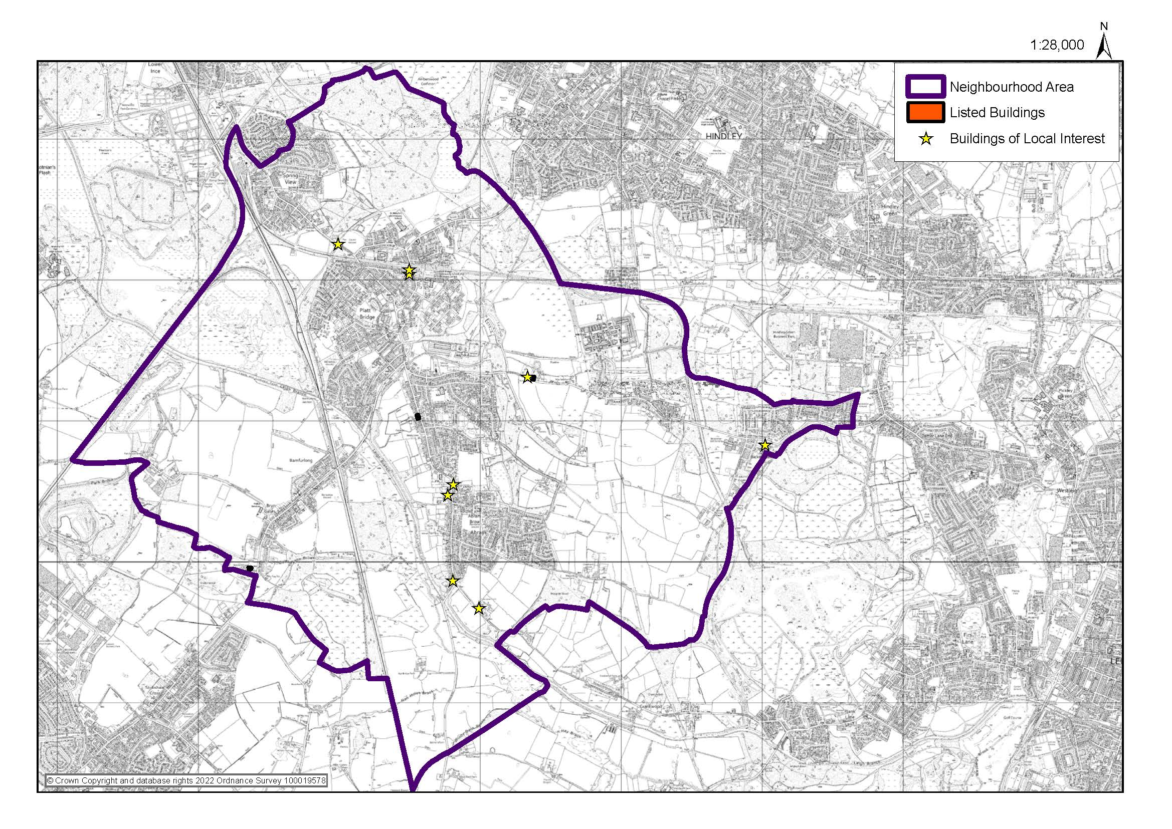
Figure 3 - Heritage Assets

Productive green spaces
There are a number of sites in the Neighbourhood Area currently producing food for local people’s private use.
This Plan identifies the below sites, as current productive green spaces:
- Abram Ward Community Garden;
- Bryn Gates Allotments, Bamfurlong;
- James Street Allotments, Bamfurlong;
- Low Hall Park Allotments, Platt Bridge.
This plan aims to support the repurposing of some areas within appropriate local green spaces to sites of production for community benefit; such as orchards, vegetable gardens, coppicing of trees, charcoal burning, mushroom cultivation or wood crafts. These policies aim to support setting up production and other facilities for community businesses on appropriate green space.
Sites have been identified with the potential to be productive for community benefit (i.e. to be managed by community businesses and/or social enterprises). These are:
- Maypole Wood;
- Platt Bridge Community Zone Garden;
- Victoria Fields.
The ACT Forum and WLCC, in partnership with local people and other organisations, are working with local green spaces in the neighbourhood; the aim is to investigate the potential for other appropriate sites to be more productive for the community, greater health and wellbeing and for the better management of land spaces productively.

Policy BEC1: Business, Enterprise and Community Facilities
- New employment space and community facilities will be supported in or immediately adjacent to the existing urban areas, providing there is no significant adverse impact on:
  - The amenities of nearby residential properties;
  - The built character of the village, having regard to Policy DES1.
- Diversification of existing businesses in the rural parts of the area, outside of the urban areas, will be supported providing:
  - there is no adverse impact on the amenities of residential properties;
  - there is no harm to the open and rural landscape character of the area;
  - the scheme does not comprise inappropriate development in the Green Belt.
- Development involving the loss of existing business, enterprise or community facilities will only be supported where:
  - Equivalent or better facilities are provided in close proximity; or
  - It can be demonstrated that the use is no longer required or viable.

Interpretation:
The policy supports employment (Use Class E) and community facilities, which are quite often the same thing [such as local shops and pubs].
The policy supports diversification and expansion of businesses in the rural area, providing they do not have adverse impact on residential amenity or the open and rural landscape character. Within the Green Belt, national and local policies on Green Belts would obviously also apply.
Given the wide-ranging nature of Use Class E and associated permitted development rights, it may be necessary to consider planning conditions on planning permissions for new businesses to prevent unsustainable changes of use, which could harm the five villages. This applies to development both in and outside of the five villages.

Residential Development

Purpose
To enable housing development, to meet local need.

Rationale and Evidence
This feeds into the Housing and Planning Alignment with Policy Frameworks.
Housing affordability in the Neighbourhood Area is a mixed picture. Home ownership is considered affordable in some respects, because house prices are quite low. In 2015, it was identified that the ratio of house price affordability [based on house prices in the lowest ranges] and residents’ average incomes was the lowest in the borough. This meant that households with an income of £14,000 would have been able to afford to buy a low-value property in Abram, however this house price was unaffordable to 27.5% of the resident population. It was also identified that 35.5% of the population in Abram Ward would not have been able to afford to privately rent a two-bedroom house in the ward. Wigan Housing Needs Assessment - Final Report May 2020 section 4 shows a worsening picture for 2018, with 35% of median household income needed for lower quartile rent [Wigan Housing Needs Assessment - Final Report May 2020 table 4.16] and 7.5x income multiple required for lower quartile property purchase [Wigan Housing Needs Assessment - Final Report May 2020 table 4.19].
Wigan Housing Needs Assessment - Sub Area Profile May 2020 page 7 determines the housing need for the Abram Ward to be 2 & 3 bedroom houses, 2 & 3 bedroom flats and 1 & 2 bedroom bungalows, specifically mentioning that there is no need for additional 4 or more bedroom homes.
Our vision is to improve and update the Neighbourhood Area within the next 20 years by improving our Economic Development, in order to entice new business, enterprise and employment within our local ward, also providing sustainable and affordable homes via housing and planning and ensuring they are placed in areas that does not affect our countryside, environment, health and wellbeing. Putting these things in place will improve and protect the ward for the residents that already live within the Neighbourhood Area and entice and attract new residents and businesses into the area, in turn boosting our likeability and economy, sustaining it for the next generation to come.

Urban Area
The following maps show the existing urban areas for each of the five villages that make up the Neighbourhood Area
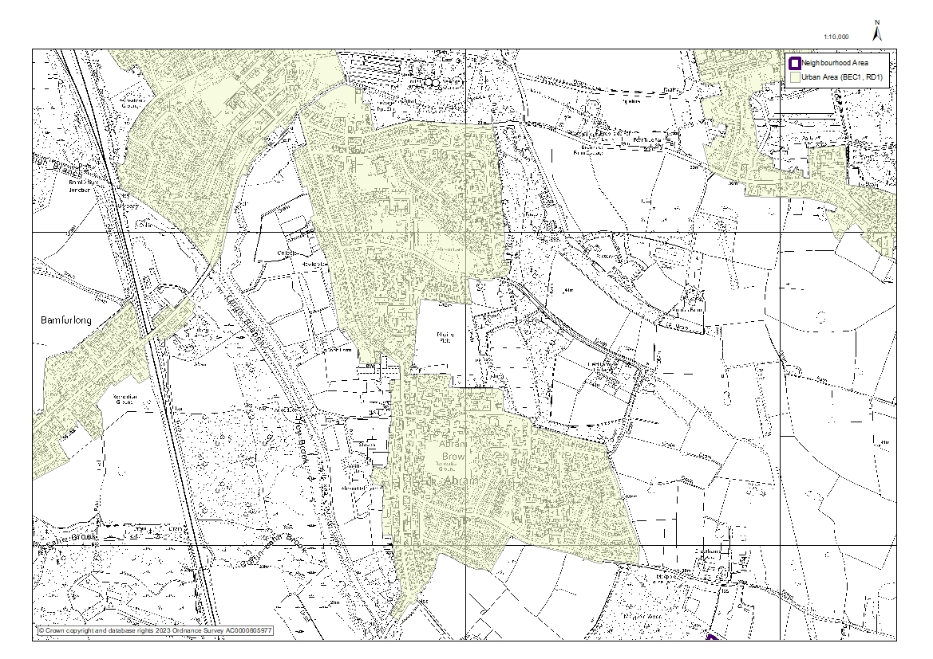
Figure 4 - Abram Urban Area
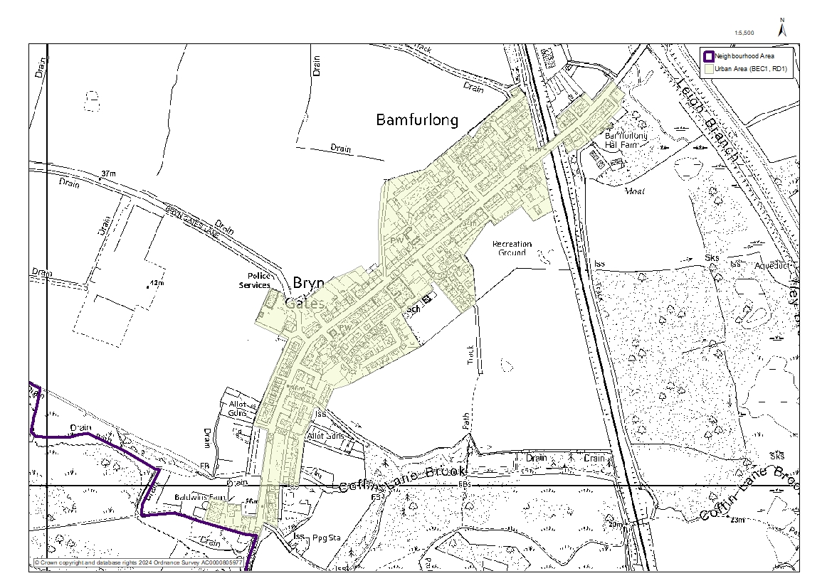
Figure 5 - Bamfurlong and Bryn Gates Urban Area
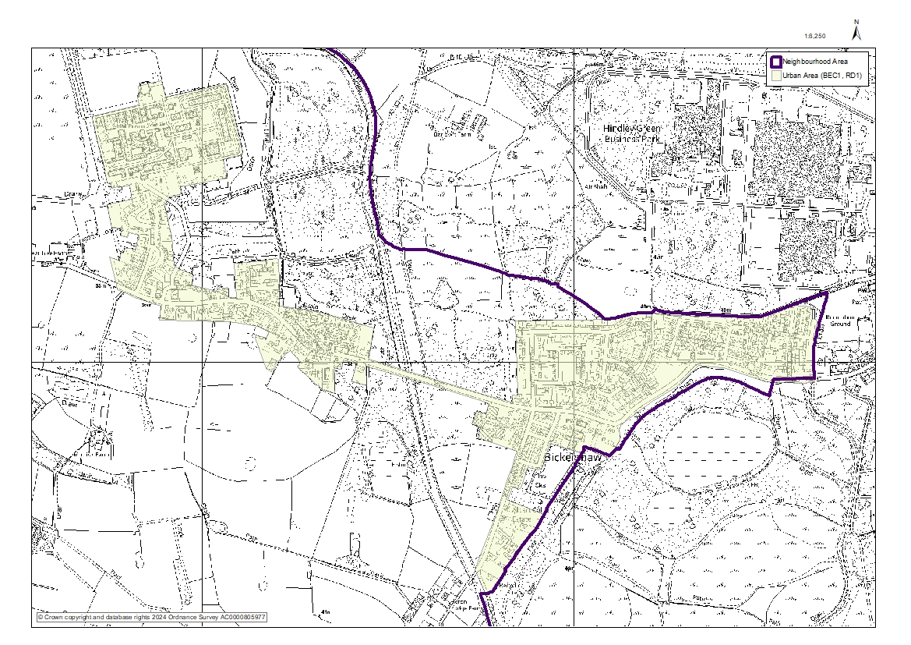
Figure 6 - Bickershaw Urban Area
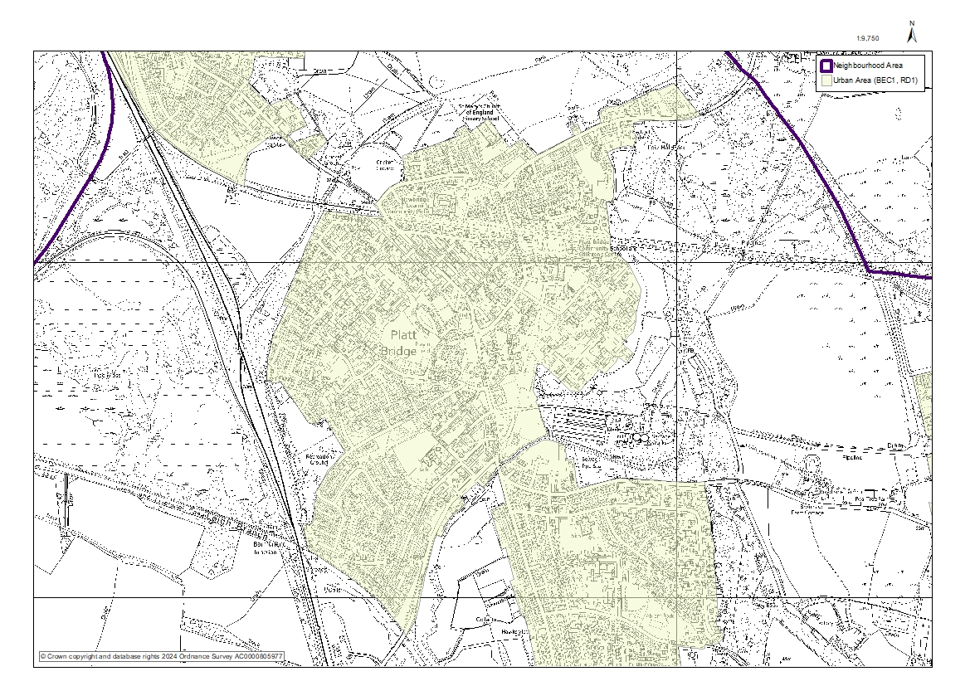
Figure 7 - Platt Bridge Urban Area
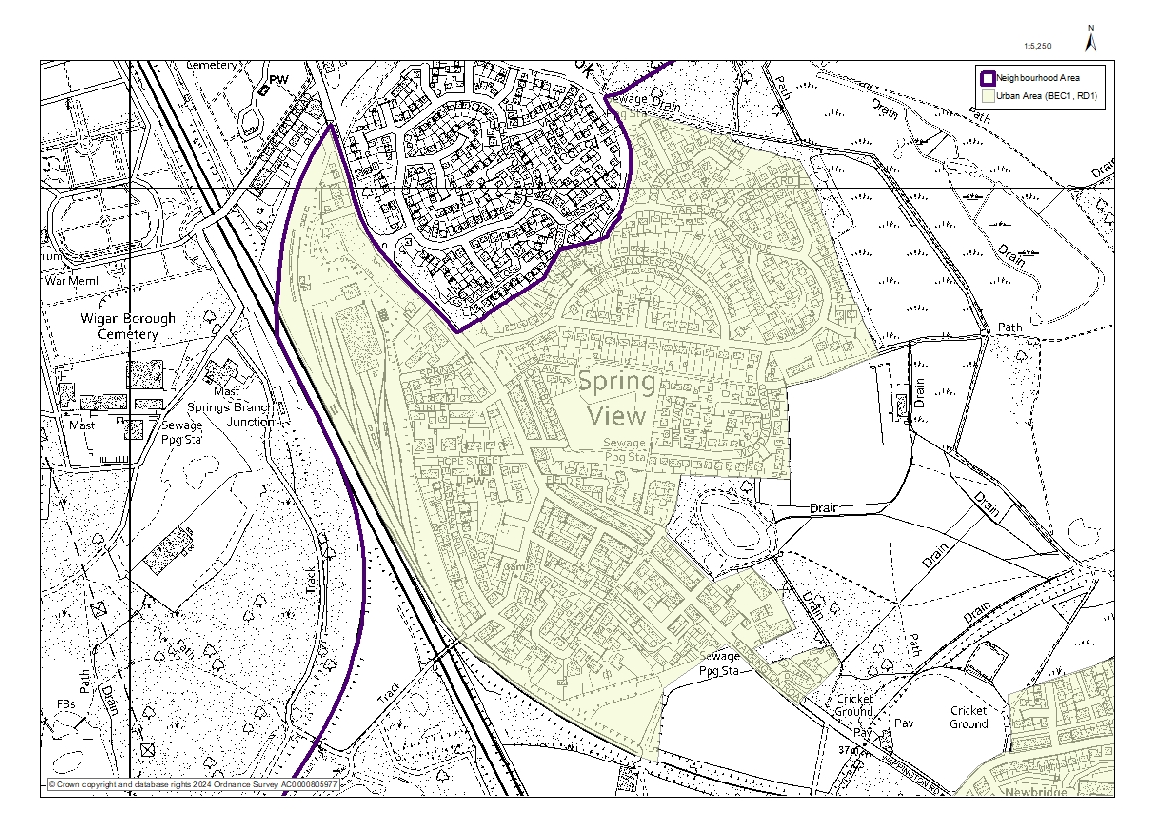
Figure 8 - Spring View Urban Area

Specialist Care Provision
Relative to both Wigan Borough and National levels, the Abram Ward has a young population with a higher percentage of children under 16 and young adults under 25, along with a lower percentage of people aged over 65. It has similar proportion of people aged 25-64. For comparison purposes, the percentages of people by age group for ward, borough and national can be seen in the table below.

Age Range | Abram Ward | Wigan Borough | England
Under 16 | 20.6% | 18.9% | 18.9%
16 to 24 | 12.7% | 11% | 11.9%
25 to 64 | 54.1% | 53.9% | 52.9%
Over 65 | 12.6% | 16.3% | 16.3%

Life expectancy for males at birth in the Abram Ward is 76.7 years, which is below the Wigan Borough average of 77.6 and considered significantly worse by Public Health England (PHE) than the overall England lifespan of 79.4. Life expectancy for females at birth in the ward is 78.4 years, again below the overall Wigan Borough age of 81.1 and considered significantly worse by PHE than the overall England age of 83.1.

Policy RD1: Residential Development
- Residential development will be supported in the following locations, subject to them having no significant detrimental impact on the amenities of existing residential properties or being inappropriate development in the Green Belt:
  - Brownfield sites;
  - Infill sites within existing built frontages in the urban areas.
- The following are encouraged and will be supported:
  - Schemes comprising 100% affordable housing;
  - Smaller (1, 2, 3 bedroom) houses and apartments;
  - Housing suitable for the older people;
  - Special care schemes;
  - Community-led or self-build housing.
- Strong encouragement is given to incorporation of measures to reduce the environmental impact and running costs of the properties, including by achieving environmental performance in excess of building regulation requirements.

Interpretation:
The policy highlights local needs. Support for housing schemes is subject to the requirements of design and other relevant policies being met, including the requirement in Policy DES1 for positive design features to reduce carbon use and achievement of biodiversity net gain.
Viability considerations will not justify poor or unsustainable design which fails to meet the requirements of the design policy. Where developers seek reduction of the proportion of affordable housing provision on viability grounds, a housing mix based on predominantly smaller properties would help to create affordability for first time buyers.
For sites in the Green Belt, the requirements and restrictions of national and local policies on Green Belts would also apply.

Refurbishment

Purpose
To support the refurbishment and reuse of vacant or under-used properties.

Rationale and Evidence
This feeds into the Housing and Planning Alignment with Policy Frameworks.
We have brownfield land sites within Greater Manchester, as well as the Wigan Borough and the Abram Ward. In line with National Planning Policy Framework 2023 and in conjunction with the Government Legislation and White Paper on Green Belt land development, the Neighbourhood Plan has a preference for brownfield sites.
At present there are no plans from Wigan Council to develop any areas of Green Belt within the Neighbourhood Area, however we need to ensure all suitable, viable and deliverable brownfield land in and around the Wigan Borough and our ward is fully utilised. To this end, any derelict properties should be reused for potential redevelopment into housing, any brownfield land utilised for potential use of housing redevelopment and any other land that was once developed in the past to perform a change of use to allow that land to be redeveloped for new homes.
The council has had a long-standing priority of bringing long term empty properties back into use. This has resulted in a continual reduction of long-term empty homes in the Wigan Borough from 2,498 in 2008 to 1,644 in 2015. This represents around only 1.15% of the borough’s total housing stock, which is below national and regional averages. The Council monitors the level of empty homes on an annual basis and reports this to Government.
The Council will continue to prioritise bringing long term vacant properties back into use and optimising the delivery of homes on brownfield sites and other sites outside of the Green Belt. Around 80% of the identified housing need in the borough to 2037 is proposed on land outside the Green Belt [as per Wigan Housing Needs Assessment - Final Report May 2020].
Health and safety implications can happen if this issue is not addressed due to unsafe buildings.

Policy REF1: Refurbishment
- Schemes which sensitively refurbish and reuse vacant buildings will be supported, including temporary uses, subject to there being no significant adverse impact on the amenities of residential properties.
- Support will be given to refurbishment schemes that would enhance the urban and industrial character of the area through the reinstatement of original features or reversal of previous harmful alterations.
- Refurbishment schemes for designated heritage assets should preserve listed buildings and their settings.
- Refurbishment schemes for non-designated heritage assets should preserve or enhance the historic or architectural qualities of the building and the setting of the building.

Interpretation:
The policy supports refurbishment and improvement of properties, subject to amenity, design and heritage considerations. The policy supports temporary or ‘meanwhile’ uses, such as pop-up shops, cafes etc, as a precursor to the more permanent regeneration of sites.
Designated heritage assets would include listed buildings and conservation areas. Non-designated heritage assets would include buildings on a local list, the historic environment record or otherwise identified in any heritage-related document.

Air Quality

Purpose
To promote clean air.

Rationale and Evidence
This feeds into the Environment, Health and Wellbeing Alignment with Policy Frameworks.
This Plan aims to facilitate the Neighbourhood Area becoming a healthy place, as defined in Planning Practice Guidance, ‘A healthy place is one which supports and promotes healthy behaviours and environments and a reduction in health inequalities for people of all ages. It will provide the community with opportunities to improve their physical and mental health, and support community engagement and wellbeing. It meets the needs of children and young people to grow and develop.’
The centre of Platt Bridge has three air quality management areas, all on the A537 leading to and from Wigan and through the ward’s central junction in Platt Bridge, which links all five villages. This policy aims to reduce air pollution in general and during building work.

Policy AQ1: Air Quality
- Development that generates vehicle movements or has other potential to increase in air pollution should include mitigation measures as part of the scheme.

Interpretation:
Other policies in this plan on design, landscape and transport have implications for air quality. For example, Policy TM1 sets out requirements for cycle storage and vehicle charging points, whilst pedestrian permeability and connectivity are also dealt with in Policy DES1.
Wigan Council’s Development and Air Quality Supplementary Planning Document will be helpful in securing compliance with the policy.
Mitigation measures could include electric vehicle charging points; the provision of safe, direct and good quality walking and cycling connections; the provision of secure cycle storage; the provision of tree and hedge planting and other green screens; landscape design and building design with superior environmental performance.

Green Spaces

Purpose
To protect and enhance green spaces.
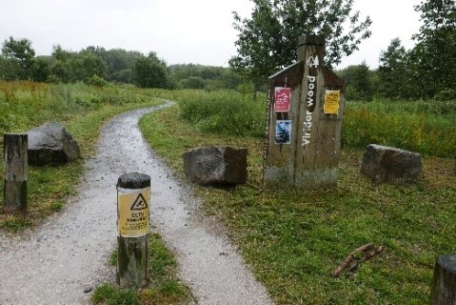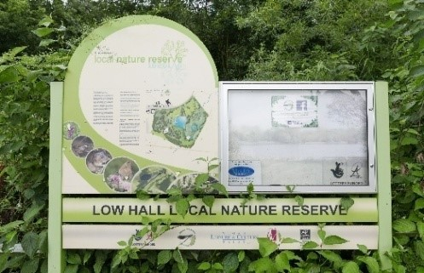

Rationale and Evidence
This feeds into the Environment, Health and Wellbeing Alignment with Policy Frameworks.
The policies are designed to enhance the green spaces within the Neighbourhood Area in response to the key findings from the consultations held. The protection of natural habitat, woodland and hedgerows are important in retaining the green space that surrounds the five villages. The policies will contribute to Greater Manchester’s plan to increase the planting of trees across the city region. There are sites within the Neighbourhood Area that are important and should be designated as Local Green Space. It is important that these spaces are retained and enhanced to benefit the community and encourage informal recreation use to improve health and wellbeing. One such green space is the Platt Bridge Community Green, as identified in the Platt Bridge Community Green Visioning Report.

Nature Reserves
The Neighbourhood Area is mainly within the Green Belt and is fully within the Greenheart and the Greater Manchester Wetlands area (Abram Ward Baseline Evidence paragraphs 3.2 and 3.6). It has a diverse range of habitats [many of which are restored landscapes] including grasslands, woodlands and wetlands. This is a network of key Green Infrastructure which provides resilience to climate change and key local and regional ecological habitats, offering green corridors for insects, birds and small mammals, some of which are rare and endangered (Abram Ward Baseline Evidence section 3).
The Neighbourhood Area’s Sites of Special Scientific Interest (SSSIs), Sites of Biological Importance (SBIs) and Flashes of Wigan and Leigh National Nature Reserve (NNR), which can be seen in Figure 9, are:
- Low Hall Park (NNR, SBI);
- Ince Moss (NNR, SSSI, SBI [area known as Horrock’s Flash which occupies the same area as Ince Moss]);
- Abram Flashes (NNR, SSSI);
- Three Sisters (NNR, SBI [overlapping with neighbouring Ashton Ward]);
- Amberswood Common (SBI);
- Barlow’s Farm (SBI [overlapping with neighbouring ward Hindley Green]);
- Maypole Wood (SBI, Abram Ward Baseline Evidence paragraph 3.3);
- Platt Bridge Heath (SBI).
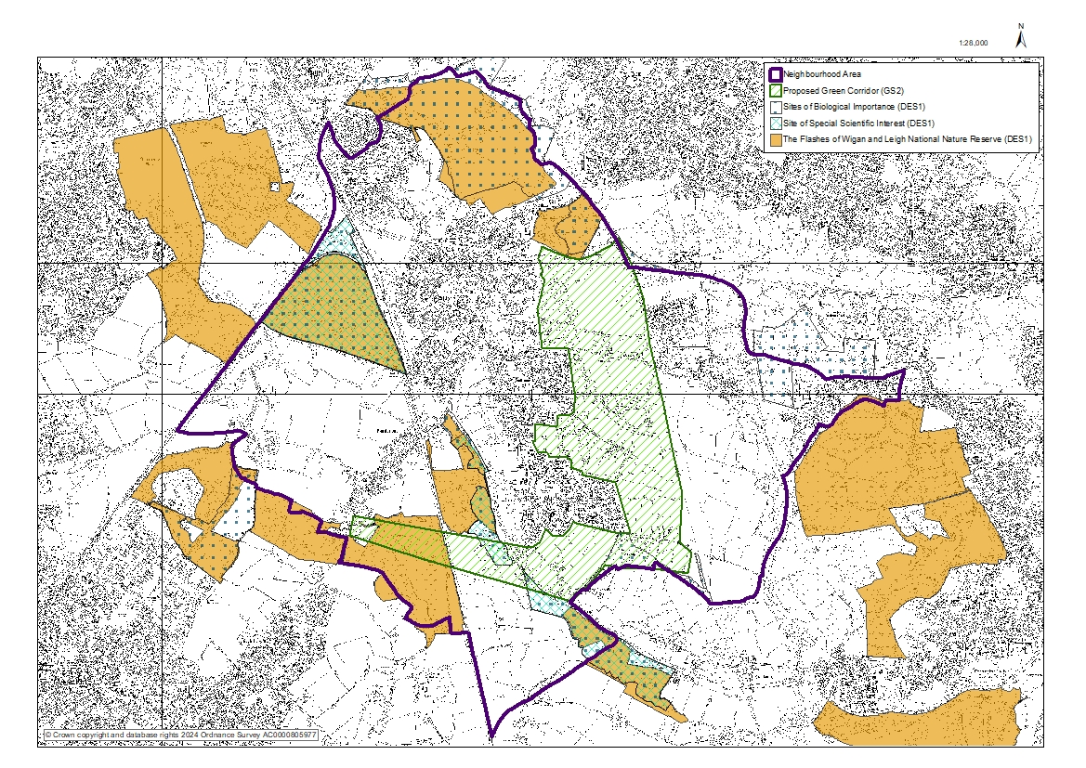
Figure 9 - Proposed Green Corridor, Sites of Special Scientific Interest (SSSIs), Sites of Biological Importance (SBIs) and Flashes of Wigan and Leigh National Nature Reserve (NNR)

Proposed Green Corridor
The Neighbourhood Plan designates a Proposed Green Corridor (Figure 9), which links housing areas to workplaces and community facilities and promotes active travel modes such as walking and cycling. It also acts as a vital linkage for wildlife dispersal between wetlands and the countryside, which creates a better place to live, work and visit, with increased access to jobs, amenities and services. This new Green Corridor is desirable to consolidate much needed connectivity between the five villages. It is part of the Green Belt that almost entirely surrounds the five villages and a large area of Green Corridor (Wigan Local Plan Core Strategy Policy CP12, Abram Ward Baseline Evidence paragraph 3.2), incorporating some of Wigan Council’s Greenway Network (Abram Ward Baseline Evidence paragraph 3.12) and land characterised by Wigan Council in its Open Space, Sport and Recreation Provision and Needs Assessment as Natural and Semi-Natural Open Spaces:
- ‘Woodcock Park’, near Woodcock Drive (Open Space, Sport and Recreation Provision and Needs Assessment AB/NG/6);
- ‘Kingsdown Flash’, known locally as Polly’s Pond, near Lee Lane (Open Space, Sport and Recreation Provision and Needs Assessment AB/NG/5, Abram Ward Baseline Evidence table 2);
- Viridor Woods (Forestry Commission) Bolton Road (Open Space, Sport and Recreation Provision and Needs Assessment AB/NG/34).
The Proposed Green Corridor links Maypole Wood, Kingsdown Flash [locally known as Polly’s Pond], Low Hall, Abram Flashes, Viridor Woods and The Three Sisters, incorporating parts of the Abram Ward Circular Walks, as well as other existing bridleways and footpaths. It has been designated to strengthen, consolidate and connect the Neighbourhood Area’s inter-related pattern of valued green spaces, i.e. its Green Infrastructure (Abram Ward Baseline Evidence paragraph 3.12), to ensure good quality green corridors for biodiversity, as well as managing flood risk and enhancing community recreation and access. This will ensure that this land can be further enhanced and managed appropriately (for example ensuring that footpaths are kept open and in good condition).

Amenity Green Spaces
Good quality Green Infrastructure can help improve a local community’s physical health and mental wellbeing through exercise, recreational activities in the outdoors, social interaction and caring for nature. Access to high quality green spaces is very important as this relates to a particular issue in a ward where health challenges are a concern, with life expectancy well below national averages for both men and women and where young children’s weight at reception age is above the national average.
Wigan Councils’ Open Space, Sport and Recreation Provision and Needs Assessment characterises Victoria Fields as a Natural and Semi-Natural Open Space and Maypole Wood as Woodland. The Neighbourhood Plan designates pieces of land as Local Green Spaces due to their significance as a green space close to the community these spaces serve, people living and working in Bickershaw and in Abram. This aims to ensure that local people will have ongoing access to high quality green spaces. Victoria fields is a former colliery site, which has been restored back to natural landscape and is managed in part by local groups and organisations including Bickershaw Village Residents’ Association; it creates a key corridor between Low Hall and Bickershaw Country Park. It is adjacent on its eastern edge to Barlow Moor SBI. Maypole Wood is a former site that has partly been used for colliery waste, clay brick production and rail transportation for coal and is managed by Abram Woodland & Wildlife Conservation Group; it forms a link between Bickershaw Country Park and the SSSIs. Both sites are regularly used by local people for recreation and walking and form part of the Abram Ward Circular Walks; they hold special significance for local people, due to their heritage as former industrial sites in each of the villages, which remain of strong significance to local people whose families worked there.
The Neighbourhood Area has a number of other important green spaces; it has smaller areas of woodland, sports playing fields, recreation grounds, playgrounds and other green spaces [known as Amenity Green Space in the Open Space, Sport and Recreation Provision and Needs Assessment]. ACT Forum has also identified a number of key ponds used regularly for fishing by local people.
The Abram Ward has a high number of children under 16, which is higher than the average for the Wigan Borough. Apart from playing fields, there are a limited number of facilities centred on sport, fitness, leisure, culture or entertainment for young people in the area. The Placed Consultation highlighted that local people have a strong interest in the increase and improvement of children’s play spaces throughout the Neighbourhood Area [especially as regards safety and inclusion of disabled children] and identified that some green spaces and play areas are not in good condition and nor well-maintained. It is essential to maintain and improve the condition of green spaces, including playing fields and playgrounds in each of the five villages, to ensure all children and young people have the access to outdoor play they need for their health and development.
The Placed Consultation also highlighted that local people would like to see more meadow planting in its green spaces. Suitable planting, including meadow flowers on grassed areas to support biodiversity and species migration, and the creation of swales (a low area of land that is moist or marshy, that will allow water to run off a site) with appropriate planting to help mitigate against flooding and climate change can significantly enhance the attractiveness of a local green space. Signage to identify the location of local green spaces in the five villages is poor.
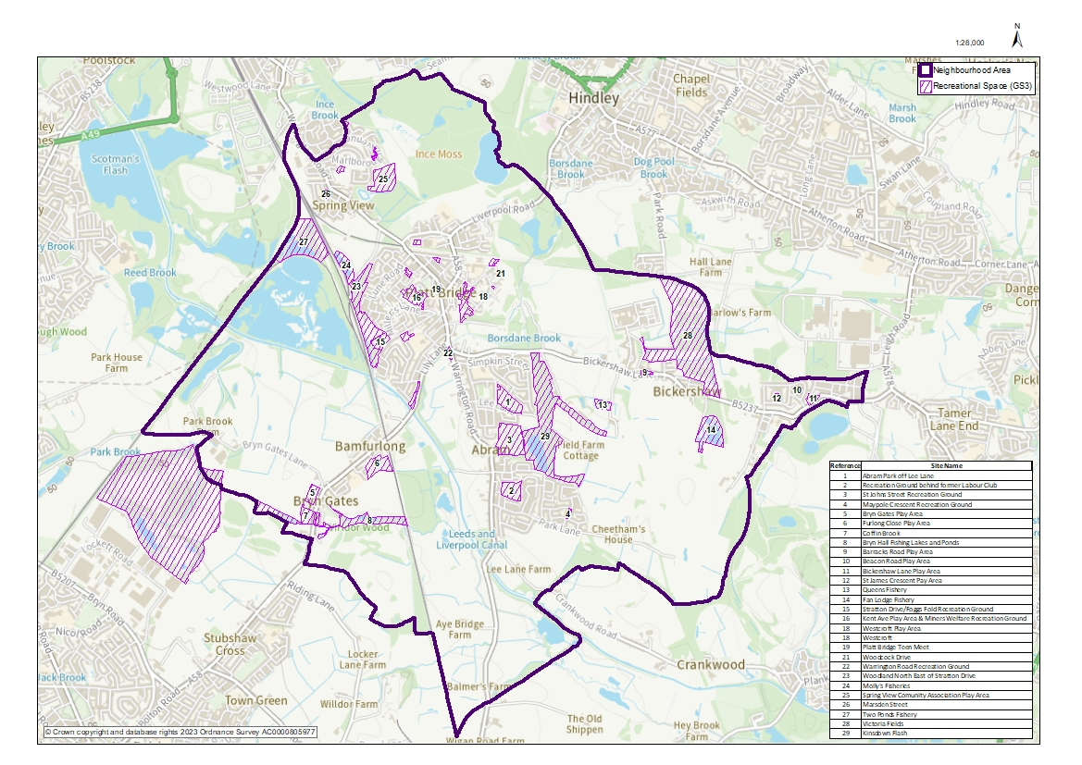
Figure 10 - Amenity Greenspace and Recreational Space

Open Spaces and Recreation
The Neighbourhood Plan identifies four other key green spaces in the Neighbourhood Area, identified in Wigan Council’s Open Space, Sport and Recreation Provision and Needs Assessment as Natural and Semi-Natural Greenspace. These are:
- Victoria Fields;
- Viridor Woods;
- Kingsdown Flash [known locally as Polly’s Pond]
- Platt Bridge Community Green.
Farming and Coal Mining have been important to the Neighbourhood Area. There are a number of designated rights of way (Abram Ward Baseline Evidence paragraph 7.16) and many other footpaths and bridle-paths leading through and across the countryside surrounding the five villages. Additionally, the Leigh Branch of the Leeds Liverpool canal is part of Wigan’s Greenway Network (Abram Ward Baseline Evidence paragraph 3.12). The Neighbourhood Plan aims for local people in the Neighbourhood Area to be able to easily access these local nature reserves and other green spaces. Improving connectivity between the villages will improve local people’s connection to local nature reserves and other green spaces in the Neighbourhood Area, which the Placed Consultation identified a need for (Placed Consultation 2018 page 15). Walking and cycling in and around these green spaces and from one village to another was also identified in the Placed Consultation as very important to local people and is key to enhancing and maintaining local people’s physical and mental health. The Neighbourhood Plan also aims for those living elsewhere in the borough and further afield across the region to recognise and appreciate these landscapes for themselves.

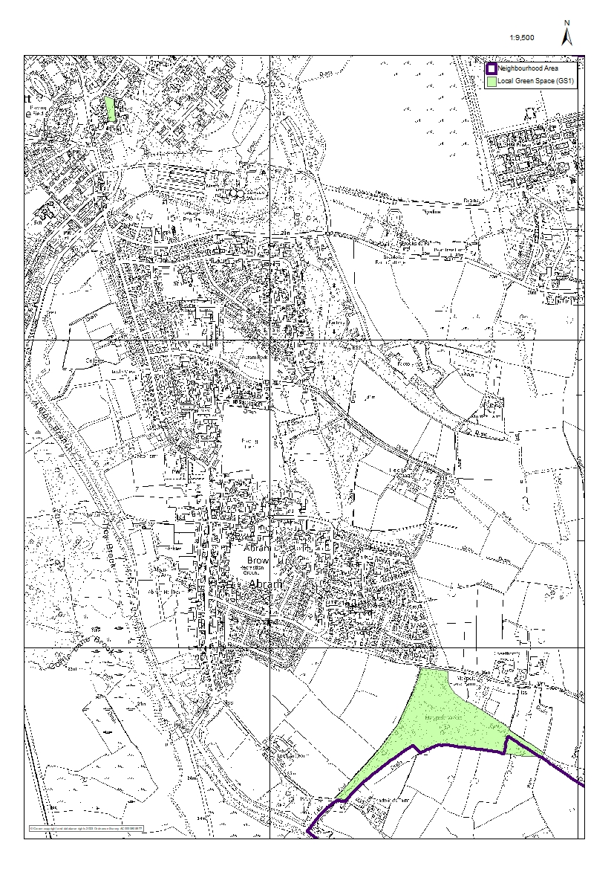
Figure 11 - Local Green Space Designation

Policy GS1: Local Green Space
- The following spaces are designated as Local Green Spaces:
  - LGS1: Maypole Wood,
  - LGS2: Platt Bridge Community Green;
- Development must not encroach onto Local Green Spaces, unless it comprises small-scale development to enhance the community use of the space and it does not compromise the open or green character.
- Development must not have any detrimental impact on the special community value, amenity, safety or accessibility of Local Green Space.

Interpretation:
The National Planning Policy Framework 2023 makes clear that LGS designation introduces similar levels of protection to that for green belts. However, it should be noted that the purposes for LGS and Green Belt are quite different.
Small scale development that would enhance LGS could include seating, play space or sports facilities.
The requirement not to have any detrimental impact on the special community value, amenity, safety or accessibility of Local Green Space applies to development in and around the LGS.

Policy GS2: Proposed Green Corridor
- Development must not disrupt or compromise the identified area for the proposed green corridor (Figure 9) or have any detrimental impact on its amenity, safety or accessibility.

Interpretation:
The policy protects the Neighbourhood Area’s strategic green space network, recognising its importance in terms of movement, nature conservation, wildlife, biodiversity and supporting healthy lifestyles.

Policy GS3: Recreational and Green Spaces
- Development should not harm the area’s parks, recreation spaces, play areas and fishing ponds, including any significant adverse impact on their community use, amenity, safety or accessibility.
- Development should take opportunities to enhance parks, recreation spaces, play areas and fishing ponds and their settings.

Interpretation:
The policy applies to all parks, recreation spaces, play areas and fishing ponds, including the following in particular:
- Abram
  - Abram Park, off Lee Lane,
  - Recreation ground behind former Labour Club,
  - St Johns Street Recreation Ground,
  - Kingsdown Flash [locally known as Polly’s Pond],
  - Maypole Crescent Recreational ground;
- Bamfurlong
  - Bryn Gates Play Area,
  - Furlong Close Play Area,
  - Coffin Brook,
  - Bryn Hall Fishing Lakes and Ponds;
- Bickershaw
  - Barracks Road Play Area,
  - Beacon Road Play Area,
  - Bickershaw Lane Play Area,
  - Fan Lodge Fishery,
  - Queens Fishery,
  - St James Crescent Play Area,
  - Victoria Fields;
- Platt Bridge
  - Stratton Drive/Fogg Folds Recreation Ground,
  - Kent Avenue Play Area,
  - Neville Street Play Area,
  - Westcroft Play Area,
  - Platt Bridge Teen Meet,
  - Scafell Grove Recreation Ground,
  - Woodcock Drive Recreation Ground,
  - Miners Welfare Recreation Ground,
  - Warrington Road Recreation Ground,
  - Woodland Northeast of Stratton Drive (AB/WL/18 on Open Space, Sport and Recreation Provision and Needs Assessment),
  - Molly’s Fisheries;
- Spring View
  - Spring View Community Association Play Area (Repton Avenue),
  - Taylors Lane recreation grounds,
  - Two Ponds Fishery

Sustainable Design

Purpose
To ensure development is well designed and sustainable.

Rationale and Evidence
This feeds into the Housing and Planning Alignment with Policy Frameworks.
Housing character differs within each of the five villages, although all feature Victorian terraces. Developments in the last 40 years have clarified no overall typical housing typology in any of the villages, however Places for Everyone [emerging local policy] Policy JP-P 1 (Sustainable Places) states that ‘we aim to become one of the most liveable city regions in the world, consisting of a series of beautiful, healthy and varied places’ and that new development should wherever possible be visually stimulating, creating interesting and imaginative environments which raise the human spirit through the use of green space, public art and quality design, whilst responding to local history and culture. Good quality sustainable building designs that are environmentally friendly, as well as being economically efficient, are key to effectively lowering our carbon footprint that directly effects our environment. The Abram Ward has some areas considered by the Environment Agency as at high risk of flooding; it has areas in Flood Zones 2 (0.1% chance of flooding each year from rivers each year) and 3 (a 1% chance). Places for Everyone [emerging local policy] Policy JP-S 4 (Resilience) and JP-S 5 (Flood Risk and the Water Environment) also identify climate change and surface water run-off as risks for Greater Manchester and the Wigan Borough in particular, with 12% of its properties in high risk areas. It seeks to address these issues by using ‘natural flood management measures that work with natural processes can provide multiple benefits for people and wildlife, helping to restore habitats, improve water quality and reduce soil erosion, as well as lowering peak flows and flash flooding.’
Building for Healthy Life 2020 sets out twelve main considerations under the scheme:
- Connections – integrating the development into the surroundings by reinforcing existing connections and creating new ones. Respecting the land and existing buildings of the site.
- Facilities and services – ensuring the development is near to parks, schools, workplaces, community facilities and so on.
- Public transport – good access to different modes of public transport to reduce dependency on cars.
- Meeting local housing requirements – a mix of houses to meet local demand.
- Character –a place with a locally inspired and unique character.
- Working with the site and its context – making use of the local landscape, climate and existing topography.
- Creating well defined streets and spaces – plots organised to form an attractive development.
- Easy to find your way around – well thought out layout to encourage walking, and making it easy to locate and find things.
- Streets for all – creating streets that can be social spaces and that encourage lower vehicle speeds for safety.
- Car parking – manage parking for residents and visitors so that vehicles do not dominate the streets.
- Public and private spaces – clearly defined areas, well governed and safe.
- External storage and amenity space – providing space for vehicles, cycles, bins and recycling.

Carbon Objectives
The Neighbourhood Plan supports the carbon objectives in Places for Everyone [emerging local policy] Policy JP-S2, whose approach is ambitious and above national requirements, in the following ways:
- Promoting the retrofitting of existing buildings with measures to improve energy efficiency and generate renewable and low carbon energy, heating and cooling.
- Taking a positive approach to renewable and low carbon energy schemes, particularly schemes that are led by, or meet the needs of local communities.
- Increasing the range of nature-based solutions including carbon sequestration through the restoration of peat-based habitats e.g. Amberswood, woodland management, tree-planting and natural flood management techniques.

Energy efficiency and on-site renewable energy
The Neighbourhood Plan aims for energy efficiency and on-site renewable energy by using smart and modern building practices that are available to us without losing the quality of the build. Certain systems can be put in place and are worth considering: Timber frames and SIPs (Structural Insulated Panels) [are very sustainable and environmentally friendly and are a modern building practice using smart building designs]; locally sourced building materials; solar panels; correct insulation; correct recycling; water saving products such as short-flush and rain water harvesting; energy saving lights and sensors; etc. Each of these systems and combinations are key to the carbon footprint reduction target by 2035.
SIPs offer benefits at all levels of building design and construction – for architects, designers and builders, as well as the building residents or occupiers:
- SIPs have many uses, including internal and external walls, floors, and roof surfaces;
- SIPs can be combined with other building materials, such as brick, block, stone, tiles, slate, wood, steel and glass;
- Roof trusses can be eliminated, allowing space under the roof to serve as usable living space.
- SIPs allow a home or office to be constructed much faster than is possible with traditional framing;
- SIPs are structurally superior to traditional wood framing – stronger and less susceptible to shifting;
- SIP-constructed buildings are roughly 50 percent more energy efficient than those constructed with traditional framing
- Buildings constructed with SIPs are airtight and free of drafts and cold areas, equivalent U-values can be achieved with thinner walls;
- Buildings constructed with SIPs are considerably quieter than with traditional framing – SIPs can be an important element in soundproofing design.
- Labour costs are reduced when compared to traditional framing.

Policy DES1: Sustainable Design, Character and Biodiversity
- Development should be well-designed and sustainable and reinforce the locally distinctive character of the area’s villages, built environments and landscapes, meeting the following requirements of this policy, proportionate to the scale and nature of the scheme.
- Development should complement the character of the surrounding townscape in terms of height, scale, massing, and set-back from the road.
- Development within the five villages must complement their urban and industrial character.
- High quality materials should be used to complement the existing palette of traditional local materials and use of recycled materials and materials from sustainable sources are also supported.
- Development should provide convenient pedestrian and cycle links to surrounding paths and footways and allow for easy movement within the site, for people with different levels of mobility.
- Development should provide active frontages (elevations with windows) to streets and spaces and avoid flanking them with high enclosures or blank walls.
- Development should have no detrimental impact on the area’s protected landscapes, wildlife habitats, ecology or biodiversity.
- Development should include positive green design features to reduce carbon use, support wildlife and ecology and create net gain in biodiversity.
- High quality landscape design and greenery should be an integral part of the design and layout of development.
- Discretely sited and screened storage for bins and recycling must be provided, in addition to meeting Policy TM1’s requirement for cycle storage.
- Creative and innovative design will be supported, especially where it incorporates green features and superior environmental performance.

Interpretation:
The policy applies according to the scale and nature of the scheme. For example, some parts of the policy clearly only apply where new roads and layout are being created. The five villages are Abram, Bamfurlong, Bickershaw, Platt Bridge and Spring View and all have their own distinctive character. Complementing height should take account of the predominantly 2-3 storey character of the area. This would not prevent one story development in appropriate locations. The requirement to complement urban and industrial character should not be interpreted as imposing the act of copying older buildings, but in complementing the existing townscape character and functional character of buildings. Local materials include brick, plain clay tiles, terracotta and stone.
Green design is strongly encouraged, both in terms of buildings and landscaping. Green features could include things like living walls. Green roofs, locally sourced building materials, materials with low embodied energy, solar panels, material with superior insulation properties; recycling facilities; water saving products such as short flush and grey water recycling; smart home systems for lighting, heating and power.
Design and access statements, where required, should demonstrate how the requirements of this policy and policies TM1 and TM2 have been met.

Transport and Movement

Purpose
To create more sustainable work/life patterns, supported by a range of community facilities and local employment opportunities, which support economic development, sustainable growth and healthy active people.

Rationale and Evidence
This feeds into the Environment, Health and Wellbeing Alignment with Policy Frameworks and the Economic Development Alignment with Policy Frameworks.
The Neighbourhood Area’s five villages have had distinct histories and identities, however the success of the Neighbourhood Plan will be in working together and sharing resources to improve the Neighbourhood Area as a whole, including being better connected. Wigan Council reports that the borough as a whole has high rates of commuting out of the borough for work (Abram Ward Baseline Evidence paragraph 7.14), having no train station and a poor bus service. Greater Manchester Transport Strategy 2040 reports that the Abram Ward does not score highly for access to public transport, therefore most local people use private cars to travel around the area, into Wigan centre and to other neighbouring areas. The 360 bus service provides half hourly services to Wigan, Golborne, Newton-le-Willows (including the rail station) and Warrington, however this only serves Platt Bridge and Abram.
The Abram Ward is one of 25 wards in the Wigan Borough and is located at the borough centre, covering an area of nearly 13 square kilometres (approximately 8 square miles). The Abram Ward’s five settlements [Abram, Bamfurlong, Bickershaw, Platt Bridge and Spring View] are positioned equidistant between the Wigan Borough’s two main towns [Wigan and Leigh]. The five villages are almost completely surrounded by Green Belt and much of this open land comprises green spaces that are attractive and bio-diverse. The Abram Ward is well positioned in the Wigan Borough as a convenient place to live, for an easy commute within the borough or to the surrounding cities of Manchester, Liverpool or Preston, however this is only true for residents with easy access to a car.
There are two key arterial A roads passing through and connecting the five settlements to each other and to other areas. They form a key junction through the central village of Platt Bridge. The A537 leads from the A580 through Abram, Platt Bridge and Spring View to Lower Ince and then on to Wigan town centre; the A58 links the M6 to Ashton-in-Makerfield, Hindley and Bolton; the B5237 connects the A537 to Bickershaw, then south to Leigh or north to Hindley Green. The main roads [A58, A573 and B5237] are very busy throughout the area and key junctions get very congested during morning and evening rush hours and school-run times [especially as the Neighbourhood Area does not have a mainstream secondary school].
Increasing active travel for getting to work, school, shopping and to visit friends and family such as walking and cycling can have a positive impact on physical health and mental wellbeing; this is key to overcoming the Neighbourhood Area’s health challenges and a key feature of Places for Everyone [emerging local policy]’s Policy JP-Strat 14 [A Sustainable and Integrated Transport Network]. Poorly designed cycling infrastructure can make conditions for cycling less safe for cyclists than providing no infrastructure at all. Developers are required to produce well-designed cycling infrastructure, adopting standards set out in the Department of Transport’s guidance ‘Cycling Infrastructure Design’. This policy aims to improve the Neighbourhood Area’s pedestrian and cycle routes and improve active travel to better connect the five villages.
It is important that the streets (pavements and roads) in the Neighbourhood Area are safe and easy to use for all people regardless of age or disability. Increasing connectivity between the five villages will enhance the regular use of businesses in each of the villages. The Placed Consultation reported that people in one village lack awareness of what assets and amenities are available in other villages (Placed Consultation 2018 page 14) and there are concerns that the smaller villages are not as well used as they could be (Placed Consultation 2018 page 15); in recent years this has led to the loss of all but one of Bamfurlong’s shops.
Platt Bridge Community Green Visioning Report identified that Platt Bridge, with its role as the central hub of the Neighbourhood Area, is generally used as a pass-through (Platt Bridge Community Green Visioning Report page 10). Better connections between the five villages using active travel modes will encourage people to stay and use their facilities and amenities, strengthening the whole economy as a result. Enhanced connectivity between the five villages will also create a joint sense of local identity and culture, strengthening social bonds and deepening collective pride in the area. This may also attract new customers to the area.

Abram Ward Circular Walks
ACT Forum members and WLCC have worked with Lancashire Wildlife Trust to develop the new Abram Ward Circular Walks. A series of walks (and cycle routes) have been created, based on a main circular route linking Amberswood Common with Pennington Flash [south of the Neighbourhood Area] via Bickershaw, returning by looping up east of Abram and Platt Bridge. Additional radial paths connect to the five villages and key community facilities (Figure 12 - Abram Ward Circular Walks).
Access to the five villages via Abram Ward Circular Walks:
- Abram [Warrington Road for Abram Brow];
- Bamfurlong [Furlong Close and Bryn Gates Lane for Playing Fields];
- Bickershaw [Bickershaw Lane for Bickershaw Village Community Club];
- Platt Bridge [Liverpool Road for Platt Bridge Centre and Platt Bridge Community Green, Sherwood Way for Platt Bridge Community Zone];
- Spring View [Walthew Lane for Spring View Community Sports Association].
All of the key green spaces in the Neighbourhood Area [and those adjacent] are connected to the Abram Ward Circular Walks:
- Amberswood Common;
- Bickershaw Country Park (in adjacent area) ;
- Ince Moss/Horrock’s Flash;
- Kingsdown Flash;
- Low Hall;
- Maypole Wood;
- Three Sisters [small area within the Neighbourhood Area];
- Pennington Flash [in adjacent area];
- Victoria Fields;
- Viridor Woods;
- Wigan Flashes [adjacent].
At certain points, the Abram Ward Circular Walks link with some of the existing designated rights of way, the Wigan Greenway Network and elements of the existing TfGM cycle networks (including Beelines). The Abram Ward Circular Walks provide significant enhancement of the footpath network, aiding healthy physical activity and creating essential linkages between the five villages and the key green space assets in the Neighbourhood Area.
The Lancashire Wildlife Trust continue to work with landowners and the local authority to enhance the conditions of the paths and open up some closed off routes on the Abram Ward Circular Walks. It is noted by the Lancashire Wildlife Trust that clear signage is generally lacking for the navigation of footpaths and links to villages and community and commercial facilities within the Neighbourhood Area; they will thus support the erection of signage on the Abram Ward Circular Walks to help connect walkers (and cyclists) to the five villages, community facilities and key green spaces such as Amberswood Common. Once local people get used to using the new Abram Ward Circular Walks, they will be inspired to use other paths and make their own journeys using the footpaths, bridleways and cycling networks, thus further enhancing their appreciation of their local area whilst supporting their mental and physical health and wellbeing.
The Abram Ward Circular Walks create a healthy walking option for local people to connect locally to work, school, friends and family, whilst also connecting them to adjacent green spaces in neighbouring areas such as Pennington Flash. The canal path is already well utilised for leisure and travel to work in Wigan centre and considered safe and accessible by local people (Placed Consultation 2018 page 10). This path will be well signposted to inspire local people to branch out onto other parts of the Abram Ward Circular Walks.
Local people have expressed strong interest in green gym equipment being placed around the Neighbourhood Area to give further healthy outdoor physical exercise for local people. Proposed Green Gyms sites in Bamfurlong (Bryn Gates Play Area), Bickershaw (Bickershaw Village Community Club) and Platt Bridge (Platt Bridge Community Green) can be found in the Policies Map section.
The Sustrans cycle route 55 runs along the northeast edge of the Neighbourhood Area, very close to the Abram Ward Circular Walks, Victoria Fields and Bickershaw. This route is in development leading to Wigan and Manchester and has the potential to be linked to the Abram Ward Circular Walks with signage [both physical and online].
The Abram Ward Circular Walks will also support an increase in local and regional tourism into the area. Although the Abram Ward is part of the Greenheart Regional Park, it doesn’t currently have any local or regional tourism making up its local economy. The Abram Ward is frequently an area which people drive through without stopping to use local community or commercial facilities. The Abram Ward Circular Walks will offer a strong reason to travel to the Neighbourhood Area. The main circular route is 10 km long and local and regional walkers wishing to explore the area and appreciate the beauty and diversity of the habitats will visit the neighbourhood. This will also strengthen the local economy through use of local shops and cafes.
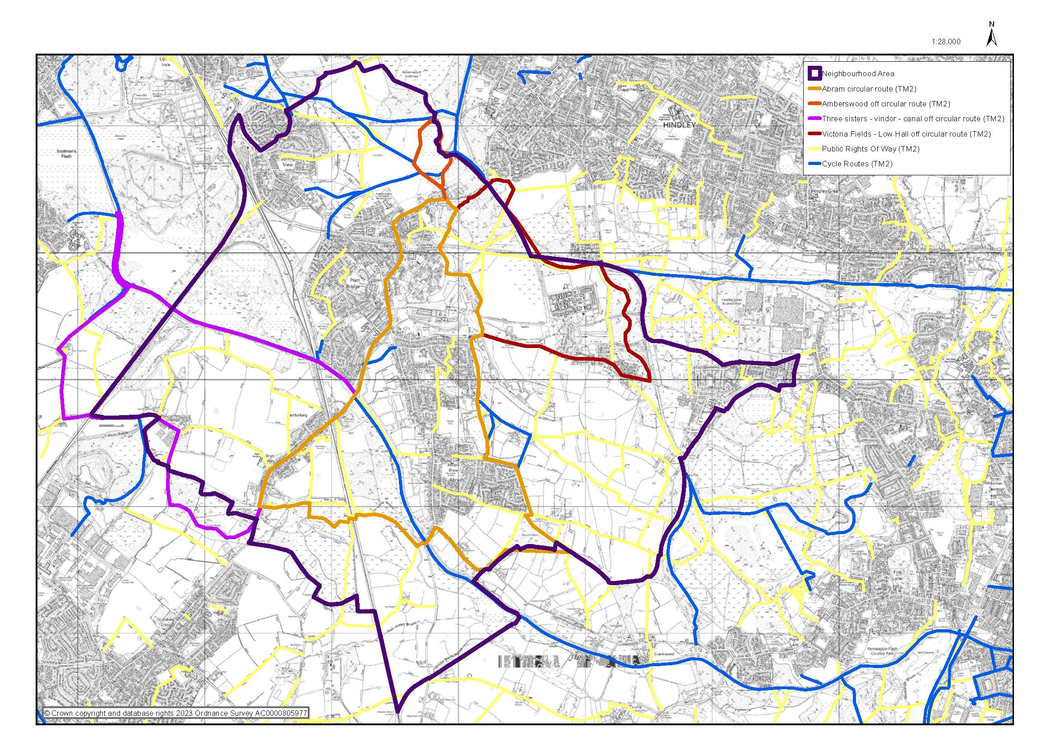
Figure 12 - Abram Ward Circular Walks

Policy TM1: Transport and Movement
- Development must be supported by an adequate and balanced range of transport provision, including sustainable forms of transport, proportionate to the scale and nature of the development.
- The layout of development must prioritise pedestrian convenience and safety, also meeting the requirements of Policy DES1.
- Development likely to generate additional journeys must include secure and covered storage for cycles, including for all new dwellings, and shower and changing facilities where new employment is being created.
- Transport infrastructure should be designed to help create a high-quality public realm and sense of place.
- Drives and parking spaces should be surfaced using water permeable materials or be served by appropriate sustainable urban drainage systems.
- Parking areas should include vehicle charging points, with smart charging functionality.

Interpretation:
The policy requires developers to consider sustainable forms of transport and walking and to avoid a narrow focus on motor vehicles.
The requirements to prioritise pedestrian convenience and create a high-quality public realm should be applied in conjunction with Policy DES1. Transport infrastructure forms part of the public realm, so it is necessary to consider amenity and quality of place, not just highway standards.
Design and access statements, where required, should demonstrate how the requirements of this policy and Policies TM2 and DES1 have been met.

Policy TM2: Footpaths and Cycleways
- Development should not encroach onto footpaths or cycleways unless it can be demonstrated that it can be effectively rerouted or replaced to an equivalent or improved standard.
- Development should have no significant adverse impact on the amenity, safety or accessibility of footpaths or cycleways.
- Enhancements to the Abram Ward Circular Walks, including improved accessibility by walking and cycling, will be supported.
- Development proposals which restrict pedestrian and cycling access into the villages from the Abram Ward Circular Walks will not be supported.

Interpretation:
The policy protects footpaths and cycleways and seeks to avoid adverse impacts from adjacent or nearby development.
Examples of harm to the amenity or safety of footpaths could include placing high fences or enclosures adjacent to them, creating poor amenity and lack of surveillance.

Infrastructure Priorities
In the use of planning infrastructure monies, this Neighbourhood Plan would suggest the following priorities:
- Improvement to cycle and pedestrian paths, including stronger links to the Abram Ward Circular Walks, and cycle parking;
- Additional bus stops;
- Improvements to signage, especially to the Abram Ward Circular Walks;
- Support to improve community facilities, especially business hubs.

Purpose
To create more sustainable work/life patterns, supported by a range of community facilities and local employment opportunities, which support economic development, sustainable growth and healthy active people.

Rationale and Evidence
This feeds into the Economic Development Alignment with Policy Frameworks.
There is a strong association with deprivation and the density of fast-food outlets. In 2015 it was identified that the Abram Ward was significantly worse than England as a whole in the areas of income deprivation, child poverty and older people in deprivation. Platt Bridge Business Premises Report identified that 17% of all business premises (9 premises) in Platt Bridge are in the A5 (Hot Food Takeaway) use class. The Neighbourhood Plan thus supports the control of hot food takeaways in the Neighbourhood Area, due to serious concerns about the general population’s health in the area and especially the health of children and young people in the Abram Ward (Abram Ward Baseline Evidence paragraph 5.3).
Hot food takeaway businesses, which only open at night and have closed shutters during the day, have a negative impact on the vitality of commercial zones. Platt Bridge Business Premises Report identified that of 61 business premises in Platt Bridge Centre only 2 were in the A3 (Restaurant and Cafes) use class, with only one of these being an active business. Increasing the number of sit-down eating options for families, shoppers and commuters, which open throughout the day and into the evening, will help enliven Village Commercial Zones by increasing dwell time in the villages and thus strengthening the local economy. The Placed Consultation reported that local people felt an increase in community cafes would support the strengthening of the local economy. They also commented on a lack of diverse food options, the need for places for families to eat in the evenings and the need for more social spaces.

Business premises developments and job opportunities
The ACT Forum strongly supports the growth and development of small businesses of all types [private, local, independent, social enterprises and community businesses] throughout the Neighbourhood Area. The Abram Ward has lower employment than other parts of Wigan and England as a whole, with local residents also having significantly lower educational attainment than other parts of Wigan and England as a whole. However, a higher percentage are in manual and skilled trades than in the rest of Wigan and England as whole (Abram Ward Baseline Evidence paragraph 7.3). WLCC’s community wealth building approach, through its Made in Wigan programme, is to encourage local people to repurpose their practical skills towards working in or running new social businesses, which also benefit the local community.
The Neighbourhood Plan seeks to encourage local independent and community business and social enterprises to set up and relocate in the Neighbourhood Area, to increase local jobs and training opportunities. This will begin to address the decline in business premises in each of the five villages in line with national trends, as part of a strategy to strengthen the local economy and create jobs and training opportunities.
The Neighbourhood Plan also aims to encourage new businesses to expand, set up and/or relocate to the Neighbourhood Area to occupy existing retail and service premises, workshops and processing/production facilities. Platt Bridge Business Premises Report reported that currently only 8% of business premises in Platt Bridge are in the B1 (Business Light Industry) use class.
The Neighbourhood Plan recognises expanding businesses may need additional production, storage and servicing facilities. It is a concern that there are a number of vacant and sometimes derelict premises in the Neighbourhood Area (particularly identified in the Platt Bridge Business Premises Report), where ownership of the site is unknown locally. These premises are unused assets, which could be benefitting the community and supporting the building of a stronger local community.

Delivering the Plan
The Neighbourhood Plan’s vision and objectives will be achieved by the implementation of policies as planning proposals are brought forward and will be considered and determined by Wigan Council Local Planning Authority.
Delivery of the Plan will require private investment from landowners and developers. It is hoped that the Plan aligns with the delivery of future planned infrastructure proposals from Wigan Council, Transport for Greater Manchester and Greater Manchester Combined Authority.

