ACT Neighbourhood Plan

Local Green Space Assessment

Introduction
The National Planning Policy Framework 2023 created a new designation of ‘Local Green Space’.
Local Green Space (LGS) designation allows local communities to protect green spaces of local importance for reasons including setting and nature conservation. Local communities can identify green spaces through their local and neighbourhood plans, which will then receive protection equivalent to Green Belt land.
If planning permission has already been granted for the land, it is not normally possible to designate it as Local Green Space. If the space already has a designation, such as a site of special scientific interest, consideration will be given if an additional designation would add any local benefit.
In order to qualify as a Local Green Space, the green area must meet the criteria set out in the National Planning Policy Framework 2023. There is no set distance for how close the green space needs to be to the local community, or the minimum size, which will depend on local circumstances. The management responsibilities for the LGS are with the landowner and no specific restrictions or obligations are placed on the landowner with the designation.
National Planning Policy Framework 2023 paragraph 76 states: “Local communities through local and neighbourhood plans should be able to identify for special protection green areas of particular importance to them. By designating land as Local Green Space local communities will be able to rule out new development other than in very special circumstances.
Identifying land as Local Green Space should therefore be consistent with the local planning of sustainable development and complement investment in sufficient homes, jobs and other essential services. Local Green Spaces should only be designated when a plan is prepared or reviewed and be capable of enduring beyond the end of the plan period.”
Abram Ward Communities Together (ACT) Neighbourhood Plan identifies two sites in the Neighbourhood Area that can be designated as Local Green Space and two further greenspace sites to be protected by Policy GS3 in the Neighbourhood Plan, chosen through study and consultation with the local community. Each fulfils the requirements of the National Planning Policy Framework 2023 guidelines as outlined in the evidence below.
The sites identified within the Neighbourhood Area (see Map A) highlighted in green are:
- LGS1: Maypole Wood
- LGS2: Platt Bridge Community Green
- Kingsdown Flash [known locally as Polly’s Pond]
- Victoria Fields
Information on the four sites is outlined as well as how each of the sites complies with the National Planning Policy Framework 2023 criteria in qualifying it for LGS status. There are no pending planning applications on any of the four sites.

National Policy
The National Planning Policy Framework 2023 sets out the criteria for designating Local Green Space, as follows:
101. The designation of land as Local Green Space through local and neighbourhood plans allows communities to identify and protect green areas of particular importance to them. Designating land as Local Green Space should be consistent with the local planning of sustainable development and complement investment in sufficient homes, jobs and other essential services. Local Green Spaces should only be designated when a plan is prepared or updated and be capable of enduring beyond the end of the plan period.
102. The Local Green Space designation should only be used where the green space is:
- in reasonably close proximity to the community it serves;
- demonstrably special to a local community and holds a particular local significance, for example because of its beauty, historic significance, recreational value (including as a playing field), tranquillity or richness of its wildlife; and
- local in character and is not an extensive tract of land.
103. Policies for managing development within a Local Green Space should be consistent with those for Green Belts.

Analysis of Sites
The Neighbourhood Plan identifies four key green spaces in the Neighbourhood Area, two of which are identified in Wigan Council’s Open Space, Sport and Recreation Provision and Needs Assessment as Natural and Semi-Natural Greenspace.
These are:
- LGS1: Maypole Wood
- LGS2: Platt Bridge Community Green
- Kingsdown Flash [known locally as Polly’s Pond];
- Victoria Fields.
Farming and Coal Mining have been important to the Abram Ward. There are a number of designated rights of way (Abram Ward Baseline Evidence, paragraph 7.16) and many other footpaths and bridlepaths leading through and across the countryside surrounding the five villages.
Wigan Councils’ Open Space, Sport and Recreation Provision and Needs Assessment characterises Victoria Fields as a Natural and Semi-Natural Open Space and Maypole Wood as Woodland. The Neighbourhood Plan designates pieces of land as Local Green Spaces due to their significance as a green space close to the community these spaces serve, people living and working in Bickershaw and in Abram. This aims to ensure that local people will have ongoing access to high quality green spaces. Victoria fields is a former colliery site, which has been restored back to natural landscape and is managed in part by local groups and organisations including Bickershaw Village Residents’ Association; it creates a key corridor between Low Hall and Bickershaw Country Park. It is adjacent on its eastern edge to Barlow Moor SBI. Maypole Wood is a former site that has partly been used for colliery waste, clay brick production and rail transportation for coal and is managed by Abram Woodland & Wildlife Conservation Group; it forms a link between Bickershaw Country Park and the SSSIs. All sites are regularly used by local people for recreation and walking and form part of the Abram Ward Circular Walks; they hold special significance for local people, due to their heritage as former industrial sites in each of the villages, which remain of strong significance to local people whose families worked there.

Green Space Designations

Key for Maps
Greenspace Site
Neighbourhood Boundary

The Abram Ward
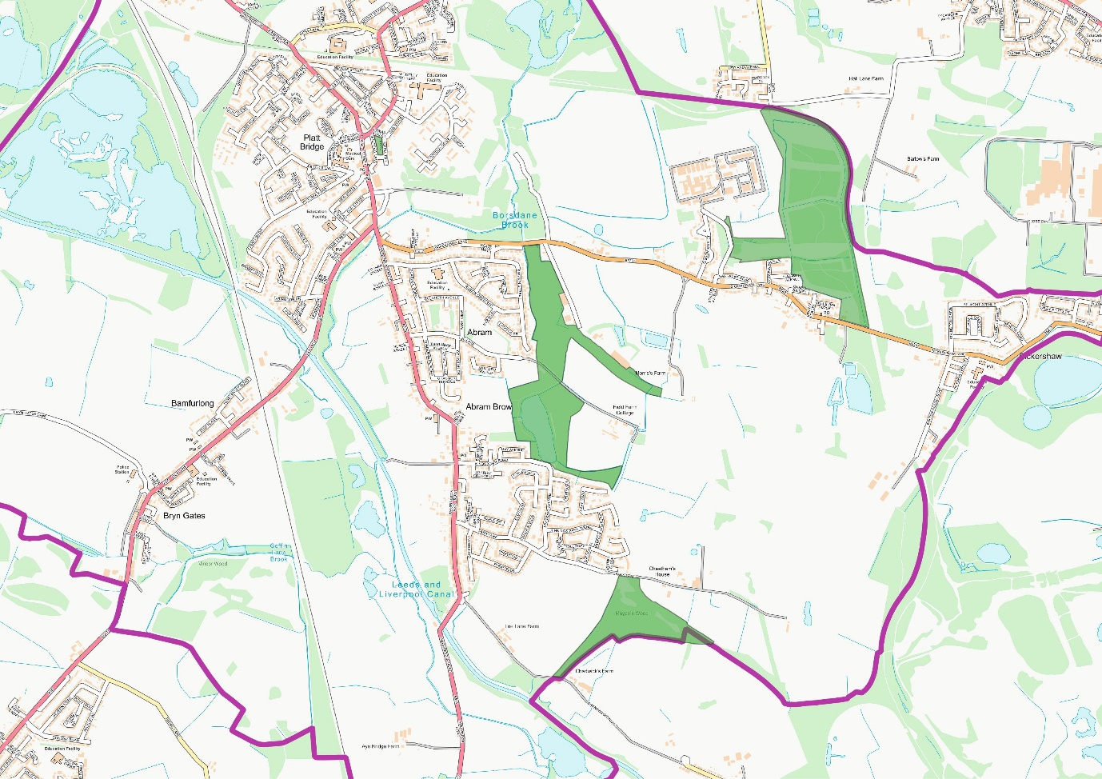
Map A: The ACT Neighbourhood Area

LGS1: Maypole Wood
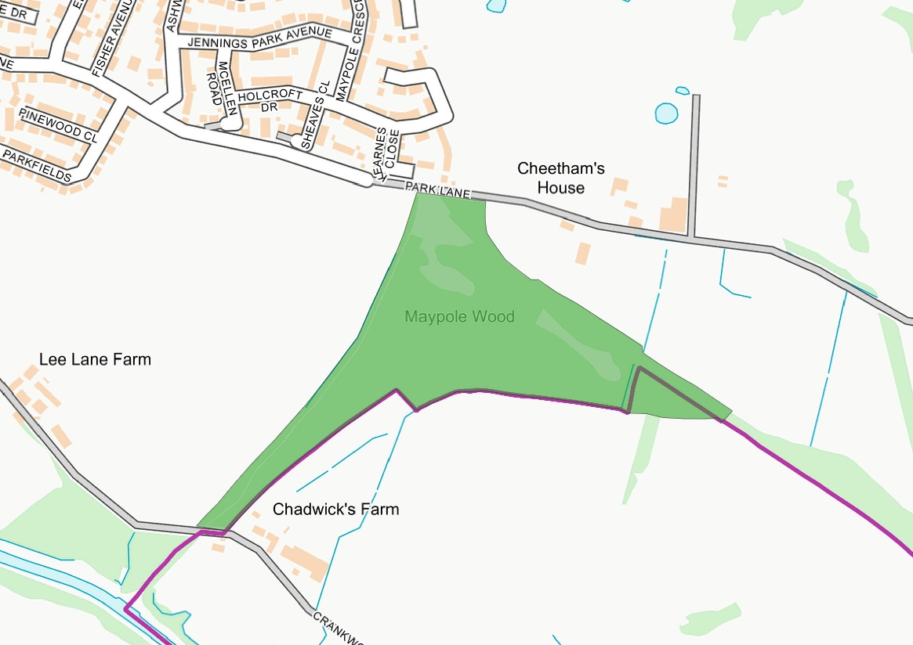
Map B: Maypole Wood

LGS2: Platt Bridge Community Green
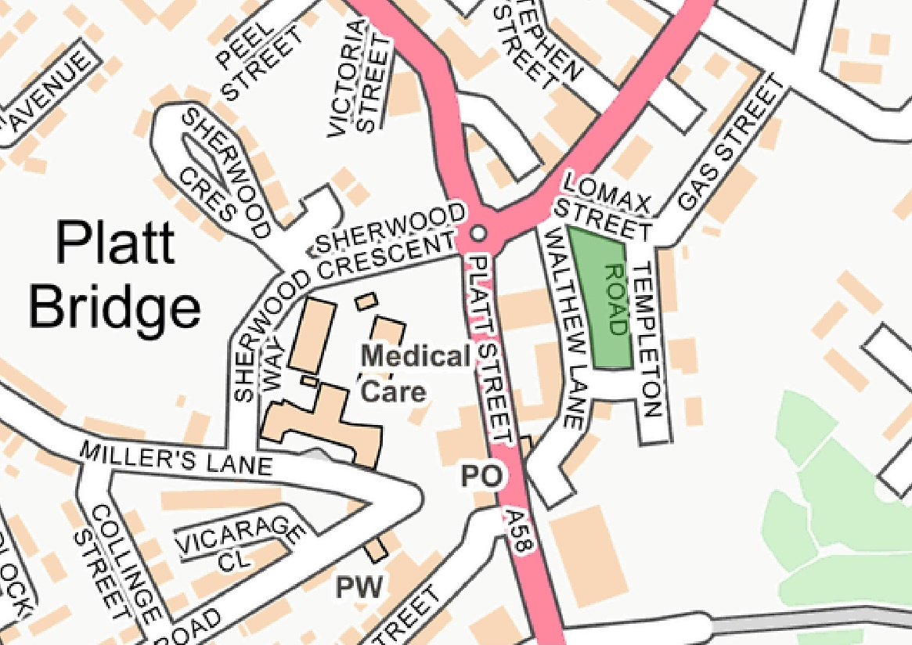
Map C: Platt Bridge Community Green

Kingsdown Flash [known locally as Polly’s Pond]
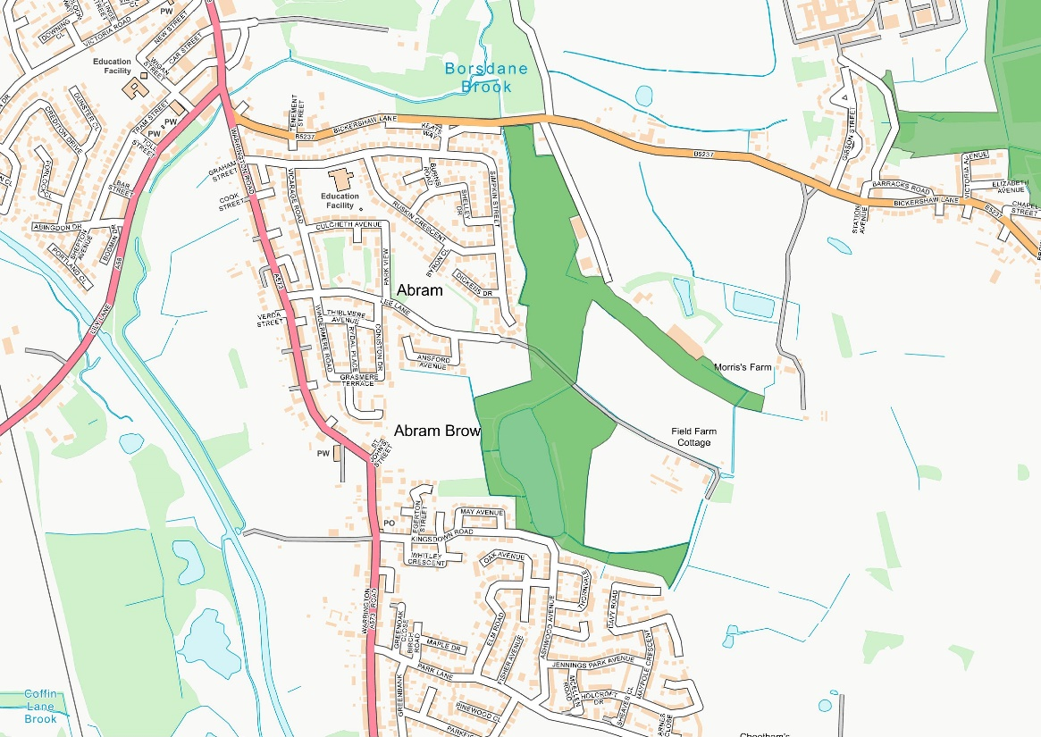
Map D: Kingsdown Flash [known locally as Polly's Pond]

Victoria Fields
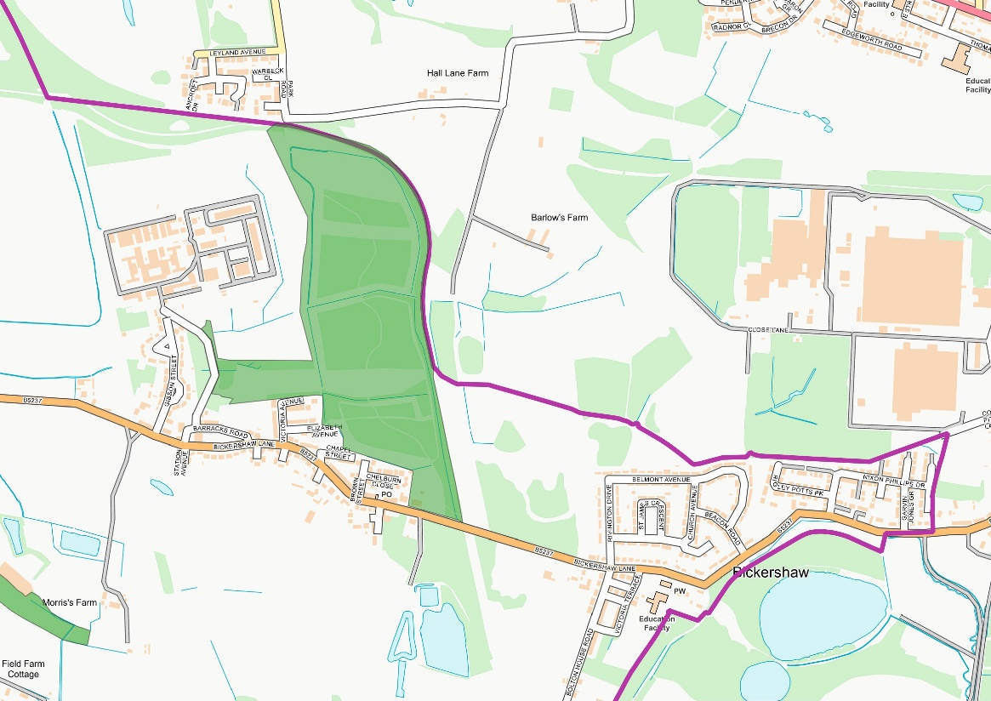
Map E: Victoria Fields

Community Value
The Neighbourhood Area has a wide range of attractive, accessible green spaces. The area is at the centre of Wigan’s countryside “The Greenheart”. There are two Sites of Special Scientific Interest (SSSIs), seven Sites of Biological Importance (SBIs) and four areas within the Flashes of Wigan and Leigh National Nature Reserve (NNR).
These green spaces play an important role in providing Wigan’s essential Green Infrastructure. Many of them form important wildlife habitats and the neighbourhood forms a key role in Wigan’s ecological network, being part of the Greater Manchester Wetlands area and the Carbon Landscape Project.
Abram Ward is mainly within the Green Belt and is fully within the Greenheart and the Greater Manchester Wetlands area (Abram Ward Baseline Evidence, paragraphs 3.2 and 3.6). It has a diverse range of habitats [many of which are restored landscapes] including grasslands, woodlands and wetlands. This is a network of key Green Infrastructure which provides resilience to climate change and key local and regional ecological habitats, offering green corridors for insects, birds and small mammals, some of which are rare and endangered (Abram Ward Baseline Evidence, section 3).

Suitability for LGS Designation

LGS1: Maypole Wood
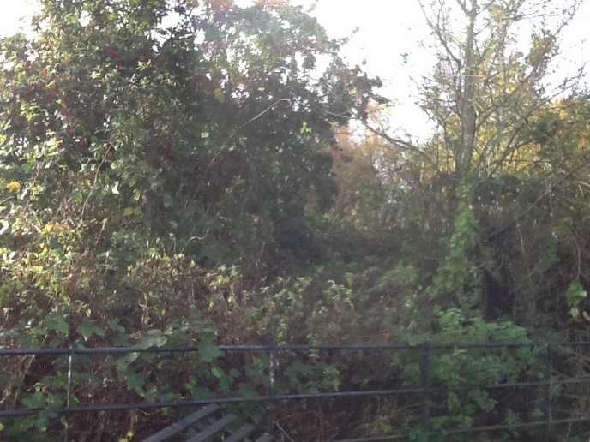

Located on Park Lane which connects to the A573 Warrington Road in Abram.
Wigan Council’s Open Space, Sport and Recreation Provision and Needs Assessment characterises Maypole Wood as woodland.
Maypole Wood is a former site that has been used for colliery waste, clay brick production and rail transportation for coal and is managed by Abram Woodland and Wildlife Conservation Group.
Maypole Wood is regularly used by local people for recreation and walking and form part of the Abram circular walks.
This area holds special significance for local people, due to the heritage and contributes significantly to Wigan’s woodland assets.
There is a tradition of Morris Dancing in the area and there is a fenced off dedicated ground on Park Lane, Abram near to Maypole Wood.
Maypole Wood has prime Willow Tit habitat and is already functioning as a habitat corridor. Nightjar and numerous bat species have been sighted in the area.
Maypole Wood is in an excellent position to encourage locals and visitors to engage with wildlife and conservation.
In relation to the National Planning Policy Framework 2023 criteria “where the green space is in reasonably close proximity to the community it serves”, the site is in close proximity to the community. In relation to the National Planning Policy Framework 2023 criteria “where the green area is demonstrably special to a local community and holds a particular local significance, for example because of its beauty, historic significance, recreational value, tranquillity or richness of its wildlife”, the site fulfils all these aspects.

Special Community Value | The space is of special community value, as described above.
Area of Space (Ha) | 7.811Ha
Planning Permissions or Site Allocations | None
Other Designations | In relation to the National Planning Policy Framework 2023 criteria “where the green area is demonstrably special to a local community and holds a particular local significance, for example because of its beauty, historic significance, recreational value, tranquillity or richness of its wildlife”, the site fulfils all these aspects.
Not an Extensive Tract of Land | In relation to the National Planning Policy Framework 2023 criteria “where the green area concerned is local in character and is not an extensive tract of land”, the site fulfils these aspects.
Close to the Community it Serves | The area is a valuable site to the community and provides much-needed recreational space to the nearby populations in the area. It is rich in wildlife and well used by residents and visitors.

LGS2: Platt Bridge Community Green
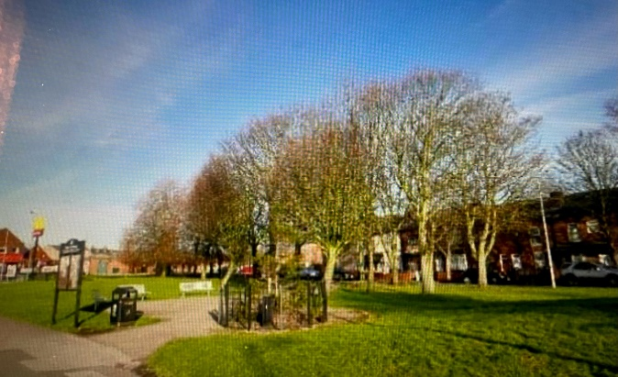
Located in Platt Bridge centre and access from Liverpool Road and Warrington Road.
Platt Bridge Community Green is positioned in the centre of Platt Bridge’s shopping area (Figure 8), surrounded to the East and South by residential housing, and to the North and West by business premises.
Community Green was created following the regeneration of Platt Bridge Centre in 2011.
A visioning exercise was held in 2019 which identified six benefits:
- Promotes a sense of comfort
- Creates improved accessibility
- Builds and supports the local economy
- Social interaction
- Promotes health
- Nurtures and defines a sense of community
The project has identified that the community are keen to see the Community Green redesigned as a flexible space able to provide a centrally located outdoor space for an occasional or regular community market, which would bring people into the ward to shop at the market, socialise together and boost footfall at the businesses in Platt Bridge Centre.
National Planning Policy Framework 2023 criteria “where the green area is demonstrably special to a local community and holds a particular local significance, for example because of its beauty, historic significance, recreational value, tranquillity or richness of its wildlife”, the site fulfils the aspect of recreational value.

Special Community Value | The space is of special community value, as described above.
Area of Space (Ha) | 1.593 Ha
Planning Permissions or Site Allocations | None
Other Designations | In relation to the National Planning Policy Framework 2023 criteria “where the green area is demonstrably special to a local community and holds a particular local significance, for example because of its beauty, historic significance, recreational value, tranquillity or richness of its wildlife”, the site fulfils all these aspects.
Not an Extensive Tract of Land | In relation to the National Planning Policy Framework 2023 criteria “where the green area concerned is local in character and is not an extensive tract of land”, the site fulfils these aspects.
Close to the Community it Serves | The area is a valuable site to the community and provides much-needed recreational space to the nearby populations in the area. It is rich in wildlife and well used by residents and visitors.

Kingsdown Flash (known locally as Polly’s Pond)
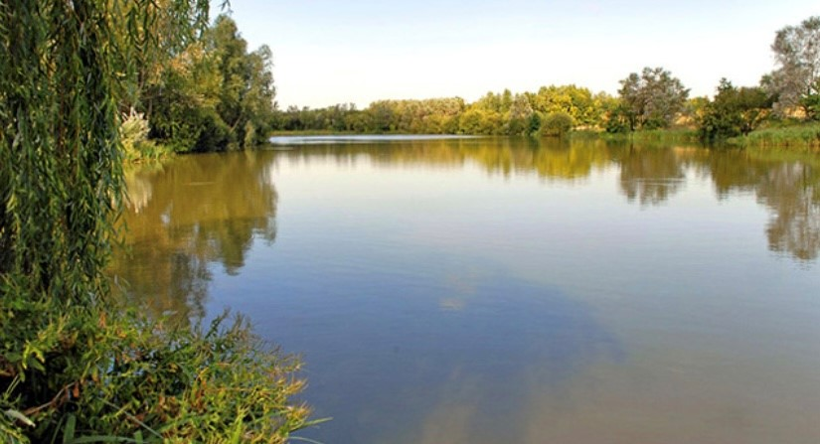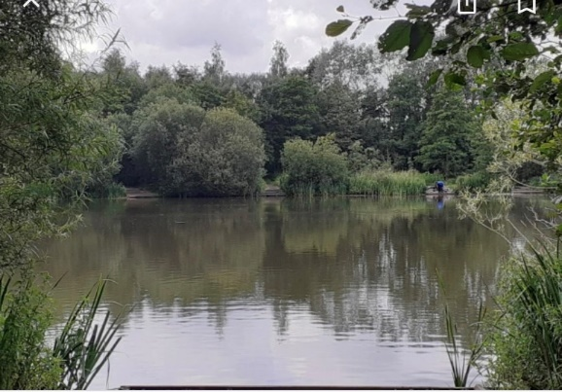
Located near Lee Lane and Kingsdown Road, both connecting to the A573 Warrington Road in Abram.
A narrow stretch of woodland forms a woodland corridor connecting the woods at Maypole to Polly’s pond.
Polly’s pond can be accessed from Bickershaw Lane through the public footpaths connecting Bickershaw and Abram through natural woodland.
The site has value in terms of wildlife and biodiversity.
Fishing takes place at Polly’s Pond which adds to the importance of activities linked to mental wellbeing.
Polly’s Pond is an important connectivity link in the area.
Polly’s Pond is an area of natural beauty and is well used by local people from the surrounding housing estates and visitors.
In relation to the National Planning Policy Framework 2023 criteria “where the green space is in reasonably close proximity to the community it serves”, the site is in close proximity to the community. In relation to the National Planning Policy Framework 2023 criteria “where the green area is demonstrably special to a local community and holds a particular local significance, for example because of its beauty, historic significance, recreational value, tranquillity or richness of its wildlife”, the site fulfils all these aspects.

Special Community Value | The space is of special community value, as described above.
Area of Space (Ha) | 19.055Ha
Planning Permissions or Site Allocations | None
Other Designations | In relation to the National Planning Policy Framework 2023 criteria “where the green area is demonstrably special to a local community and holds a particular local significance, for example because of its beauty, historic significance, recreational value, tranquillity or richness of its wildlife”, the site fulfils all these aspects.
Not an Extensive Tract of Land | In relation to the National Planning Policy Framework 2023 criteria “where the green area concerned is local in character and is not an extensive tract of land”, the site is too large to fulfil these aspects.
Close to the Community it Serves | The area is a valuable site to the community and provides much-needed recreational space to the nearby populations in the area. It is rich in wildlife and well used by residents and visitors.

Victoria Fields
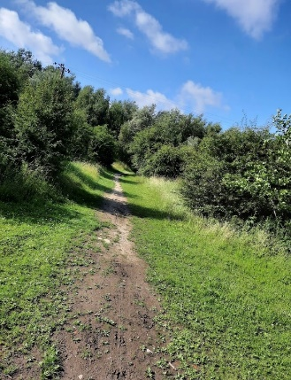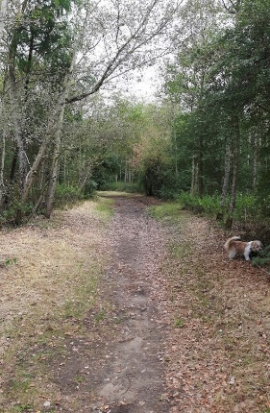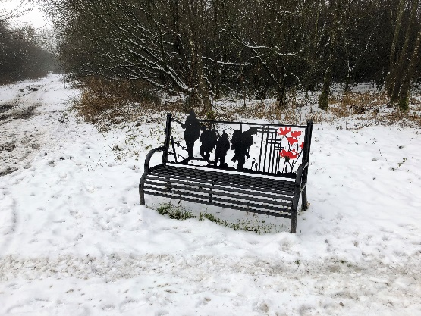

Located on road B5237 Bickershaw Lane which connects to the A573 Warrington Road in Abram.
Wigan Council’s Open Space, Sport and Recreation Provision and Needs Assessment characterises Victoria Fields as a Natural and Semi-Natural open space.
Area of natural beauty and appealing to walkers/cyclists and bridle pathways.
The open space is part of Bickershaw’ s heritage from the farming land to its coal mining history as Victoria Fields is a former colliery site, which has been restored back to natural landscape.
Part of the Jubilee way in 2016 and improved the walkways within Victoria Fields to enjoy and improve health and fitness. This site is special to local people and holds local significance and encourages visitors from surrounding areas.
The community worked with an arts group to develop and install a creative and environmental space for outdoor community events. Increasing health, wellbeing and connection with nature. A community garden area has also been created that is enjoyed for periods of reflection and local community groups encouraged to support the maintenance and upkeep of this area. Community events and trails are held which reflect the seasons.
A willow sculpture trail has been installed to encourage all ages to spot the sculptures hidden amongst the trees and information board about the wildlife and fauna to be found.
To celebrate the centenary of WW1 a heritage trail was developed with research undertaken by community groups and placed within Victoria Fields with WW1 commemorative benches and information board to remember the lives of the young men from Bickershaw.
The site is owned by Wigan Metropolitan Borough Council (Wigan MBC). The local authority local plan designation is ‘Recreational Open Space’.
The site has value in terms of wildlife and biodiversity.
Part of the site runs parallel to a former railway which was the main line to Bickershaw Colliery.
In relation to the National Planning Policy Framework 2023 criteria “where the green space is in reasonably close proximity to the community it serves”, the site is in close proximity to the community. In relation to the National Planning Policy Framework 2023 criteria “where the green area is demonstrably special to a local community and holds a particular local significance, for example because of its beauty, historic significance, recreational value, tranquillity or richness of its wildlife”, the site fulfils all these aspects.
It is well used by walkers, cyclists and horse riders and during the Covid pandemic rock trails were created.
In relation to the National Planning Policy Framework 2023 criteria “where the green area concerned is local in character and is
not an extensive tract of land”, the site fulfils these aspects.
The site is local in character as it contains ponds which are typical of the area, many of which have been created by past mining activity over hundreds of years. Trees in the woodland are typical of the area.
The site is not an extensive tract of land and relates well to the local area, and will further do so working with the developments of Bickershaw country park which is in close proximity and extends the connectivity of walkways in the area.

Special Community Value | The space is of special community value, as described above.
Area of Space (Ha) | 23.632 Ha
Planning Permissions or Site Allocations | None
Other Designations | In relation to the National Planning Policy Framework 2023 criteria “where the green area is demonstrably special to a local community and holds a particular local significance, for example because of its beauty, historic significance, recreational value, tranquillity or richness of its wildlife”, the site fulfils all these aspects.
Not an Extensive Tract of Land | In relation to the National Planning Policy Framework 2023 criteria “where the green area concerned is local in character and is not an extensive tract of land”, the site is too large to fulfil these aspects.
Close to the Community it Serves | The area is a valuable site to the community and provides much-needed recreational space to the nearby populations in the area. It is rich in wildlife and well used by residents and visitors.

Conclusion
There is clear evidence that the following two sites closely match the criteria for LGS designation:
- LGS1: Maypole Wood
- LGS2: Platt Bridge Community Green
Whilst the other two sites are too large in area to match the criteria for LGS designation and will instead be protected by Policy GS3 in the Neighbourhood Plan:
- Kingsdown Flash [known locally as Polly’s Pond];
- Victoria Fields.
All four sites are ideally located to support the strategic aims for recreation, health and wellbeing. Retaining them as green space will also bring economic benefits by improving the “Quality of Place” within our neighbourhood area.

